Romanian Naval Academy
1st Fulgerului Street, Constanta, Romania, 900218
Tel/fax: +40-241-643096

e-mail: international@anmb.ro


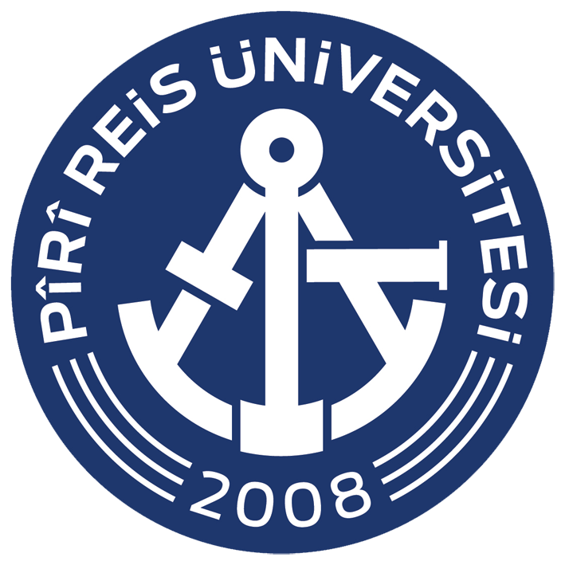


Constanta, February 19th 2025

INVITATION LETTER

Dear Partners,
Based on the fruitful and traditional cooperation developed between our institutions in the field of Maritime Education and Training, we are honoured to renew our esteemed consideration in respect of your valuable contribution provided, as ongoing support, for initiating and implementing joint projects and programmes for research and development.
Taking under consideration the implementation calendar of the joint project CUL-MAR-Skills - ” MARitime Soft Skills for Onboard Healthy Nutrition and CULinary Arts in Seagoing Services” awarded to our partnership under KA220-VET - Cooperation partnerships in vocational education and training, contract no. 2023-1-RO01-KA220-HED-000155888, we would like to invite 2 (two) representatives of your institution, selected from the nominated project team members, to participate in the Transnational Meeting No. 3 – TPM3 Project meeting – virtual project meeting - ”Curricular developments for Food Logistics Services responsible”, organized and conducted ONLINE by the Romanian Naval Academy as Lead Partner, during February 19th 2025/13:00-16:00 EET.
This online meeting will be a valuable occasion for planning and checking the project objectives and tasks assignment and progress, enforcing the knowledge and good practices exchange between the project members.
Point of contact (POC) for registration and for further assistance will be Cdr (N) Marius CUCU, who can be reached by e-mail: erasmus@anmb.ro, or by phone: +40-761.689.616 and fax: +40.241.643096.

Respectfully Yours,

COMMANDANT (RECTOR) OF THE ROMANIAN NAVAL ACADEMY

Rear Admiral Alecu TOMA
Associate Professor, Eng. PhD

