KA220-VET - Cooperation partnerships in vocational education and training
2023-1-RO01-KA220-VET-000156711

MARitime Soft Skills for Onboard Healthy Nutrition and CULinary Arts in Seagoing Services - CUL-MAR-Skills

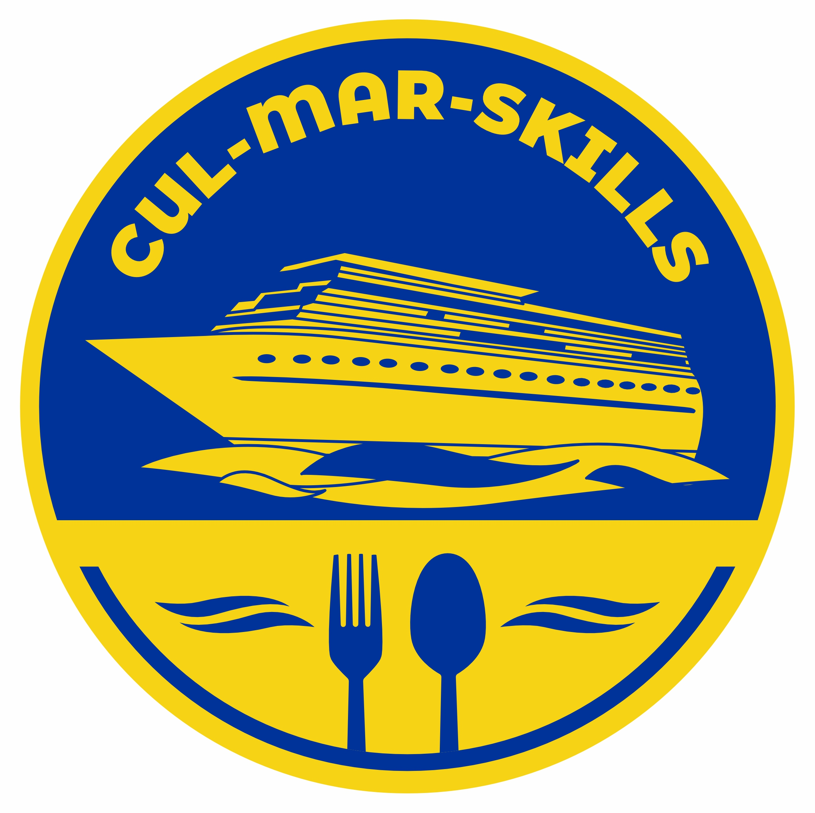

TRAINING MANUAL FOR COOKING SKILLS MODULE C4S

19-23 MAY 2025
PIRI REIS UNIVERSITY
ISTANBUL/TURKIYE

Table of Contents
19 MAY 2025 3
20 MAY 2025 4
EGGPLANT MENEMEN (TURKISH-STYLE SCRAMBLED EGGS WITH EGGPLANT) 4
WHOLE WHEAT BREAD WITH AVOCADO & WHITE CHEESE 5
HONEY-YOGURT OAT CUPS 6
GINGER-LEMON TEA / TURKISH BLACK TEA (UNSWEETENED) 7
21 MAY 2025 11
CHICKEN & VEGETABLE STEW (CLAY POT STYLE) 11
BULGUR PILAF 12
GAVURDAĞI SALAD 13
AYRAN WITH FRESH BASIL 14
DRIED FIG DESSERT 15
22 MAY 2025 16
EZOGELIN SOUP 16
CHICKPEA & TUNA SALAD WITH FRESH HERBS 17
WHOLE WHEAT PASTA WITH SUN-DRIED TOMATOES AND BLACK OLIVES 18
SUGAR-FREE OAT PUDDING 19
GINGER & CARROT SOUP 20
WHOLE WHEAT PASTA WITH TOMATO SAUCE (ONE-POT) 21
TUNA PATTIES WITH YOGURT DIP 22
DATE ENERGY BALLS WITH WALNUTS AND RAISINS 23
23 MAY 2023 24

19 MAY 2025
On the first day of training, students will be given a general overview of the tools used in the galley and various basic cooking techniques. In addition, the importance of the galley on board will be emphasized, and the relationship between sailors' nutrition and health will be explained.

These activities will take place in the seaside campus of the PRU.
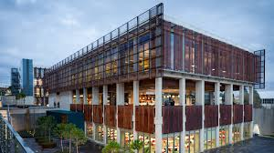
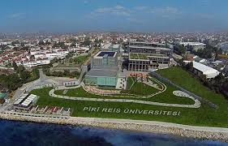



20 MAY 2025

EGGPLANT MENEMEN (TURKISH-STYLE SCRAMBLED EGGS WITH EGGPLANT)
Dish Type: | Main (Breakfast) | Yield: | 2 servings
Prep Time: | 10 minutes | Cooking Time: | 10 minutes
Ingredients:

• 2 tbsp olive oil
• 1 small eggplant (appx. 200 g), diced
• 1 green pepper, chopped

• 2 medium tomato, grated
• 2 eggs
• Salt and black pepper to taste
• Optional: ¼ tsp pepper flakes (Aleppo pepper)

Method:
1. Heat olive oil in a nonstick pan over medium heat.
2. Add diced eggplant and sauté until soft and lightly browned (approx. 5 minutes).
3. Add chopped green pepper and cook for 2–3 minutes until softened.
4. Stir in grated tomato and season with salt, pepper, and optional pepper flakes8.
5. Simmer for 2–3 minutes until slightly thickened.
6. Crack eggs directly into the pan and gently scramble until just set.
7. Serve hot, optionally with bread.

Nutritional Information (Per Serving): ~180 kcal | High in protein and fiber | Supports satiety and digestion | Vegetable-based

20 MAY 2025

WHOLE WHEAT BREAD WITH AVOCADO & WHITE CHEESE
Dish Type: | Main (Breakfast) | Yield: | 2 slices (1 per serving)
Prep Time: | 5 minutes | Cooking Time: | 2 minutes

Ingredients:

- 2 slices whole wheat bread
- ½ ripe avocado

- 40 g white cheese, crumbled
- Optional: Pinch of chili flakes or lemon zest
Method:
1. Toast the bread slices until crisp.
2. Mash avocado with a fork and spread evenly over the toast.
3. Sprinkle crumbled white cheese on top.
4. Garnish with chili flakes or lemon zest if desired. Serve immediately.

Nutritional Information (Per Serving): ~220 kcal | Rich in complex carbs and healthy fats | Helps blood sugar balance | Long-lasting energy

20 MAY 2025

HONEY-YOGURT OAT CUPS
Dish Type: | Dessert / Light Breakfast | Yield: | 2 portions
Prep Time: | 5 minutes | Cooking Time: | x

Ingredients:

- 4 tbsp rolled oats
- ½ cup plain yogurt

- 1 tsp honey
- Optional: 1 tbsp crushed walnuts or seasonal dried fruit

Method:
1. In two small bowls or cups, add 2 tbsp oats per serving.
2. Spoon yogurt over the oats.
3. Drizzle with honey.
4. Garnish with crushed walnuts or dried fruit if available.
5. Chill for a few minutes or serve immediately.

Nutritional Information (Per Serving): ~150 kcal | Contains probiotics | Good for digestion | Easy no-cook preparation

20 MAY 2025

GINGER-LEMON TEA / TURKISH BLACK TEA (UNSWEETENED)
Dish Type: | Beverage | Yield: | 1 cup
Prep Time: | 2 minutes | Cooking Time: | 5–10 minutes

Ingredients:
Option A – Ginger-Lemon Tea:

- 1 tsp fresh grated ginger (or ¼ tsp powdered)
- Juice of ¼ lemon
- 1 cup hot water

Option B – Turkish Black Tea:

- 1 tsp loose Turkish black tea
- 1 cup hot water

Method:
Option A: Steep ginger in hot water for 5–7 minutes, add lemon juice, strain if needed.
Option B: Brew tea in a çaydanlık or infuser for 10 minutes. Serve without sugar.

Nutritional Information (Per Serving): ~5–15 kcal | Hydrating and digestive | Supports immunity | Very low energy consumption

20 MAY 2025
PART 2 – BALANCED MARITIME LUNCH
________________________________________
SALMON EN PAPILLOTE WITH MEDITERRANEAN RATATOUILLE
Dish Type: Main
Yield: 2 servings
Prep Time: 10 minutes
Cooking Time: 20–25 minutes
Ingredients:
• 2 salmon fillets (approx. 120 g each)
• 1 small zucchini, sliced
• 1 small eggplant, diced
• 1 small red bell pepper, sliced
• 1 small onion, thinly sliced
• 1 small tomato, chopped
• 1 tbsp olive oil
• Salt and black pepper to taste
• Optional: fresh thyme or rosemary
• 2 sheets of parchment paper

Method:
1. Preheat oven to 180°C (350°F).
2. Toss all vegetables with olive oil, salt, pepper, and optional herbs.
3. Lay out parchment paper sheets. Divide vegetables evenly in the center of each.
4. Place a salmon fillet on top of the vegetables. Season the salmon with salt and pepper.
5. Fold parchment paper into a sealed packet (en papillote).
6. Bake for 20–25 minutes at 190 C until salmon is cooked through and vegetables are tender.
7. Serve directly in parchment or plate with packet opened for steam effect.
Nutritional Information (Per Serving):
~400 kcal | Rich in Omega-3s | Heart-healthy | Oven-baked for low energy use | Minimal cleanup

20 MAY 2025
CHICKEN STIR-FRY WITH VEGETABLES AND BROWN RICE
Dish Type: Main, Yield: 2 servings
Prep Time: 10 minutes
Cooking Time: 15–18 minutes
Ingredients:
• 200 g chicken breast, thinly sliced
• 1 cup assorted vegetables (carrot, bell pepper, broccoli), sliced
• 1 tbsp soy sauce (low sodium)
• 1 tbsp olive oil
• 1 garlic clove, minced
• 1/2 cup cooked brown rice
• Salt and black pepper to taste
• Optional: 1 tsp sesame seeds or grated ginger
Method:
1. Heat olive oil in a pan or wok over medium-high heat.
2. Add chicken slices, season lightly with salt and pepper, and sauté until browned (approx. 5–6 minutes).
3. Add garlic and vegetables, stir-fry for 5–6 minutes until vegetables are tender-crisp.
4. Add soy sauce and mix thoroughly.
5. Serve with cooked brown rice on the side or mixed in. Garnish if desired.
Nutritional Information (Per Serving):
~450 kcal | Balanced in protein, fiber, and complex carbs | One-pan meal | Reduces water and energy usage

21 MAY 2025

CHICKEN & VEGETABLE STEW (CLAY POT STYLE)
Dish Type: | Main | Yield: | 2 servings
Prep Time: | 10 minutes | Cooking Time: | 35–40 minutes

Ingredients:

- 200 g chicken thigh or breast, cubed
- 2 tbsp olive oil
- 1 small onion, diced
- 1 small potato, cubed
- 1 carrot, sliced
- ½ green pepper, chopped
- 1 small tomato, chopped
- 1 bay leaf
- ½ tsp dried thyme
- 1 cup water
- Salt and black pepper, to taste

Method:
1. Heat olive oil in a clay pot or saucepan. Brown chicken on all sides.
2. Add onion, potato, carrot, and green pepper. Sauté briefly.
3. Stir in tomato, herbs, salt, and pepper.
4. Add water to just cover ingredients.
5. Cover and simmer over low heat for 35–40 minutes until vegetables are tender.
6. Serve hot directly from the pot.

Nutritional Information (Per Serving): ~380 kcal | One-pot, nutrient-rich | Low waste and energy-efficient | High in protein and fiber

21 MAY 2025

BULGUR PILAF
Dish Type: | Side | Yield: | 2 servings
Prep Time: | 5 minutes | Cooking Time: | 15–20 minutes

Ingredients:

- ½ cup coarse bulgur
- 1 small onion, finely chopped
- 1 tbsp tomato paste or grated tomato
- 1 tbsp olive oil
- 1 cup hot water or vegetable stock
- Salt to taste

Method:
- 1. Heat olive oil in a small pot. Add onion and sauté until translucent.
- 2. Stir in tomato paste and cook briefly.
- 3. Add bulgur and mix well.
- 4. Pour in hot water or stock and season with salt.
- 5. Cover and simmer on low heat for 15–20 minutes until liquid is absorbed.
- 6. Let rest 5 minutes before fluffing and serving.

Nutritional Information (Per Serving): ~180 kcal | High in fiber | Long shelf-life grain | Supports gut health

21 MAY 2025

GAVURDAĞI SALAD
Dish Type: | Salad / Side | Yield: | 2 servings
Prep Time: | 10 minutes | Cooking Time: | No cooking required

Ingredients:

- 2 tomatoes, finely diced
- 2 cucumbers, finely diced
- 2 tbsp chopped walnuts
- 2 tbsp finely chopped parsley
- 1 tbsp pomegranate molasses
- 1 tbsp olive oil
- Salt to taste
- Optional: sumac or pul biber

Method:
1. Combine tomatoes, walnuts, and parsley in a mixing bowl.
2. Drizzle with pomegranate molasses and olive oil.
3. Season with salt and optional spices.
4. Toss well and serve fresh.

Nutritional Information (Per Serving): ~160 kcal | Rich in antioxidants | Uses local, seasonal ingredients | No cooking needed

21 MAY 2025

AYRAN WITH FRESH BASIL
Dish Type: | Beverage | Yield: | 1 glass
Prep Time: | 2 minutes | Cooking Time: | No cooking required

Ingredients:

- 100 g plain yogurt
- 50–70 ml cold water
- Salt to taste
- 2–3 fresh basil leaves, finely chopped

Method:
1. Whisk yogurt with water and a pinch of salt until smooth.
2. Stir in finely chopped basil.
3. Serve cold.

Nutritional Information (Per Serving): ~90 kcal | Probiotic and hydrating | Supports digestion and electrolyte balance

21 MAY 2025

DRIED FIG DESSERT
Dish Type: | Dessert / Snack | Yield: | 2 servings
Prep Time: | 3 minutes | Cooking Time: | Optional 1–2 minutes (for softening)
Ingredients:

- 8 dried figs
- 500 ml milk
- Optional: cinnamon or orange zest

Method:
1. Soak the dried figs in hot water for about 1 hour until soft.

2. Chop the softened figs into small cubes and place them in a bowl.
3. Heat the milk in a saucepan until it's just slightly hotter than yogurt-fermenting temperature. Then remove it from heat.

4. Pour a ladleful of the hot milk over the figs and mash them well with a wooden spoon, or blend them slightly for a smoother texture.

5. Add the mashed figs back into the pot with the rest of the milk and stir once.

6. Pour the mixture into small serving cups.

- Cover each cup with a napkin, plate, or plastic wrap, then cover them all with a clean kitchen towel to keep warm.

- Let them "sleep" (ferment) at room temperature for about 2 hours.

9. After that, uncover and refrigerate for 2–3 hours until fully chilled.

Nutritional Information (Per Serving): ~120 kcal | High in fiber | Naturally sweet | No refrigeration required

22 MAY 2025

EZOGELIN SOUP
Dish Type: | Starter | Yield: | 2 small bowls
Prep Time: | 10 minutes | Cooking Time: | 20–25 minutes

Ingredients:

- 2 tbsp red lentils
- 1 tbsp rice
- 1 tbsp bulgur
- ½ small onion, grated
- 1 tsp tomato paste
- 2 cups water
- Dried mint, chili flakes, butter

Method:
1. Sauté grated onion and tomato paste in a small amount of butter.
2. Add lentils, rice, and bulgur. Stir well.
3. Pour in water and bring to a boil.
4. Reduce heat and simmer for 20–25 minutes, stirring occasionally.
5. Season with dried mint and chili flakes before serving.

Nutritional Information (Per Serving): ~160 kcal | High in plant protein and fiber | Gentle on digestion | Low-cost and energy-efficient

22 MAY 2025

CHICKPEA & TUNA SALAD WITH FRESH HERBS
Dish Type: | Main | Yield: | 2 servings
Prep Time: | 10 minutes | Cooking Time: | No cooking required

Ingredients:

- 1 small can tuna (in water or olive oil)
- ½ cup cooked chickpeas
- 1 tbsp chopped parsley
- 1 tbsp lemon juice
- 1 tbsp olive oil
- Salt and pepper to taste

Method:
1. Drain tuna and mix in a bowl with chickpeas and chopped parsley.
2. Add lemon juice and olive oil.
3. Season with salt and pepper.
4. Serve chilled or at room temperature.

Nutritional Information (Per Serving): ~300 kcal | Uses canned and dry staples | Protein-rich | Sustained energy for long work hours

22 MAY 2025

WHOLE WHEAT PASTA WITH SUN-DRIED TOMATOES AND BLACK OLIVES
Dish Type: | Main | Yield: | 2 servings
Prep Time: | 5 minutes | Cooking Time: | 10–12 minutes

Ingredients:

- 100 g whole wheat pasta
- 4–5 sun-dried tomatoes, chopped
- 6 black olives, pitted and halved
- 1 tbsp olive oil
- 1 garlic clove, optional
- Chopped parsley or basil

Method:
- 1. Cook pasta in boiling salted water until al dente. Drain.
- 2. Sauté garlic in olive oil (if using), then add sun-dried tomatoes and olives.
- 3. Toss the cooked pasta into the pan and mix well.
- 4. Garnish with chopped herbs and serve.
Nutritional Information (Per Serving):
~320 kcal | Whole grain carbs | Shelf-stable ingredients | High in fiber and healthy fats

22 MAY 2025

SUGAR-FREE OAT PUDDING
Dish Type: | Dessert | Yield: | 2 portions
Prep Time: | 5 minutes | Cooking Time: | 10 minutes

Ingredients:
- ½ cup rolled oats
- 1 cup water or milk
- 1 tsp cinnamon or cocoa powder (optional)
- Pinch of salt
- Optional: vanilla extract
Method:
1. In a small pot, combine oats, liquid, and flavorings.
2. Simmer over low heat for 8–10 minutes until thick and creamy.
3. Let cool slightly before serving.
4. Serve warm or chilled.

Nutritional Information (Per Serving): ~180 kcal | Low glycemic index | Filling | Helps manage sugar intake onboard

22 MAY 2025

GINGER & CARROT SOUP
Dish Type: | Starter | Yield: | 2 servings
Prep Time: | 5 minutes | Cooking Time: | 20 minutes

Ingredients:

- 1 tbsp olive oil
- 2 carrots, chopped
- ½ onion, chopped
- 1 tsp fresh grated ginger
- 2 cups water or vegetable stock
- Salt and pepper to taste

Method:
1. Sauté onion, carrots, and ginger in olive oil for 3–4 minutes.
2. Add water or stock and bring to a boil.
3. Simmer for 15 minutes until carrots are soft.
4. Blend until smooth. Adjust seasoning and serve hot.

Nutritional Information (Per Serving): ~130 kcal | Immune-supportive | Made from long-storage ingredients | Light and easy to digest

22 MAY 2025

WHOLE WHEAT PASTA WITH TOMATO SAUCE (ONE-POT)
Dish Type: | Main | Yield: | 2 servings
Prep Time: | 5 minutes | Cooking Time: | 10–12 minutes

Ingredients:

- 100 g whole wheat pasta
- 1 cup water
- ½ cup canned tomato
- 1 tsp olive oil
- Garlic, herbs, salt to taste

Method:
1. Combine all ingredients in a single pot.
2. Bring to a boil, then reduce heat and simmer until pasta is cooked and liquid is absorbed.
3. Stir occasionally to prevent sticking.
4. Serve immediately, optionally with cheese or herbs.
Nutritional Information (Per Serving): ~300 kcal | Energy- and water-efficient | Balanced and satisfying | Easy preparation

22 MAY 2025

TUNA PATTIES WITH YOGURT DIP
Dish Type: | Main | Yield: | 2 servings (4 small patties)
Prep Time: | 10 minutes | Cooking Time: | 6–8 minutes

Ingredients:

- 1 can tuna, drained
- 2 tbsp oats
- 1 egg
- 1 tbsp parsley, chopped
- Salt and pepper to taste
- Oil for pan-frying
- Yogurt, 2 tbsp (for dip)
- Lemon juice, 1 tsp
- Dried mint or dill, optional

Method:
1. In a bowl, combine tuna, oats, egg, parsley, salt, and pepper.
2. Form mixture into 4 small patties.
3. Pan-fry on medium heat until golden and crispy, 3–4 minutes per side.
4. Mix yogurt with lemon juice and herbs to make the dip.
5. Serve patties hot with yogurt dip on the side.
Nutritional Information (Per Serving): ~250 kcal | High in protein | Shelf-stable ingredients | Makes use of canned tuna and oats

22 MAY 2025

DATE ENERGY BALLS WITH WALNUTS AND RAISINS
Dish Type: | Dessert / Snack | Yield: | 2 servings (6 balls)
Prep Time: | 10 minutes | Cooking Time: | No cooking required

Ingredients:

- 6 dates, pitted
- 2 tbsp walnuts
- 1 tbsp raisins
- Optional: cinnamon or coconut flakes

Method:
1. Blend dates, walnuts, and raisins in a food processor until sticky and combined.
2. Form into small balls using your hands.
3. Roll in cinnamon or coconut if desired.
4. Store in an airtight container. No refrigeration needed.
Nutritional Information (Per Serving): ~140 kcal per 2 pieces | Energy-boosting | No added sugar | Long shelf life

23 MAY 2023
After four intensive days of training, the fifth and final day will be an opportunity to consolidate knowledge and celebrate progress. The morning will begin with a practical assessment where students are tasked with preparing a full meal—starter, main course, and dessert—under simulated shipboard conditions. This will give them a chance to demonstrate their culinary skills, time management, and ability to work in a team. Some case-based questions will be asked to test theoretical understanding.
Midday will be dedicated to peer review and group reflection. Students will sample each other’s dishes and offer constructive feedback. Group discussions will allow them to share what they found most valuable during the training and how they intend to apply their skills on board. This will promote self-awareness and reinforce learning through shared experiences.
In the afternoon, a guest speaker from the maritime hospitality industry—such as an experienced ship chef or catering manager—will be invited to provide real-world insights and answer questions. This is also a good time to offer career guidance, helping students understand the process of applying for shipboard positions.
The training will conclude with a short closing ceremony. Participants will receive certificates of completion. A group photo will be taken, and light refreshments will be served to help mark the end of the training in a positive, memorable way, reinforcing camaraderie among future seafarers/ galley staff.

