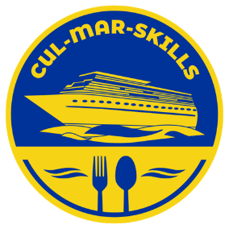
KA220-VET - Cooperation partnerships in vocational education and training
2023-1-RO01-KA220-HED-000155888
MARitime Soft Skills for Onboard Healthy Nutrition and CULinary Arts in Seagoing Services – CUL-MAR-Skills

APPLICATION FORM
C1T - Training module for instructors "Onboard Healthy Nutrition” November 4th – 8th 2024, Constanta/ROMANIA
COUNTRY
UNIVERSITY
POC:
Email:
Phone number
Attendees:
1 | Military / Civilian |  | Title |  | Sex |  |  | Date of birth  DD/MM/YY |  |  | ID/Passport  number
1 | M C |  |  |  | F M
1 | Name (first / last)
2 | Military / Civilian |  | Title |  | Sex |  |  |  | Date of birth  DD/MM/YY |  | ID/Passport  number
2 | M C |  | . |  | F M
2 | Name (first / last)
3 | Military / Civilian |  | Title |  | Sex |  |  |  | Date of birth  DD/MM/YY |  | ID/Passport  number
3 | M C |  | . |  | F M
3 | Name (first / last)
ITINERARY
Arrival |  | Plane Bus Personal Car Other
Date / Hour
Airport
Departure |  | Plane Bus Personal Car Other
Date / Hour
Airport
ACCOMMODATION FORM – to be booked individually
03/11/2024 to 04/11/2024 |  |  |  | YES NO
04/11/2024 to 05/11/2024 |  |  |  | YES NO
05/11/2024 to 06/11/2024 |  |  |  | YES NO
06/11/2024 to 07/11/2024 |  |  |  | YES NO
07/11/2024 to 08/11/2024 |  |  |  | YES NO
08/11/2024 to 09/11/2024 |  |  |  | YES NO
SPECIAL REQUESTS & QUESTIONS

