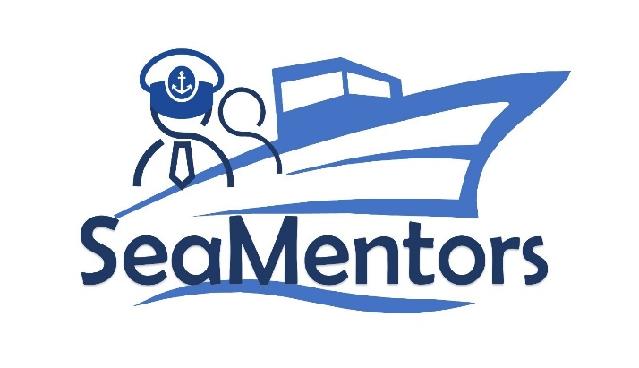

SEA MENTORS
SEAfarers Experiential Knowledge Based MENTORS Project number: KA220-VET-93A876D8

Interview
for SEA MENTORS

2023

Şemsettin Background

Extensive experience in operating and managing Oil/Chem. tankers with a strong background in maritime navigation, safety protocols, and vessel operations.
Experience on inspection of maritime industry such as SIRE, CDI, PSC, USCG, Flag, Class and CAP.
High skills on berthing / unberthing maneuvers.
Experience on STS operations.
Extensive experience on maintenance of the vessel.
Experience on dry docking as master and chief mate.

Sea Career;
Master
- 18 Months Experience - Oil/Chem. Tanker 16664DWT - ICE Class 1A1 - Epoxy Coating
- Trading Area; Canada Seaways, East Coast of USA, Mediterranean, North Europe, Baltic Region
- Extensive experience on ice navigation,
- Extensive tank cleaning / tank preparation experiences on Annex I / II (Tall Oil Crude & Pitch, Beat Molasses, UAN, Benzene, CPPs, etc. )

Master
- 18 Months Experience - Oil/Chem. Tanker 16500DWT - ICE Class 1A1 - Epoxy Coating
- Trading Area; North Europe, Baltic Region
- Extensive experience on ice navigation,
- Extensive tank cleaning / tank preparation experiences on Annex I (CPP & DPP) products

Chief Officer
- 20 Months Experience - Oil/Chem. Tanker 16500DWT - ICE Class 1A1 - Epoxy Coating
- Trading Area; Mediterranean, North Europe, Baltic Region
- Extensive experience on ice navigation,
- Extensive tank cleaning / tank preparation experiences on Annex I / II products

Chief Officer
- 28 Months Experience - Oil/Chem. Tanker 16500DWT - ICE Class 1A1 - Epoxy Coating
- Trading Area; Mediterranean, North Europe, Baltic Region
- Extensive experience on ice navigation,
- Extensive tank cleaning / tank preparation experiences on Annex I products

OOW
- 28 Months Experience - Oil/Chem. Tanker 16500DWT - ICE Class 1A1 - Epoxy Coating
- Trading Area; Mediterranean, North Europe, Baltic Region & Far East,
- Cargoes Annex I / II products

OOW
- 2 Months Experience - Oil Product Tanker 31990DWT
- Trading Area; Mediterranean and Black Sea
- Cargoes Annex I products

Interview Notes

Question: Hello, first of all, thank you for your participation. We are conducting this interview with you as part of the SEA MENTORS project to share your accumulated knowledge and experiences with the new generations. Shall we begin with the questions?

Answer: Hello, of course. Please proceed.

Question: What position are you currently holding, and which company are you working for?

Answer: I am currently working as a long-distance ship captain on a chemical tanker.

Question: Thank you for your answer. Could you briefly describe your maritime experience? For example, your years of service and the types of vessels you have worked on.

Answer: My maritime experience began in 2006. Since then, I have worked as a Turkish company's Zodiac for a short time, and then as a third, second officer, and captain on tankers. Our contracts usually last for about 4 months, but they can vary depending on the ports of call of the vessels. Throughout my maritime career, I have accumulated a total of 17 years of experience.

Question: Thank you for your answer. Let's move on to the next question. When evaluating a captain candidate or a young employee on board, what qualities do you look for?

Answer: Firstly, I assess whether they are suitable for our profession. This is something that becomes apparent after they start experiencing life at sea, as our profession is quite different from other jobs, and the suitability is better understood through practical experiences. People may perceive maritime work as a land-based job until they actually start experiencing it during their internships. The real professional experiences begin when they become deck officers. Unfortunately, our job is a 24/7 commitment, and it takes time to adapt to this environment. Therefore, evaluating their personality for suitability is crucial.

Next, their educational background is essential. Have they effectively utilized their education? Have they built a good knowledge base during their education that supports and enables successful progress in their careers?

Furthermore, their ability to work within the team is crucial. Can they get along well with other team members? This is also important when evaluating them.

Another significant aspect is how they handle challenges and problems. Do they approach problems with a solution-oriented mindset or do they tend to complain when faced with difficulties? It is crucial to work with individuals who can generate solutions rather than dwelling on complaints.

Additionally, I consider their motivation for the next step in their career. Are they enthusiastic about the next rank or position, or are they content with their current position? If they lack enthusiasm and goals for their future, they might not be very productive. On the other hand, if they are eager to learn and progress, they are more likely to make the most of the cumulative learning process in the maritime industry.

Question: Thank you. Let's move on to the next question. Could you share a challenging situation you encountered in your professional life?

Answer: I can share an example, but it may require some discretion as it involves a small accident during berthing.

Question: Thank you for your answer. Let's proceed to the next question. What are the barriers and challenges in achieving gender equality in the maritime industry?

Answer: Our profession has traditionally been perceived as a male-dominated field. While progress has been made in recent years, women still face challenges in entering the industry. There is sometimes a perception that women might have lower physical strength, which could impact their ability to handle tasks like handling ropes or opening valves. Additionally, there may be concerns about their integration within a team of predominantly male crew members.

Moreover, gender biases and stereotypes can create barriers for women seeking leadership roles within the maritime sector. Companies may need to implement specific procedures to ensure the employment of a certain percentage of female workers to foster gender diversity and equality in the workplace.

While there have been improvements, there is still work to be done to create a more inclusive and equal environment in the maritime industry.

Question: Thank you for your insights. Moving on to the last question. Mentorship involves a more experienced and knowledgeable person guiding a less experienced individual. Why would a new deck officer or a young employee on board need a mentor? Do you consider yourself suitable to be a mentor, and if so, what qualities do you possess that make you a mentor?

Answer: Experience can be acquired in two ways. First, by understanding and analyzing the experiences of others and applying them to oneself, one can progress more efficiently in less time. Second, one can choose to gain experience through trial and error, which often comes with a price, as it requires more time and may yield less productive results. Therefore, having a mentor is vital for new individuals starting their careers as deck officers. A mentor who is actively involved in the profession, stays updated with current requirements, and constantly renews themselves is essential. This mentorship helps guide them towards successful paths by utilizing the accumulated knowledge and experiences.

As for myself, I believe I possess the qualities necessary to be a mentor. I keep myself updated with the changing requirements of the maritime industry and continually strive to improve and learn. I believe in a solution-oriented approach to challenges and emphasize the importance of a "no blame culture," where individuals take responsibility for their actions and focus on learning from mistakes. Additionally, I value the importance of teamwork and effective communication.

In summary, I see myself as a suitable mentor because of my willingness to share knowledge, my focus on continuous improvement, and my commitment to fostering a positive and solution-oriented approach in the maritime industry.

Furkan Kaya: Thank you very much for sharing your valuable insights and experiences with us.

Şemsettin Demir: You're welcome. It was my pleasure to participate in this interview. Thank you for having me.

