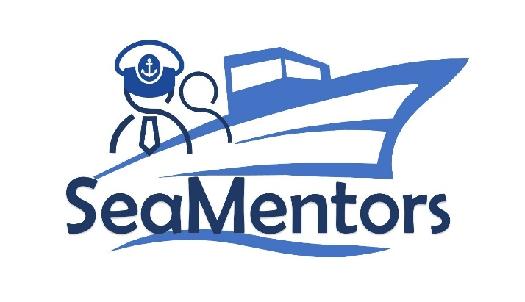

SEA MENTORS
SEAfarers Experiential Knowledge Based MENTORS Project number: KA220-VET-93A876D8

Interview with Professionals/Experts
for SEA MENTORS

2023

Capt. Oğuzhan Aksoy

Oğuzhan Aksoy stands out as an experienced mariner with over 16 years of uninterrupted experience at sea. He took his initial steps in the maritime career as a sea intern and gradually ascended to the highest position in the maritime world, achieving the title of Unlimited Master Mariner.
He completed a program for an unlimited seafarer at the Turkish Maritime Education Center (TUDEV). Subsequently, he served as an Ocean Vessel Surveillance Officer and Ocean Chief Officer at renowned shipping companies like AKSAY Shipping Company and V.Group, and as an Unlimited Master Mariner at KOÇ Group, one of Turkey's leading organizations. Currently, he is employed at Kuwait Oil Company. Throughout his career, Oğuzhan Aksoy has gained extensive maritime experience, managing various cargo types such as chemicals, oil, and crude oil, and overseeing more than 150 different cargo operations. During this time, he has developed a significant array of skills related to ship management and operational expertise.
Oğuzhan Aksoy's rich educational background has complemented his successful career in the maritime industry. His undergraduate studies in International Trade and Logistics Management at Istanbul University have allowed him to blend his knowledge and expertise in the maritime sector with management skills.

Interview Notes

Question: Hello, first of all, thank you for your participation. We are conducting this interview with you as part of the SEA MENTORS project to share your accumulated knowledge and experiences with the new generations. Shall we begin with the questions?

Answer: Hello, of course. Please proceed.

Question: What position are you currently holding, and which company are you working for?

Answer: I am currently working at Kuveyt Oil Company.

Question: Thank you for your answer. Could you briefly describe your maritime experience? For example, your years of service and the types of vessels you have worked on.
Answer: My maritime experience started after I graduated from the Istanbul Turkish Maritime Education Foundation, now known as Piri Reis University, in 2007-2008. After graduation, I started working on chemical tankers at Aksay Denizcilik, which is now known as Base Tanker in Europe, and currently as Ken. My experience on chemical tankers and at Aksay continued until 2012 when Aksay's operations in Turkey ceased. After that, from 2012 to 2019-2020, I served on chemical tankers and CPP (Clean Product Petroleum) tankers at International Tanker Management Dubai, which is part of a group. My maritime career has now reached 17 years. Throughout this time, I have always worked on tanker vessels, including chemical tankers, petroleum product tankers, and crude oil tankers. In terms of size, I have served on vessels ranging from 5,000 tons to 165,000 tons. Additionally, during this period, I participated in various projects, such as vessel deliveries, re-deliveries to charterers, shipyard works, and underwater maintenance. I have worked as a third officer, second officer, chief officer, and ship captain. From 2012 to 2023, I served as a ship captain. Recently, I have just started working as a Marine Pilot.

Question: Thank you for your answer. Let's move on to the next question. When evaluating a captain candidate or a young employee on board, what qualities do you look for?

Answer: Firstly, it is important for them to be able to comply with their company's safety management system and have a sense of duty and responsibility. Another essential quality I look for is leadership skills, the ability to mentor, and most importantly, what I call the "no blame culture," which means interpreting and expanding the duties assigned to them without blaming others and the system. Additionally, I assess qualities such as respectful behaviour towards others and the ability to communicate fluently.

In summary, they should possess knowledge, be able to apply it practically, and be open to learning. In the maritime sector, we know that people may have knowledge gaps and areas for improvement. However, in order to evaluate them, they must be able to perform their main duties and responsibilities. For example, they should be able to carry out watchkeeping in accordance with international norms safely.

Question: Thank you. Let's move on to the next question. Could you share a challenging situation you encountered in your professional life?

Answer: In our professional life, we may face challenges, of course. However, as we do not engage in impromptu actions, we first plan, hold sharing meetings, conduct risk assessments, and safety analyses before starting any task. Therefore, there is no particular challenging situation that comes to my mind. However, one challenge I frequently encounter in management is related to the competence of the personnel. For example, in a certain incident, I faced some obstacles with a crew member who couldn't improve their competence. To give an example, they claimed that we couldn't load 6 parcels of cargo with the assistance of the Second Officer, but with my support, we successfully loaded, transported, and discharged the cargo.

In conclusion, as someone who plans and carries out tasks in accordance with international norms, I haven't faced any remarkable challenging situation. Throughout my 17 years of maritime experience, I haven't encountered any maritime accidents, environmental pollution, loss of life, or injuries.

Question: Thank you. Moving on to the next question. What are the barriers and challenges in achieving gender equality in the maritime industry?

Answer: Yes, it's a great question, thank you. We acknowledge that there are barriers to achieving gender equality in the maritime industry. This industry is often considered to be male-dominated, and it can be difficult for women to find a place in it. However, we see progress as universities do not discriminate based on gender, and female students attending relevant universities in Turkey face challenges in entering the industry. This situation is gradually changing and progressing. Yet, there are still some barriers to overcome. For example, there is a perception that women may have lower physical strength, making it challenging for them to perform tasks like handling ropes or opening valves. Moreover, the perspective of companies can also be limiting. For instance, there may be concerns that a woman may not fit in a team of 20 men, or that the dynamics on board might be disrupted, or she may not be able to adapt to this environment.

Other challenges may include female performance being less accepted than that of male colleagues, or facing various biases. Additionally, the lack of specific procedures in companies to employ a certain percentage of female workers can be a significant challenge. Discussions resulting from these procedures indicate that female employees are outnumbered by male employees in many companies.

Although more can be said about barriers and challenges, the time constraints limit the scope of our discussion.

Question: Thank you. Moving on to the last question. A mentorship is a form of guidance provided by a more experienced and knowledgeable person to a less experienced individual. Why would a new officer or a young employee on board need a mentor? Do you consider yourself suitable to be a mentor, and if so, what qualities do you possess that make you a mentor?

Answer: A new officer starting their career on board would need a mentor primarily for practical or academic applications. As these applications are not included in the curricula of relevant universities and are not feasible to include, they need a mentor to learn these applications, be able to use them in the future, and teach them to others.

As a mentor, I embrace the most critical leadership quality, "no blame culture." I always blame the system instead of blaming an individual. This is because maritime operations are a team effort and based on a rule-based system. These rules are not written by a single person, not executed by a single person, and not decided by a single person. Therefore, I try to turn even a mistake into a useful lesson through the "lesson learned" application based on the system.

As a mentor and leader, I believe it is my duty to ensure that everyone on board rests and maintains their health while performing tasks in a healthy manner. I think one of the reasons I see myself as a mentor is that I am continuously striving to improve and learn. I follow the principle of "Learn, share, calibrate, innovate." Additionally, I believe I have valuable experience, having worked with various maritime companies both domestically and internationally. I am currently employed by a state-owned company affiliated with one of the world's largest petroleum refineries.

Thank you very much.

