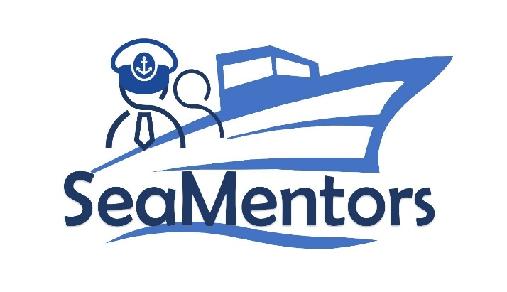

SEA MENTORS
SEAfarers Experiential Knowledge Based MENTORS Project number: KA220-VET-93A876D8

Interview with Professionals/Experts
for SEA MENTORS

2023

Capt. Ercüment Utkucan Savaş

Ercüment Utkucan SAVAS can be introduced as a professional with a distinctive career in the maritime industry. In 2010, he graduated with honors, receiving a Higher National Diploma in Navigational Engineering from the Turkish Maritime Education Center, also known as Piri Reis University.
After graduating from Piri Reis University, he had the opportunity to secure a scholarship under the EU Leonardo Mobility TRAIN4C-III Project funds, which enabled him to continue his education in the Navigation Engineering program at Glasgow College of Nautical Studies.
Over the past decade, he has gained extensive experience in various types of vessels such as Bulk Carriers, Ro-Ro Passenger ships, Oil/Product Tankers, Chemical and LPG tankers, Drill ships, and PSV vessels. This hands-on experience led him to serve as a Deck Superintendent for a year.
A pivotal point in his career was his active involvement as a captain in sea trials for newly constructed offshore and other vessels. Additionally, he has been deeply engaged in the SeaSafer project within the framework of the European Union. This project focuses on effectively simulating and responding to ship accidents through collaborative efforts. He has undertaken the role of a researcher, contributing to this project in partner countries including Turkey, Lithuania, Portugal, Romania, Bulgaria, and Greece. Further details about this important initiative can be found at https://seasafer.com/.
His interest in the maritime realm originates from his grandfather, who was a sailor and navigation instructor. This familial influence ignited his curiosity in navigation engineering, and his English education allowed him to explore the subject in-depth. English, widely known as the "language of the sea" in the maritime industry, significantly enhanced his language skills in his profession.
During his cadet training at sea, he had the opportunity to work as a part-time trainee at YASA Shipping (www.yasaholding.com). This connection continued even after he obtained his Officer of the Watch Qualification, contributing significantly to his personal and professional development. Today, holding a Chief Officer certificate, he eagerly looks forward to new challenges in his career.
His journey from cadetship to working as an officer at sea allowed him to establish a network spanning the globe, from Asia to Europe and America. His passion for exploring diverse cultures is paralleled by his photography hobby, capturing memories from his global travels. Apart from his maritime interests, he finds solace in reading Turkish, English, and American literature. His strong bonds with family remain unwavering, with regular theater visits among the many activities that strengthen their connections.

Interview Notes

Question: Hello, first of all, thank you for your participation. We are conducting this interview with you as part of the SEA MENTORS project to share your accumulated knowledge and experiences with the new generations. Shall we begin with the questions?
Answer: Hello, of course.

Question: What position are you currently holding, and which company are you working for?

Answer: I am currently serving as a DP Master on a PSV DP2 vessel at Fatih Offshore.

Question: Thank you for your answer. Could you briefly describe your maritime experience? For example, your years of service and the types of vessels you have worked on.

Answer: I have 10 years of experience on various types of ships, including Crude Oil, LPG, Chemical tankers, bulk carriers, Ro-Ro Passenger, Drill ship, Seismic Survey, and PSV vessels. Additionally, I worked for one year in a tanker company onshore, taking on roles in the training department and as a Deck Superintendent.

Question: Thank you for your answer. Let's move on to the next question. When evaluating a captain candidate or a young employee on board, what qualities do you look for?

Answer: I can list our expectations from the interns coming on board as follows: They should be curious, enthusiastic, and attentive. No matter how much training they have received at their schools, life on a ship is not easy and is different from what is seen from the outside. Therefore, they need to exercise maximum care, diligence, and take necessary safety precautions for every task they perform.

Question: Thank you. Let's move on to the next question. Could you share a challenging situation you encountered in your professional life?

Answer: While working on the ship, there may be unnecessary and excessive pressures from the company; for example, during the ship's 5-year dry-docking preparation, we conducted an inspection of the ballast tanks and prepared a detailed report with photographs. However, the company officials demanded that the ship should perform the maintenance (scraping, sandblasting, and painting) of the ballast tanks before entering the dry-dock. They left the responsibility of completing the task to the ship's crew.

Question: Thank you. Moving on to the next question. What are the barriers and challenges in achieving gender equality in the maritime industry?

Answer: I believe in gender equality in the maritime sector. I have worked with both deck and engine cadets and officers in many companies.

Question: Thank you. Moving on to the last question. A mentorship is a form of guidance provided by a more experienced and knowledgeable person to a less experienced individual. Why would a new officer or a young employee on board need a mentor? Do you consider yourself suitable to be a mentor, and if so, what qualities do you possess that make you a mentor?

Answer: I believe that newcomers to the profession will need mentors because a mentor can help them succeed by sharing knowledge and experiences in all aspects. Having worked in various roles on different types of ships, I consider myself qualified to be a mentor.
Thank you very much.

