SHIP HANDLING AND MANEUVERING
ANCHORING OF THE SHIP

Anchoring terminology
Anchor | A heavy object designed to prevent a ship or structure from drifting from a desired position. This objective is achieved by lowering the anchor to the sea bed by a length of chain cable or warp. The design of anchors differs to allow, usually, a spade or hook effect into the sea bed.
Anchorage | A geographic area suitable for ships to lay at anchor. Ideally, it would have good holding ground free of strong currents and sheltered from prevailing weather. It is usually identified on a navigational chart by a small blue anchor symbol.
Anchor Aweigh | The anchor is said to be ‘A-Weigh’ at that moment when it is broken out of the holding ground and hangs clear of the sea bottom.
Anchor Ball | A black ball shape shown as a day signal by a vessel at anchor. The diameter of the shape is not less than 0.6 m and it is exhibited where it can best be seen in the fore part of the vessel.
Anchor Coming Home | A descriptive term to indicate that the anchor is being drawn home towards the ship in the operation of heaving aweigh. The action is unusual as it is normal to expect the ship to be drawn towards the anchor.
Anchor Dragging | A term describing a vessel moving her position, because the anchor is no longer secure in the sea bed and holding the vessel. The vessel is dragging her anchor as her position moves.
Anchor Pocket | A bow recess designed to accept the head of the anchor.
Anchor Watch | A term used to describe the period of time that persons would look after the safe keeping of the vessel, when at anchor. The anchor watch is usually made up of several crew members including an ‘Officer of the Anchor Watch’.
Bite | An anchor is said to ‘bite’ when it digs into the sea bottom and holds position.
Capstan | Avertical mooring drum driven by either hydraulic or electric power (early versions on sailing ships used ‘Capstan Bars’, to which manual labour was employed to turn the drum/barrel). The drum is scored with ‘whelps’ to provide increased grip and holding ability on the hawser being worked. Capstans are often designed as a combined dual element of a ‘cable holder’ and ‘warping drum’.
Chain Hook | Long handle steel hook used to manhandle chain cable.
Chain Locker | The stowage space used for the ships anchor cables.
Devils Claw | A holding claw which secures the anchor cable and provides additional securing to the anchor when the vessel is at sea.
Drop an Anchor Underfoo | To let an anchor go without veering cable. It is often used as a t second anchor to reduce the vessel’s ‘yawing’ movement when lying to a single anchor. This use of a second anchor would be usually held at ‘short stay’.
Foul Anchor | When the anchor is found to be obstructed or entangled with debris or other foreign body dragged from the sea bed, when weighing anchor.
Foul Hawse | The description given to when the two anchor cables have become turned and twisted together with both anchors deployed.
Hove in sight | That moment in time when weighing anchor, that the anchor is sighted by the Officer in Charge of the anchor party
Shackle of Cable | A length of anchor cable. The number of shackle lengths usually shackled to the anchor will vary from ship to ship. The average vessel will carry about ten (10) shackles on each anchor. A larger vessel like a VLCC, may have up to eighteen (18) shackles. Shackle length _ (15 fathoms) or (90 feet) or (27.5 metres).
Single Anchor | The operation of bringing a vessel into a single anchor where she anchors by means of only one anchor.
Veer Cable | A method of paying out the anchor cable or a hawser under controlled power.
Windlass | A deck mounted machine operated by electric, hydraulics, steam or pneumatic power, for handling anchors and cables and mooring equipment of the vessel.

Different types of anchors

The marine industry employs many types of anchors in a variety of forms. However, the common factor with all anchors is their respective holding power. Historically, anchors have developed through the centuries from the basket of stones of the ancient world’s first ships, through to the hook effect of the ‘Admiralty Pattern Anchor’ and on to the current widely used Stockless anchors.
The massive expansion in offshore environments has probably been the greatest incentive to anchor modernization. The varied types of ‘Bruce Anchor’, the Flipper Delta anchors and the many mooring type anchors in use, has reflected major development in the mooring of modern day ships.
Admiralty pattern anchors – Still used in the smaller coastal craft and fishing industry. It is sometimes referred to as a ‘Fisherman’s Anchor’. It is fitted with a stock, which is forelocked at right angles to the arms, causing one of the two flukes to ‘dig in’ to the ground. The remaining exposed arm and fluke are non-effective and could cause the anchor warp or cable to become fouled about itself.
Stockless anchors – Many types of stockless anchors have been developed over the years and all have respective peculiarities depending on manufacture. The holding power is about four times its own weight and as such, it is not considered a high holding power anchor. The distinct advantage is that they are readily stowed in the bows of the vessel in hawse pipes and as such kept easily available for immediate use.
High holding power anchors – Designs of high holding power anchors vary but they average about ten times their own weight, and are considered essential for the larger vessel, e.g. Supertankers, large passenger vessels, aircraft carriers, etc.
Flipper delta anchors – Probably one of the most modern designs in anchor operations today. It is a high holding power anchor where the angle of the flukes can be changed and set to a respective desired angle to the shank. This variable fluke angle would be determined by the nature of the holding ground. It has become popular in the offshore environment. Atripping pennant is used to break the anchor free, priorto recovery.
Mooring anchors – Many and varied in designs. They are extensively employed in holding patterns to secure buoys and offshore floats. Usually a minimum of three coupled with a chain swivel unit is normal practice for holding a buoy or light float in position.
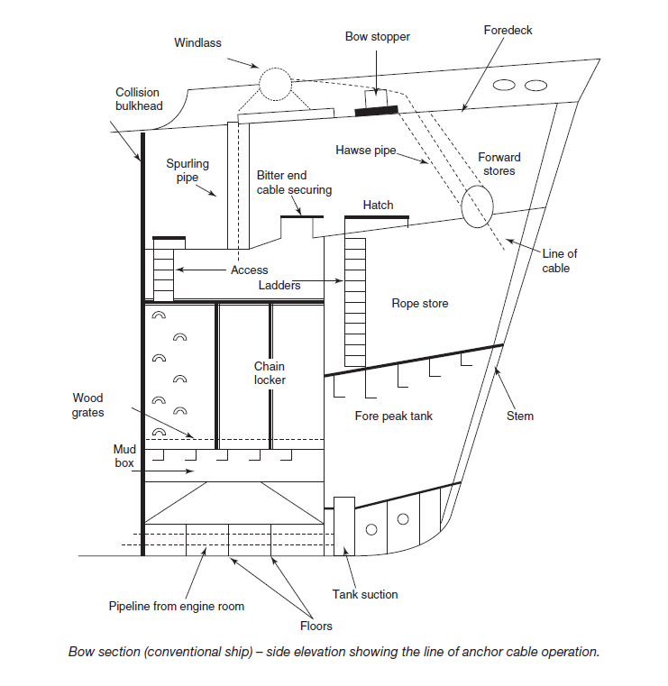

The anchor plan

An anchor plan should be established between the interested parties, namely: The Ship’s Master/Captain or Offshore Installation Manager (OIM), the Officer in Charge (OiC) of the anchor party, or the Master of Anchor Handling Vessel (AHV).
It would be expected that these key personnel would inform relevant crew members through an established chain of command, regarding relevant criteria. In the construction of any anchor plan the following items must be worthy of consideration:
1. The intended position of anchoring of the vessel.
2. The available swinging room at the intended position.
3. The depth of water at the position, at both High and Low water times.
4. That the defined position is clear of through traffic.
5. That a reasonable degree of shelter is provided at the intended position.
6. The holding ground for the anchor is good and will not lend to ‘dragging’.
7. The position as charted is free of any underwater obstructions.
8. The greatest rate of current in the intended area of the anchorage.
9. The arrival draught of the vessel in comparison with the lowest depth to ensure
adequate underkeel clearance.
10. The choice of anchor(s) to be used.
11. Whether to go to ‘single anchor’ or an alternative mooring.
12. The position of the anchor at point of release.
13. The amount of cable to pay out (scope based on several variables).
14. The ship’s course of approach towards the anchorage position.
15. The ship’s speed of approach towards the anchorage position.
16. Defined positions of stopping engines, and operating astern propulsion (Single
Anchor Operation).
17. Position monitoring systems confirmed.
18. State of tide ebb/flood determined for the time of anchoring.
19. Weather forecast obtained prior to closing the anchorage.
20. Time to engage manual steering established.
When anchoring the vessel, it would be the usual practice to have communications
by way of anchor signals prepared for day and/or night scenarios. Port and harbour
authorities may also have to be kept informed if the anchorage is inside harbour
limits or inside national waters.
Masters, or Officers in Charge, should consider that taking the vessel into an anchorage must be considered a Bridge Team operation.

Bringing the vessel to a single anchor

It would be normal procedure for a ship’s master to consider the approach towards an anchorage, and discuss the operation with the Officer in Charge of the anchor party, namely the Chief Officer of the vessel. Probably the most common of all uses of anchors is to bring a vessel into what is known as a ‘single anchor’ where the ship has adequate swinging room to turn about her one anchor position, with the turn of the tide and/or influence of the prevailing weather.
A planned approach to the intended position should be employed with the Master or Marine Pilot holding the ‘con’ of the vessel. The anchor party, on the orders of the Master, should clear away the anchor lashings and ‘walk back’ the intended anchor for use in ample time, before the vessel reaches the anchor position. The readiness of the anchor to be ‘Let Go’ should be communicated to the bridge by the intercom/phone system or ‘Walkie Talkie’ radio.
The Master would turn the vessel into a position of stemming the tide and manoeuvre the ship towards that position (as per plan) where he intends to let go the anchor. By necessity, the ship will still be making ‘headway’ in order to attain this position. Headway is taken off at this point by using astern propulsion but it will be noticed that sternway will not take an immediate effect (masters will have to estimate when the vessel is moving astern and this is not always readily observed. One method is to sight the wake from the propeller moving past the midship’s point towards the forward part of the vessel. This is a positive indication that sternway is on the vessel).
Fundamental principle of anchoring, is that it is the weight of cable and the lay of the ‘scope’ that anchors the vessel successfully, not just the weight or design of the anchor.
Once sternway is positively identified on the vessel, and the position of letting go the anchor is achieved, the Master would order the anchor to be released. The astern movement of engines would be reduced to an amount that the anchor cable could be payed out on the windlass brake, as the vessel continues to drop astern, slowly. The Officer in Charge of the anchor party would check the run of cable by using the gypsy braking system in order to achieve a lay of cable length along the sea bed. The Officer in Charge would endeavour not to pile the cable in a heap on top of, or close to, the anchor position. As the pre-determined amount of cable to be released is achieved, the engines should be stopped from moving astern. The cable will have been allowed to run and the brake would then be applied to check the amount of scope.
This should serve the purpose of digging the anchor into the sea bed and stop the vessel moving any further astern, over the ground. The ship is described as being ‘Brought Up’ to her anchor and it would be the duty of the anchor party officer to determine when the vessel is ‘brought up’ and not dragging her anchor.
Amount of anchor cable to use (single anchor)
The experience of the Master will always influence the amount of anchor cable to be employed for a single anchor operation. Most masters would work on the premise that 4 X Depth of water would be considered as the absolute minimum. The nature of the holding ground, the range and strength of tide, the current and expected weather conditions will all be factors that influence the optimum scope.
The intended time period of staying at anchor would be a further factor. When all the variables are considered the Master would still probably add another shackle length for luck and ship security.
Clearly the available swinging room must reflect the scope of cable and keep the vessel clear of surface obstructions. Consideration of the amount of cable to use would be made well before the approach is made to the anchorage; the amount being established following a chart assessment of the intended anchorage and an assessment of all variable factors which could affect the safety of the vessel. The use of a comprehensive anchor plan in the form of a checklist could be seen as beneficial and is considered good practice within some shipping companies.

Swinging room – vessel lying to a single anchor
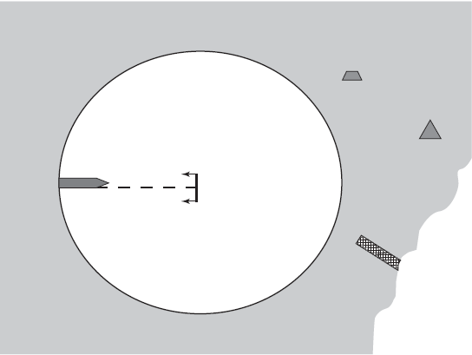
Surface obstructions must be significantly clear of the swinging circle, e.g. piers, buoys, navigation marks, etc.

Swinging room for a vessel at the single anchor will occur at the maximum scope of cable when at long stay. This circle of swing could be practically reduced by employing two anchors in the form of either a running or standing moor. Although these moorings are not generally common they are suitable when a large swinging circle is not permitted like within a canal or river, where sea room is restricted.
The vessel will swing through 180° with each turn of the tide (usually about every 6 hours). Movement of the vessel at anchor will also be influenced by the direction of wind. It is significant that wind over tide produces a powerful effect on the cable and, depending on the nature of the holding ground, may cause the anchor to break out and allow the vessel to drag her anchor, an extremely undesirable situation.
Watch Officers should be cautious to any traffic movement within the circle of swing, especially of traffic attempting to cross the ship’s bow. Such traffic would be directly affected by the same direction of tide/current and be caused to set down on the anchor cable.

Operational safety when anchoring

Certain precautions when anchoring may seem obvious to the experienced seafarer.
However, when dealing with five (5), ten (10) or twenty (20) tonne plus anchors, complacency can be the seaman’s worst enemy. Routine operations should therefore
include the following items:
1. Always check that the overside surface area is clear of small craft or other obstructions under the flare of the bow, at the intended area of letting go the anchor.
2. Routine operations should provide adequate time to walk the anchor back clear of the ‘Hawse Pipe’, prior to actually letting go.
3. Designated, experienced persons should operate the windlass and braking system. They should also be protected by suitable clothing including ‘hard hat’ and ‘eye goggles’.
4. All parties to the operation should have inter-related communications. These should be tested prior to employing the ship’s anchors. In the case of ‘walkietalkie’ radios being used, these should operate on a clearly identified shipboard frequency and seen not to interfere with other local shipping operations.
5. The marine pilot or ship’s Master who has the ‘con’ of the vessel should be continually informed as to the ‘Lead of Cable’ and the number of shackles in use. It would also be expected that the Officer in Charge of the anchor party would keep the bridge informed of any untoward occurrence, e.g. fouled anchor or windlass/power defects.
6. All recognition and sound signals should be employed promptly and correctly to highlight the status of the vessel.

The watch at anchor

It should be clearly understood by any and all watchkeeping personnel, that when the vessel goes to anchor, she is still considered ‘at sea’. As such, an effective and proper lookout must continue to be kept from the navigation bridge. The officer of the anchor watch will be responsible directly to the ship’s Master for the well being of the ship, and should be familiar with the two greatest dangers, namely:
a) own ship dragging anchor or
b) another ship dragging towards own ship.
In either of these cases the Master would be expected to come to the bridge and take the ‘con’ of the vessel.
Watch duties, inclusive of keeping the lookout, would expect to include monitoring the performance of the weather particularly closely; keeping a listening watch for radio traffic and ensuring that the vessel displays the correct navigation signals in all states of visibility. Where small launch or tender traffic is in attendance, the monitoring of movements of such traffic is considered good ship keeping practice.
Other hazards also inherent to anchoring – and something the diligence of watch personnel can go some way to defend against – are: fire, piracy, collision from another vessel, pollution, dragging and shifting position.

Anchoring principles

The amount of anchor cable employed has always been considered the critical factor when bringing a vessel into an anchorage. The anchor itself acts as a holding point from which the cable can be laid in a line on the sea bed. Ideally, this line should be at a narrow angle from the sea bed to generate a near horizontal direction of pull on the anchor; the position lending to the term ‘Long stay’.
Short stay is usually where the cable is at an acute angle to the surface and such a deployment would have a tendency to pull the anchor upwards, possibly causing it to break its holding of the surface at the sea bed.
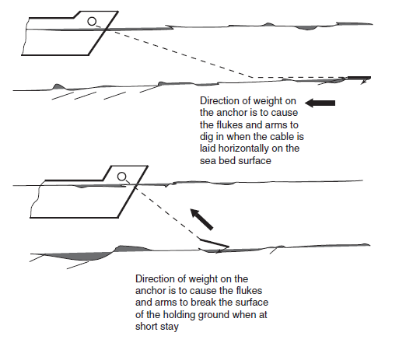

Detection of dragging anchor

One of the fundamental principles of the anchor watch is to ensure that the vessel does not break her anchor out and drag away from the anchor position. To this end, the weather conditions, state of currents and tides should be continuously monitored throughout the watch period.
Normal procedure for the watch officer at anchor would be to regularly verify the ship’s position. Where dragging is suspected, the ship’s position would be expected to change.
Such movement may be ascertained by any or all of the following methods:
1. Check the anchor bearings of the fixed landmarks. These references should be retained on the chart during the period of the anchorage; they should also be entered in the ship’s deck logbook. If they are changing, the ship’s position is changing and the vessel must be assumed to be dragging.
2. Obtain an immediate positional check from the GPS operation, to ensure that the instrument co-ordinates correspond to the Latitude and Longitude of the ship’s anchored position. Any discrepancy in position, the vessel must be assumed to be dragging its anchor.
3. Engage the variable range marker of the ship’s radar onto a fixed land object. If the range between ship and landmark opens or closes then the vessel can be assumed to be dragging its anchor.
4. Direct observation and hand contact with the anchor cable may give further indication that the ship is dragging its anchor. Adragging anchor would usually generate excessive vibration through the length of the cable, which could also indicate dragging (depending on the nature of the holding ground).

Anchoring large vessels

When a large vessel intends to deploy anchor(s), the ‘anchor plan’ should include due consideration to the speeds of approach and the speed of the vessel over the ground when walking back the anchor over the intended anchorage position. A recommendation of 0.25 knots, over the ground, should be considered as appropriate but such an estimate could be influenced by prevailing weather conditions.
It is also worth noting that monitoring the ship’s speed at such a low value does have problems and may prove difficult even with updated equipment.
The ability of the vessel to retain such a recommended speed would lend to achieving a suitable lay of cable over the sea bottom, without placing undue accelerations on the mooring equipment. The capabilities of ‘Band Brake Systems’ on larger tonnage would already seem to be operating at their upper limits and any increase in the momentum of the running cable, caused by increased vessel speed, must be considered as undesirable. Any such increase could cause overheating of a braking system and result in lost anchors and cables.
In the event that unrestricted descent of the anchor is allowed to take place, i.e. letting go, then damage to the windlass gearing and/or motors may be unavoidable. Speed limiting devices operating on the band brake may make the operator’s task of control easier but overheating could still become a problem with subsequent loss of braking efficiency. As such, over reliance on a restrictive speed, system should not become the order of the day, and the principle of walking the anchor back all the way should be adhered to.
It should be realized that 20 ton anchors are not unusual on large tankers and most masters would generally not wish to use anchors if the vessel could be safely allowed to drift in an area of clear water. Where an anchor is to be employed, turning the vessel into the tide would tend to take the ‘way’ off the vessel providing an opportune time to commence walking back on the cable. Once the anchor contacts the sea bed, the tidal direction would cause the vessel to drop away and astern from the anchor position.
A suggested approach to anchor a large vessel like a VLCC is shown bellow.
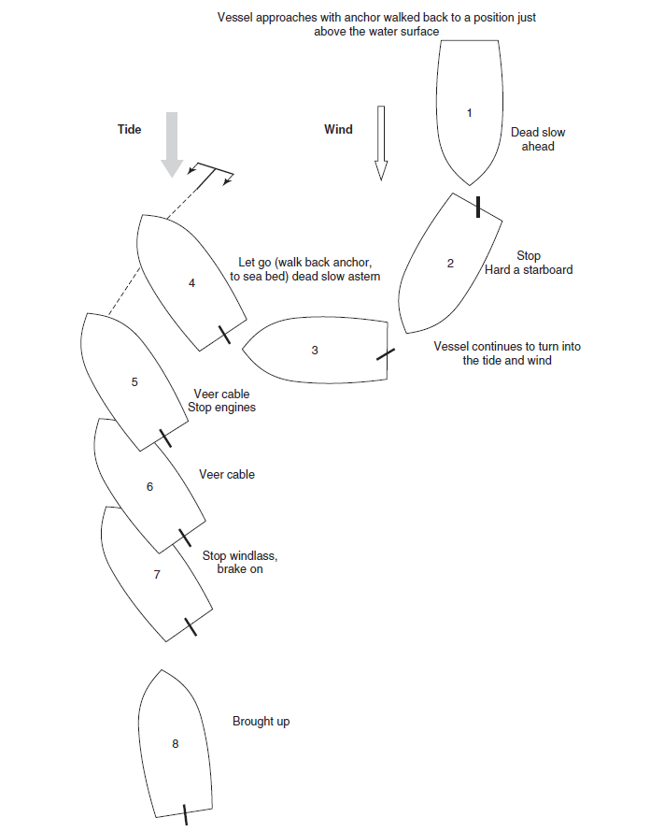
The open moor

This type of mooring is carried out in non-tidal conditions, such as when in a fresh water river. The use of two anchors, one off each bow with approximately equal lengths of cable is carried out to give greater holding power against a strong directional flow.
The open mooring should not be confused with the alternative use of two anchors where a second anchor has been used for additional holding in bad weather (usually one being deployed at long stay, with a second anchor deployed later at short stay as the weather deteriorates).
The open moor is not a practical option for tidal waters as, once the tide turns, clearly the anchor cables would foul.
Use of main engines and helm to manoeuvre from position ‘2’ towards position ‘3’ will cause the cable to bellow out in a beam direction, prior to letting the second (starboard) anchor go at position ‘3’.
Each cable can be checked and shortened as the vessel falls astern between the two anchors, so that each anchor has approximately the same scope.
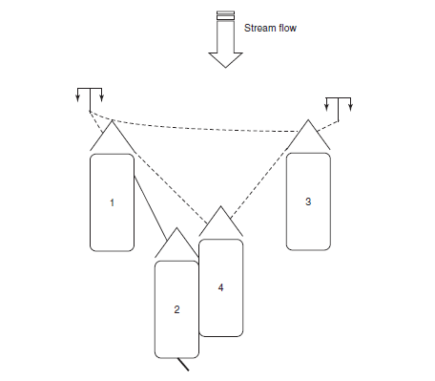

Open moor – procedure

1. Stem the current flow and adjust engine revolutions so that the vessel is stopped over the ground. Reduce the rpm and cant the bow to starboard. As the vessel moves astern and sideways let go the port anchor and pay out the cable to about four to five shackles.
2. Hold on to the port anchor and increase the rpm. The vessel will move ahead and sideways.
3. Reduce the rpm and bring the vessel head to current. Let go the starboard anchor and pay out the same amount of cable as on the port anchor.
4. Stop engines and bring the vessel up to four or five shackles on each anchor.

Mediterranean moor

The objective is to moor the vessel stern to the quay by means of mooring ropes aft and the use of both of the ship’s bow anchors forward. This type of mooring allows more vessels to moor to the berth where there is limited quay space. Some specialist vessels like tankers and Ro–Ro vessels also use the arrangement for stern discharge via an aft manifold or stern door, respectively.
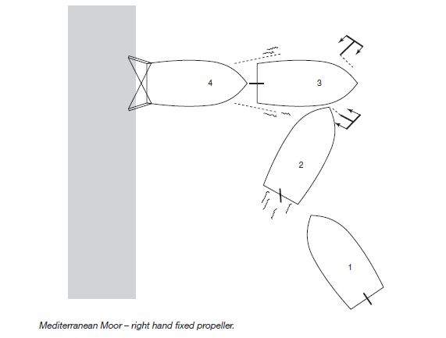

Mediterranean moor procedure

1. Approach the berth port side to, at about 11⁄2 ship’s lengths distance off. Dead slow ahead. Cant the bow towards the berth.
2. Hard to starboard and let go the starboard anchor. The starboard helm will cause the stern to swing towards the berth.
3. Stop engines. Full astern and let go the Port Anchor, rudder amidships. The effect of transverse thrust will keep the stern swinging towards the berth.
4. As the vessel gathers sternway, stop engines and pay out on both anchor cables. When the vessel reaches within heaving line distance off the berth, check the cables and pass quarter lines and crossed inboard springs.

Anchoring and anchor watch checklist

Example
