**ENGINERROOM SIMULATOR TRAINING**

**Introduction**

Automation systems applied to commercial ships generally include:

1-Electricity,

2-Main propulsion

3-Auxiliary machines.

Command and control of the electrical system connected to automation:

a) Electric generators driven by diesel engine, gas and heating tribune,

b) Normal, emergency and vital electrical energy distribution and control elements,

c) Machinery consuming electrical energy.

Command and control of the main drive system connected to automation:

a) Diesel and electric motors producing power, gas and steam turbines and their air, fuel, lubricating oil, cooling, starting air, exhaust, stim systems,

b) Power transmission system,

c) Includes rudders and propellers that transform the transmitted power into action and reaction forces.

Command and control of auxiliary machines connected to automation: Balancing, fresh water making, waste water treatment, garbage burning, air conditioning, cooling, fire warning and fighting, flue gas purification systems. The Engine Room Personnel of a ship, especially the Engine Room Watch Supervisor, are responsible for operating the automated machinery and systems economically, continuously, efficiently, safely, securely and environmentally. In this context, the example lesson given below has been prepared to emphasize the importance of a Machine Room Simulator designed with correct algorithms in scientific education.

**Course Prerequisites**

In order to understand and apply the lesson prepared as an example below, the student must have received training in Marine Diesel Engines-I and II, Thermodynamics, Automation and Engine Room Simulator-I.

**Course Description**

The ability of commercial ships to carry out transportation is only possible with the economic, continuous, efficient, safe, secure and environmentalist operation of the electrical energy required for their machinery and systems, the propulsion power and steering systems required for navigation and manoeuvring. Failure of one of these three systems causes the merchant ship's transport service to stop. The Ship Machinery Operations Engineer is responsible for correctly commanding these three systems, performing the controls correctly, and taking the necessary precautions on time, especially during the period he is responsible for the shift. The subject of this course is the monitoring of the cylinder exhaust temperatures, which gives precise information about the performance of the main drive diesel engine, by the shift supervisor using the automation system possibilities.

**Course Objectives**

The aim of this course is 1) to inform the Engine Room Watch Supervisor about the method to be applied to keep the performance of the main propulsion diesel engine at the best level, which directly affects the navigation and safety of the ship by effectively observing the exhaust flue gas temperature. 2) In this context, by making use of the possibilities and capabilities of the existing automation system, it is to increase the knowledge, experience and ability of observation, analysis, and interpretation, decision making and applying these decisions, respectively, about the operating diesel machine cylinder temperatures.

**Course tools**

The training tools for this course are 1) TRANSAS ERS500, 2) Trainee Manual Product Tanker MAN B&W 6S50MC-C, 3) Experienced Instructor.

**Scenario variables input**

NOTE: According to the purpose of this course and before starting the training, the instructor should enter the variables, assumed for the environmental conditions and diesel engine operating parameters, to the relevant data tables.

**Scenario starting conditions**

Sea state is 1. Second Engineer is in charge of Engine Room watch. Main Propulsion Diesel Engine is running at cruising speed (Nav. Full). Power Plant and Auxiliary systems are operating normally. There are no alarms. OOW is monitoring the operating values of the running systems and machines.

**The ship**

Type : Product Tanker

Max. continuous power : 8 600 kW at 127 RPM

Length : 183 meters

Breadth : 32.2 meters

Dead Weight : 50 000 t

Max Speed : 15.7 knots

**The main propulsion power engine**

Type : MAN B&W model 6S50 MC-C: 2-stroke, single acting,

direct reversible, cross-head type marine diesel engine with

constant pressure turbo-Charging.

Number of cylinders : 6

Cylinder bore : 500 mm

Length of stroke : 2 000 mm

Nominal MCR : 8 600 kW at 127 RPM

**The scenario**

1. The Second Engineer takes over the engine room watch at *t0* and observes on the real time graphics on the automation screen that the main diesel engine exhaust temperature is operating between 450-500oC with an increasing slope θ, which is in the safe operating limits (Fig.1).

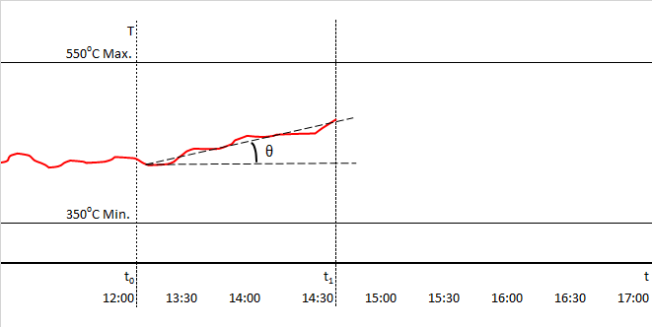

**Figure.1** Exhaust gas temperature between the hours 12:00 and 14:00

1. The OOW continues to monitor, making sure that the exhaust gas temperature continues to rise during *t1* and *t2* (Fig.2).

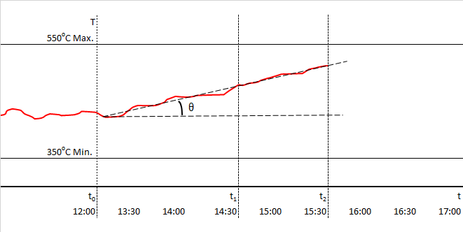

**Figure.2** Rate of exhaust gas temperature rise between the hour 14:30 and 15:30

1. The OOW understands that by extending the seaman eye line until it cuts off the maximum temperature level, the exhaust temperature at *t3* will reach the maximum limit within 60 minutes. OOW knows that when the temperature reaches this value, the controller will automatically reduce the main engine speed. Therefore, he realized that he had a maximum of 60 minutes to correct the error (Fig.3).

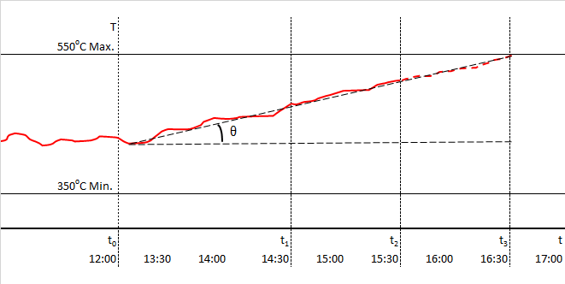

**Figure.3** Analysis of exhaust gas temperature rise and time left for corrective action

1. The OOW informs the Chief Engineer of the situation while trying to define the reasons that may effect on exhaust gas temperature increase.
2. OOW knows that it is caused by the oxidation of the injected fuel in the cylinder, and the deterioration in the fuel-air mixture ratio for any reason causes lean or rich combustion, which in turn causes an increase in the exhaust gas temperature. Therefore, OOW decides to examine the combustion process data of all cylinders to determine whether the fault is on the air or fuel side.

1. The OOW checks the high temperature (HT) side of the jacket water cooling system and sees that the temperature is within normal limits.

*NOTE: It was assumed in this scenario that, the jacket water temperature was set and operating correctly.*

1. OOW records the cylinder combustion data (Table.1) and transfers it to the interpretation graphs by using the cylinder analysis panel to interpret the exhaust gas temperature increase that will result from rich or lean combustion caused by the deterioration in the air-fuel mixture ratio (Figure 4).

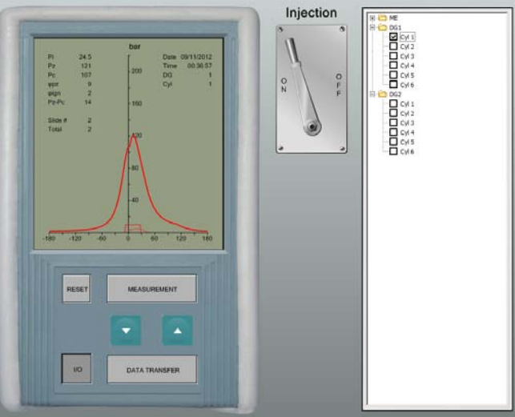

**Figure.4** Cylinder data reading and transfer panel

**Table.1** Cylinder data reading and transfer procedure

|  |  |  |
| --- | --- | --- |
| Sequence | Element | Action |
| 1 | Command touch button | To energize the panel |
| 2 | Command touch button | To reset the previous recordings |
| 3 | Command touch lever | To prepare the panel for desired recordings |
| 4 | Command Selection boxes | To select the desired diesel engines and cylinders |
| 5 | Command touch bar | To read and record the measured cylinder data |
| 6 | Control monitor | To see and control the measured cylinder data |
| 7 | Control touch bar | To transfer the measured cylinder data |

1. OOW selects comparison screen from the menu in order to determine the differences on pressure, injection and torque curves, determined from the data measured and transferred, effected from rich or lean combustion caused by the deterioration in the air-fuel mixture ratio (Fig.5).

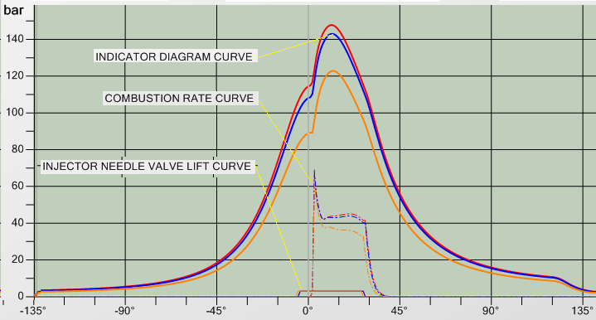

Fuel injection timing

Cylinder pressure

Cylinder pressure

**Figure.5** Comparison of the no 1, 2 and 6 cylinders data

1. The OOW sees on the graphics that no-2 cylinder pressure is higher than no-1 cylinder, while no-6 cylinder is much lower (Fig.5).
2. The OOW also sees on the graphics that no-2 cylinder torque and injection timing is almost same with no-1 cylinder while no-6 cylinder torque is less and fuel injection timing is early (Fig.5)
3. The OOW compares the deviation in cylinders exhaust gas temperatures. He/she decides that there is no problem on the intake air side as no abnormality is observed in the values of the other cylinders except the 2nd and 6th cylinders. So, OOW makes the decision that the exhaust gas temperature increase was directly related with the rich combustion in cylinder-2 while lean combustion in cylinder-6 compared to the average combustion rate of the diesel.engiig.6)

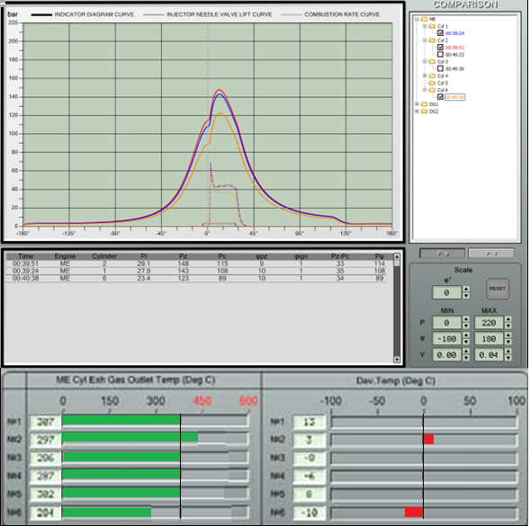

**Figure.6** Comparison of measured exhaust gas temperatures and deviation

1. OOW calls the engine performance screen to correct the amount of fuel injected into cylinder-2 and the amount and duration of fuel injected into cylinder-6. Using the command-and-control elements on the engine performance panel, OOW adjusts the 2nd and 6th cylinders fuel quantity (m) and injection duration (t) until matching the engine average values (Figure 7) (Table-2)

**Table.2** Cylinder fuel portion and injection timing adjustment procedure

|  |  |  |
| --- | --- | --- |
| Sequence | Element | Action |
| 1 | Command touch button | To select the cylinder for adjustments |
| 2 | Command touch button | To adjust the amount of fuel for selected cylinder |
| 3 | Command touch button | To adjust the duration of fuel injection for selected cylinder |
| 4 | Figure.6 | To control the changes after each adjustment |

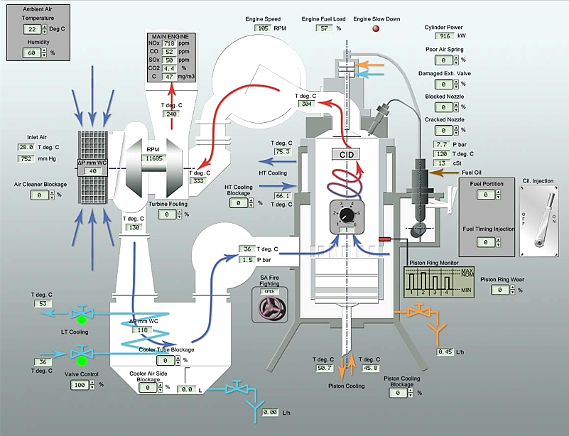

**Figure.7** Engine performance command and control panel

1. OOW is aware of that, there is maximum one hour to apply the adjustments for cylinders 2 and 6 by using the command elements “*a”* and “*b”* shown on the engine performance panel.
2. However, adjustment capability of the command element “a” is limited with ± 10% while the command element “b” is limited with ± 5%. If it is not possible to make adjustments due to limited capability of command elements, then OOW must be fast enough to make decision for further corrective actions. For instance, if amount of fuel, injected in cylinder-2, cannot be decreased by using command element “a”, it means that injector nozzles are leaking which needs replacement of the tip. On the other hand, if the fuel injection duration is not further adjusted due to 5% limitation in command element “b”, it means that timing electronic card or solenoid valve need to be rectified and the injector needs to be cleaned due to clogging.
3. In this case, OOW is responsible for performing the necessary repair and/or maintenance. In order to stop or at least slow down the main engine, he informs the chief engineer of the situation without delay. Necessary maintenance/repair is done according to the decision of the ship management.

**Conclusion**

Engine Room Simulator training is not training to start and stop ship systems and machines. ERS is designed for Ship Machinery Operations Engineers and especially for watch officers to operate ship systems and machinery economically, continuously, efficiently, safely, safely and environmentally. ERS training gives Ship Machinery Operations Engineers and Watch-keepers the ability to make correct observations and analysis, to interpret events correctly, to make the right decision and to take the necessary measures in a timely manner. This is necessary for the safety, safety and purpose of a merchant ship.