DRAUGHT (DRAFT) SURVEY

- THEORY OF THE DRAUGHT (DRAFT) SURVEY
The essence of the draft survey is the determination of the weight of the cargo according to the drafts of the ship. At first, it is necessary to determine the Constant (Const.) When the ship is empty, the weight of cargo P_{cargo}= 0. Displacement D_{o} can be calculated using (1) Formula:
D_{o} = 0 + ( P_{hfo} + P_{mdo} + P_{lo}) + (P_{bw} + P_{fw}) + Lightship + Const.
Const. = D_{o} – ( P_{hfo} + P_{mdo} + P_{lo}) – (P_{bw} + P_{fw}) – Lightship
Cargo weight determination.
When the ship is loaded, the displacement D_{c} can be calculated using (2) Formula:
D_{c} = P_{cargo} + ( P_{hfo} + P_{mdo} + P_{lo}) + (P_{bw} + P_{fw}) + Lightship + Const.
P_{cargo} = D_{c} – ( P_{hfo} + P_{mdo} + P_{lo}) – (P_{bw} + P_{fw}) – Lightship – Const.

UNECE - Draught Survey Code. UN ECE - United Nations Economic Commission for Europe. Code of Uniform Standards and Procedures for the Performance of DRAUGHT SURVEYS of Coal Cargoes
The Main Documents are Loading Manual, Stability Information Booklet, The Table of Hydrostatic Properties (see below).
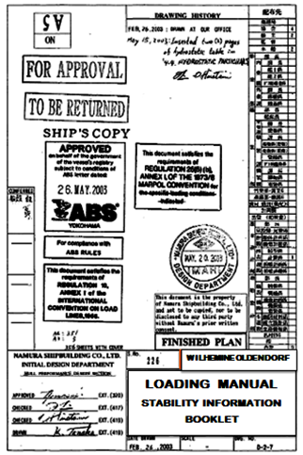
Figure 1. Loading Manual (Stability Information Booklet)
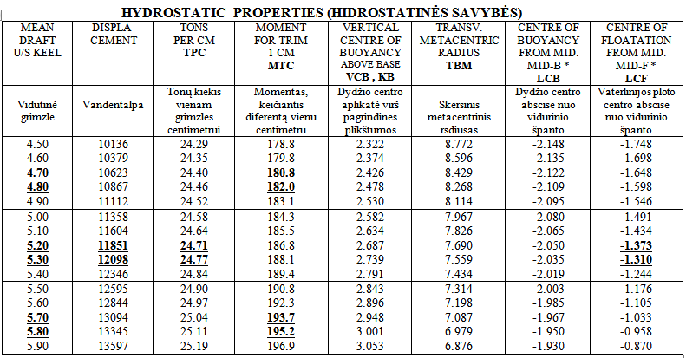
Figure 2. The Table of Hydrostatic Properties
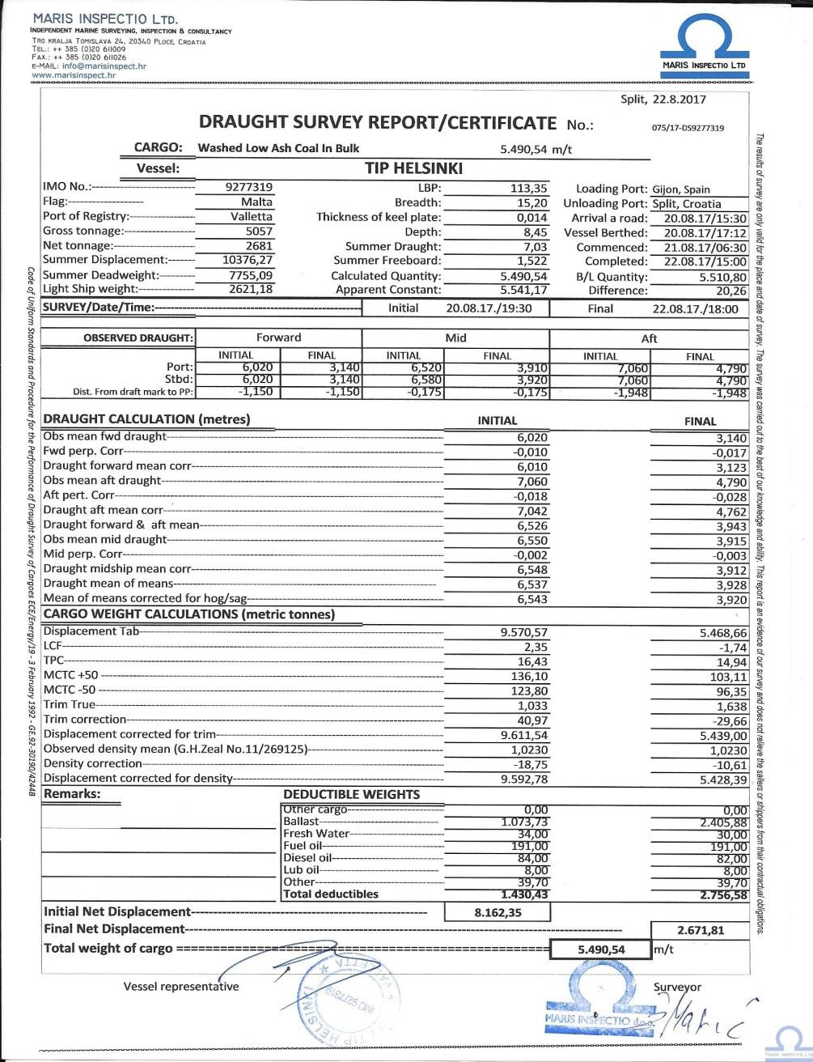
Figure 3. The draft survey report
- UNIVERSAL PROGRAM FOR DRAUGHT SURVEY, ADOPTED BY UNECE
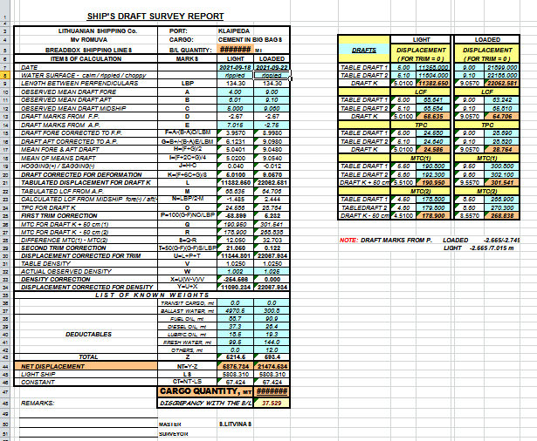

Steps and Formulas for Draught Survey that are adopted by UNECE.
1-st step - to observe six drafts: T_{f s/s,} T_{f p/s,} T_{m s/s,} T_{m p/s,} T_{a s/s,} T_{a p/s}
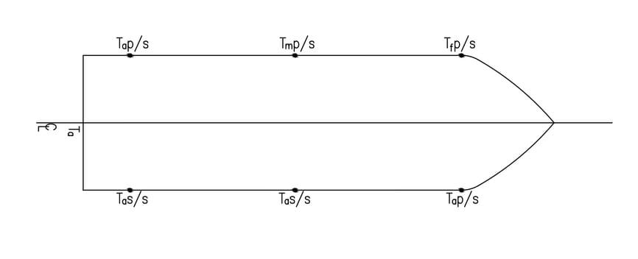
2-nd Step. To measure the density of the outer water γ
3-rd Step. To calculate observed mean draughts T_{f}, T_{a} and T_{m}.
Observed Mean Draft Fore: T_{f} = ( T_{f s/s} + T_{f p/s}) / 2
Observed Mean Draft Aft T_{a} = ( T_{a s/s} + T_{a p/s}) / 2
Observed Mean Draft Midship T_{m} = ( T_{m s/s} + T_{m p/s}) / 2
4-th Step. To find from the “Stability Information Booklet” - X_{f} - the distance of fore draft marks from forward perpendicular (FP), X_{a} - the distance of aft draft marks from aft perpendicular (AP).
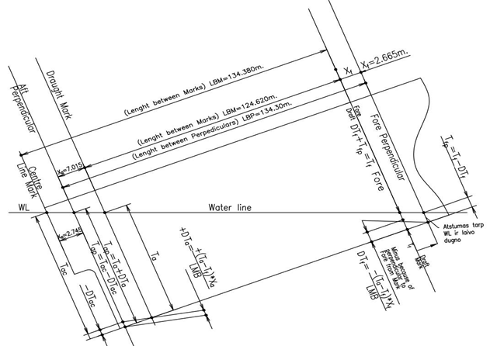
5-th Step. To calculate the drafts on perpendiculars T_{fp}, T_{ap} and find from the “Stability information booklet”
the LBP – Length Between Perpendiculars and calculate the LBM – Length Between Marks.
Draft fore corrected to forward perpendicular T_{fp} = T_{f} – ΔT_{f} ,
where T_{f} – { [( T_{a} – T_{f} ) * X_{f} ] / LBM }. Minus because of Perpendicular Fore from Mark
ΔT_{f} = – {[( T_{a} – T_{f} ) * X_{f} ] / LBM }
Draft Aft Corrected to Aft Perpendicular:
T_{ap} = T_{a} + ΔT_{a} = T_{a} + { [( T_{a} – T_{f} ) * X_{a} ] / LBM }
Plus because of Perpendicular to Aft from Mark
ΔT_{a} = + {[( T_{a} – T_{f} ) * X_{a} ] / LBM },
where Length Between Marks (LBM) = LBP – ( X_{f} + X_{a} ) = LBP –X_{f} –X_{a}
6-th Step. To calculate mean Draft on Perpendiculars T_{fap} and determinate if there is hogging ( + ) or Sagging ( – )
T_{fap} = ( T_{ap} + T_{fp} ) / 2
7-th Step. To calculate: T_{mm} - mean Corrected Draft
T_{mm} = ( T_{fp} + 2T_{m} + T_{ap} ) / 4
8-th Step. To calculate mean of means T
T = ( T_{fp} + 6T_{mm} + T_{ap} ) / 8
9-th Step. To determinate 1-st Correction. According to calculated T (Mean of Means) it is necessary using Hydrostatic Properties to determinate by Interpolation. LCF = Centre of Flotation from Mid. (Longitudinal Centre of Flotation) and TPC = Tons per Centimeter of Immersion”
1-st Corr. = $\frac{100 ∙\left(T_{ap}- T_{fp}\right)∙LCF ∙TPC}{LBP}$
10-th Step. To determinate 2-nd Corr. MTC = Moment for Trim 1 centimeter. Using Hydrostatic Properties it is necessary to determinate by Interpolation:
MTC_{(T+50cm)} = The MTC for T(Mean of Means) and plus 50 centimeters ( T + 50 )
MTC_{(T – 50cm)} = The MTC for T(Mean of Means) and minus 50 centimeters ( T – 50 )
2-nd Corr. =$\frac{50 ∙ T{RIM}^{2}∙ [{MTC}_{T+50} – {MTC}_{T-50}] }{LBP}$
11- th Step. To calculate the Displacement Corrected for Trim D_{t}
D_{(T)} = the Displacement from Hydrostatic Properties determinated for T (Mean of Means) by Interpolation
D_{t} = D_{(T)} + 1-st Corr. + 2-nd Corr.
12 – Step. To calculate density Correction D_{γ} , where γ - measured Water Density, γ_{t} = Table Density found from Stability Information Booklet (International Meaning) γ_{t} = 1,025 t/cub.m. )
D_{γ} = D_{t} * ( γ – γ_{t} ) / γ_{t}
13 – Step. To Calculate Final Displacements D_{o} or D_{c}
Displacements Corrected for Density:
D_{o} = D_{t} + D_{γ} or D_{c} = D_{t} + D_{γ}
Constant = D_{o} – ( P_{hfo} + P_{mdo} + P_{lo}) – (P_{bw} + P_{fw}) – Lightship
P_{cargo} = D_{c} – ( P_{hfo} + P_{mdo} + P_{lo}) – (P_{bw} + P_{fw}) – Lightship – Const.

- DRAUGHT SURVEYS PRACTICE

The master of the vessel should be advised in advance that a draught survey will be carried out. If this is an initial survey of a lightship, he should be asked, subject to the safety of the vessel, to ensure that the individual ballast tanks are either completely full or empty that the vessel stands upright and has a trim that is within the tank calibration tables. It is essential that cooperation between independent surveyors and ship officers takes place during draught surveys. Before carrying out the survey it is recommended that the surveyor takes time to examine the general layout plan to confirm the number and location of the various ballast, freshwater and oil bunker tanks on the ship. Equipment that can be used in the survey (www.bulkcarrierguide.com):
- Strong torch
- Patented draught mark indicator or measuring devices (tubes, indicators, etc.)
- Calibrated inclinometer or manometer
- Steel tape measure with plumb bob / stainless steel tape measure with brass plumb bob (preferably calibrated)
- Sufficient volume bucket for seawater sampling
- Calibrated patent hydrometer for draft survey
- Calibrated salinity refractometer
- Ballast water sampling device
- Computer/calculator.
A well-conducted draught survey under reasonable prevailing conditions is capable of achieving an absolute accuracy of +/- 0.5%

References:
- Barrass, C.B. and Derrett, D.R. (2013). Ship Stability for Master and Mates. Elsevier
- Bulkcarrierguide (n.d). Draught surveys practice & Measurement of bulk cargoes. www.bulkcarrierguide.com
- Dibble, J, and Mitchell, P. (1994). Draught surveys: a guide to good practice. MID-C Consultancy.
- UNECE (1992). Standards and Procedures for the Performance of Draught Surveys of Coal. https://unece.org/fileadmin/DAM/energy/se/pdfs/coal/1992_UNECE_Draught_ Survey_Code_January_1992_E.pdf

