CONTAINER STOWAGE PLAN AND LOADING OPERATION

- Introduction
The master of the ship and officers shall exercise due diligence to make the ship seaworthy, which includes ensuring that containers are stowed and secured so as to prevent damage to the ship or other containers, even if stowage and securing is the charterer's responsibility under the charterer's contract.
Officers should not allow loading to commence until a stowage plan or equivalent information has been provided for the relevant under-deck or on-deck area (bay), even if no final stowage plan is available. This will allow time to check that the stacking is correct and that the stack and tier weights are within acceptable limits. As loading proceeds, any changes made by the planners to the original stacking plan should be notified to the ship's officers, who should also note any changes to the actual stowage.
A stowage plan for container ships or bay plans is the plan and method by which different types and sizes of containers can be loaded on board a containership.
When stowing and securing containers, the following points should be borne in mind (http://shipsbusiness.com/):
- a deck stack of containers is only as strong as the weakest component in that stack. Premature failure of a component can cause loss of an entire stack. During loading, containers should be inspected for damage and, if damaged, they should be rejected.
- twist locks limit vertical and transverse movement. Diagonally crossed lashing rods, placed at the ends of a container, can withstand large tensile loads
- outside lashings are sometimes used. These are lashings that lead away from a container. However, although this arrangement provides a more rigid stow than a combination of crossed lashings and twist locks, it is less common
- containers exposed to wind loading need additional or stronger lashings. When carried in block stowage, it is the outer stacks that are exposed to wind loading. However, when carried on a partially loaded deck, isolated stacks and inboard containers can also be exposed to wind, in which case, additional lashings need to be applied
- if containers of non-standard length, that is, 45, 48 or 53 feet are carried, the ship arrangement will need to be specially adapted
- 45-foot containers fitted with additional corner posts at 40-foot spacing can be stowed on top of 40-foot containers. Lashings can be applied in the normal way. It should be noted, however, that the new corner posts may not be suitable for carrying the required loads, either from the container or from those stowed above. Lashings should not be applied to the overhang. The container specification and the Cargo Securing Manual should be consulted
- 40-foot containers may be stowed on top of 45-foot containers. However, this arrangement of stowage will present difficulties in fastening/unfastening twist locks, and it will not be possible to apply lashings to the 40-foot containers
- when carrying over-width containers, for example 45-foot or 53-foot containers with width 8' -6", adaptor platforms may be used. These must be certified by a class society or an appropriate recognized body. The arrangement must be defined and approved in the ship's Cargo Securing Manual
- twist locks should always be locked, even when the ship is at anchor, except during container loading and unloading. Lashing rods should be kept taut and, where possible, have even tension. Lashing rods should never be loose, nor should they be overtightened. Turnbuckle locking nuts should be fully tightened
- as a ship rolls, pitches and heaves in a seaway, tension, compression and racking forces are transmitted through the container frames, lashings and twist locks to the ship's structure. However, clearances between securing components and the elasticity of the container frame and lashing equipment produce a securing system that forms a flexible structure. Thus, a deck stow of containers will move
- containers can be held by only twist locks when two or three tiers are carried on deck, depending upon container weights
- arrangements with automatic and semi-automatic twist locks are used to reduce time spent securing the stow and to eliminate the need for lashers to climb the stacks

Bay-tier-row system. To identify each slot in which a container could be loaded it is developed special three-dimensional system. Every container slot in the longitudinal axis is called a bay. Each bay is given a 2-figure number. The numbering of bays could be consecutive numbering starting from 01 onwards. Every slot in the athwartship axis is called a row; the numbering of rows is by consecutive numbers, 01, 02, 03, etc. In keeping with tradition, all odd numbers are to starboard and all evens to port. Numbering starts from centre outward; this is because rows in various bays of the ship will vary depending on the position of the bay. In the vertical axis, each slot is called a tier and is numbered using consecutive even numbers, thus we have 02, 04, 06, etc., tiers on deck are numbered starting from 82 onwards, thus 82, 84, 86, etc. This is again because numbers of tiers in various bays vary as per location and such numbering clearly differentiates between under deck and on deck stowage. The main advantage of such slot numbering systems is that they can be used with data processing systems and avoid errors in location and stowage.
A numbering system for the arrangement of containers on a vessel allows the bay is specified first, then the tier (vertical layer), and finally, the container row, which runs the length of the ship.
Bay plans. On a general cargo vessel, a cargo stowage plan is a graphical display using side elevation and plan view. Such systems cannot be used for a container vessel. On a container vessel a stowage plan is depicted for each bay separately. The rows and tiers at each bay are shown as squares and each square is filled with the container data. Separate plan is used for deck and under deck for each bay.

  - Stowage planning

The planning of the stowage of containers on a container vessel is generally done ashore, this is because the turn around time of a container vessel is very short and expecting the ships’ officers to plan would unnecessarily delay the vessel. On main line vessels (i.e. those going on definite routes mainly round the world or across the pacific or Atlantic) most companies use a central planner who plans the vessel for the whole voyage. Central planners are sometimes called central co-ordinators. They plan vessels for the ports in their areas. A ship may therefore be handled by more than one planner in one complete voyage.
The factors to be taken into account when preparing a stowage plan are as follows:
1. Port rotation.
2. Stability, including GM and trim.
3. Stack weight.
4. Strength calculations, SF and BM.
5. Torsional moments.
6. Size and type of containers.
7. Flexibility.
8. Special containers.

Port Rotation. As with all stowage planning, this is the first and the most important factor. All cargo for a discharge port must be available directly for discharge, without the need for any shifting. Any shifting involved will mean additional cost as well as delay.
Stability. A vessel’s stability is defined by its Metacentric Height (GM). It is calculated as a distance between the centre of gravity of the vessel and its metacentre. Container vessels tend to have a low GM because of the large amount of deck cargo involved. The loss of GM on passage is also high because of the high speeds and hence high consumption of fuel on these vessels. Consumption in the range of 50 to 70 tons / day are normal for a 2500 TEUs (twenty equivalent units) vessel having a speed of 18 kn. Due to the deck cargo, a large windage area also exists. The Stability requirements for wind heeling moments also have to be satisfied. Low GM creates problems for manoeuvring because of heel during turning at high speeds and large rate of turns have to be avoided. Container vessels generally carry ballast in D. B. tanks as well as large amount of fuel to increase GM. Ballast carried in wing tanks including upper wing tanks helps to improve the GM and the rolling period. As far as possible, heavy containers are loaded at the bottom. Reduction of free surface, especially in fuel tanks also helps considerably.
A quick check of stowage can be achieved by comparing tier weights at each bay. In general, upper tiers should have less weight than the lower once unless different ports are involved.
The lashing module on the loading computer should alert the operator if the GM is excessive for the cargo lashings. The factored-in GM may be increased for modern vessels on account of their larger beam and improved lashing systems, allowing heavier cargo to be positioned in the upper tiers thus reducing the GM. It is usually not possible to reduce the GM by ballasting due to ballast tanks being positioned below the vessel’s centre of gravity.
Stability calculations from the shipyard are usually performed with a fixed container weight of i.e. 14 tonnes/TEU for the entire vessel, while the container weight distribution in the CSM is based on stratified container weights which is a more realistic application. Thus, there is no direct link between stability calculations from the yard and the CSM. The securing calculations should always be carried out with the maximum GM value calculated by the onboard stability software for the voyage and the actual container weights from the loading software.
The CSM will only present one loading scenario as an example. Only an onboard loading computer with integrated and approved lashing software can calculate the actual loading condition for each voyage. This software will indicate if there are any excessive forces.
Additional constraints. The additional ballast and fuel add to the dead weight and load line limits have to be taken into account. Generally, a container vessel is full by volume rather than weight, except when winter load lines apply. The trim should also be considered and cargo should be distributed evenly for optimum trim.
Stack weight. On a general cargo vessel, the load at any point must not exceed the permissible load density. In case it does, then laying dunnage increases the area over which the load rests. The weight of a container is distributed over the ‘Four Corners’. On a container vessel, the internal structure of the vessel distributes the load over the strength members of the hull. The maximum load that can be borne at the Four Corners of the cell guides is termed as the stack weight. In planning the stowage, this maximum stack weight must not be exceeded.
Strength calculations. Planning must ensure that the shearing forces and bending moments do not exceed the permissible values for the ship. An even distribution of the weight will ensure this. In case even distribution is not possible then it can be compensated for by ballast.
Torsional forces. Torsional forces exist on all ships, the two causes of torsional forces are (a) sea and swell and (b) uneven distribution of cargo. The effect of these forces depends on
- Length of the vessel
- The freeboard of the vessel and
- The beam of the vessel.
In the case of container vessels, the length, beam, as well as freeboard, is large. Container ships have, in addition, uneven distribution of cargo; this results in the ship experiencing large Torsional moments. The only controllable factor is the proper distribution of weights on board. The distribution of cargo in each bay must be even when planning stowage. Where it is not possible to have an even distribution in the bay, the Torsional moments at the bay must be reduced to below the allowable Torsional moments using ballast in the tanks at the bay. Correcting the imbalance at another area will not reduce the Torsional moment at that bay.
Size and type of containers. In planning the stowage, the size and type of containers need to be known so that the right containers are planned for the right slot. 40-ft containers can only be loaded in 40-ft. bays. 20-ft. containers can be loaded in 40-ft. bays but the ends away from the cell guides cannot be secured and are free to shift. To prevent this either they have to be secured to deck vertically using twistlocks or stackers, or over stowed with a locking 40-ft. container. The latter method is the most commonly used, because loading a row with 20 ft. containers will generally result in excess stack weight, as the load in two 20 ft. containers is more than one 40 ft. container. A 40-ft. container can be loaded on two 20-ft. containers, but two 20-ft. containers cannot be loaded on a 40-ft. container, as the container has no vertical supports in the middle and hence, will collapse. 45-ft. containers can only be loaded in bays meant for such containers or on the third tier of 40-ft. bay. 45 ft. containers have corner fittings at 40 ft. and 45 ft. hence they fit on top of 40 ft. and can be locked. The third tier stowage is to ensure that lashings lead properly and the extension does not obstruct anything. Any other sizes will have to be stowed in dedicated slots.
Containers, which are ventilated, should be stowed on deck or in holds where ventilation is possible. Other specific containers will have to be stowed as per requirements.
Flexibility. A container vessel calls at a large number of ports and loads and discharges at each. Having ensured that the port rotation is accounted for initially, it now becomes necessary to ensure that it is maintained at all subsequent loading ports immaterial of the destination of the container. Every port should in general have a bottom stow from where the loading sequence can be built up. On mainline vessels, every port is given a bottom stow. The amount of slots allotted would depend on the cargo expected from that port. A bay is divided into (P) (C) & (S) and for large quantities of cargo the whole bay may be allotted or either (P) & (S) or only (C). For trimming purposes slots are allotted both for’d and aft.
Special containers. Particular caution is to be exercised when stowing dangerous cargo on board the vessel. Any dangerous cargo presented for loading must be accompanied by a proper manifest and declaration as required by international regulations. Further, this DG cargo must be acceptable for carriage as per IMDG code guidance. The reference here is made to the list of UN numbers restricted/prohibited for carriage on board particular vessels. Specific stowage requirements for DG cargo (e.g. clear of living quarters OR if under the deck, in a mechanically ventilated space etc) may be verified from individual entries of the dangerous goods list in the IMDG code. DG segregation shall be verified for compliance with the requirements of the IMDG code. Caution must be exercised when using vessels stowage planning software for this purpose as it may or may not have comprehensive means of checking for bad stowage & segregation against the latest international requirements.
In container ship business, OOG referred to Out of Gauge Containers. They have usually stowed under-deck, and in case of an On Deck Stow, some careful consideration in planning and handling required. Local planner or agent may be requested for such approval before loading. Hatch cover clearance and Cell guide clearance must be verified to confirm that there will be no damage to the vessel or cargo when loaded. An appropriate number of slots must be kept vacant to accommodate the OOG cargo as necessary.
A refrigerated container (also a reefer box) is fitted with a refrigeration unit that can be connected to the ship's electrical supply. The stowage location of reefers must be checked against vessel reefer receptacle locations. In case reefer containers must be loaded in random locations, it must be confirmed that monitoring and repair will be possible during the voyage, and that vessel has sufficient extension cables for providing power. Reefer containers shall not be bestowed on extreme outboard locations on deck. It must be borne in mind that the number of working reefer receptacles, extension cables and the condition of auxiliary machinery (generators) available onboard may limit the maximum number of reefer containers that the vessel can safely carry.
Loadicator and loading plan computers. The computer would permit the location and respective weights of cargo/units to be entered quickly and provide values of limiting measured distance between the keel and the centre of gravity of the vessel (KG) and ‘metacentric height’ (GM) together with deadweights at respective draughts/displacements. It would also have the capability to provide a printed record of the state of loading and show a visual warning in the event of an undesirable stability condition or overload occurring.
Distribution of the ship’s tank weights, stores and consumables affecting final calculations, and total displacement would also be identifiable within the completed calculations. The primary aim of the loading computer is to ensure that the vessel always departs the berth with adequate stability for the voyage. If this situation can be achieved quickly, costly delays can be eliminated and safety criteria is complied with.
The data required to complete the stability calculations would need to be supplied by the shoreside base with regard to cargo weights. This in turn would be certificated by the driver – for Ro-Ro unit loads – obtaining a load weight certificate authorized from an approved ‘weight bridge’ prior to boarding the vessel. Draught information would inevitably come from a ‘Draught Gauge System’ for the larger vessel and be digitally processed during the period of loading.
A ship’s personnel could expect to become familiar with manipulation of the changing variables very quickly alongside the fixed weight distribution throughout the ship. This would permit, in general, few major changes to the programme, especially on short sea ferry trade routes where limited amounts of bunkers, water and stores are consumed and values stay reasonably static.
Fixed weights are applicable to a variety of units or vehicles and, as such, where units are pre-booked for the sea passage, an early estimate of the ship’s cargo load, and subsequent stability, can often be achieved even prior to the vessels arrival.
The loadicator programmes provide output in the form of:
● shear forces and bending moments affecting the vessel at its state of loading
● cargo, ballast and fuel tonnage distributions
● a statement of loaded ‘GM’, sailing draughts and deadweight

1.3 Loading operation

Before loading, the Chief Officer receives a stowage plan from the cargo planner and this plan is entered into the onboard loading computer. The plan is verified against the vessel’s Cargo Securing Manual (CSM) and, if fitted, against the lashing module of the loading computer. Container stowage plans are a proven way of tracking specific units during the sea passage. The plan identifies each unit and allows shippers to estimate arrival times and the whereabouts of their goods during every stage of shipment. It is also an effective security aspect for knowing which unit is where and tracing what goods are in what particular unit.
The Master should not allow loading to commence until the stowage plan has been checked, including the verification of the stack weights. This is particularly important when loading non-ISO standard containers. If any irregularities are identified, these should be brought to the attention of the cargo planner so they can be rectified.
Container stacking limitations and other details will be shown on the Container Safety Convention (CSC) plate fixed to the container (1 fig.)
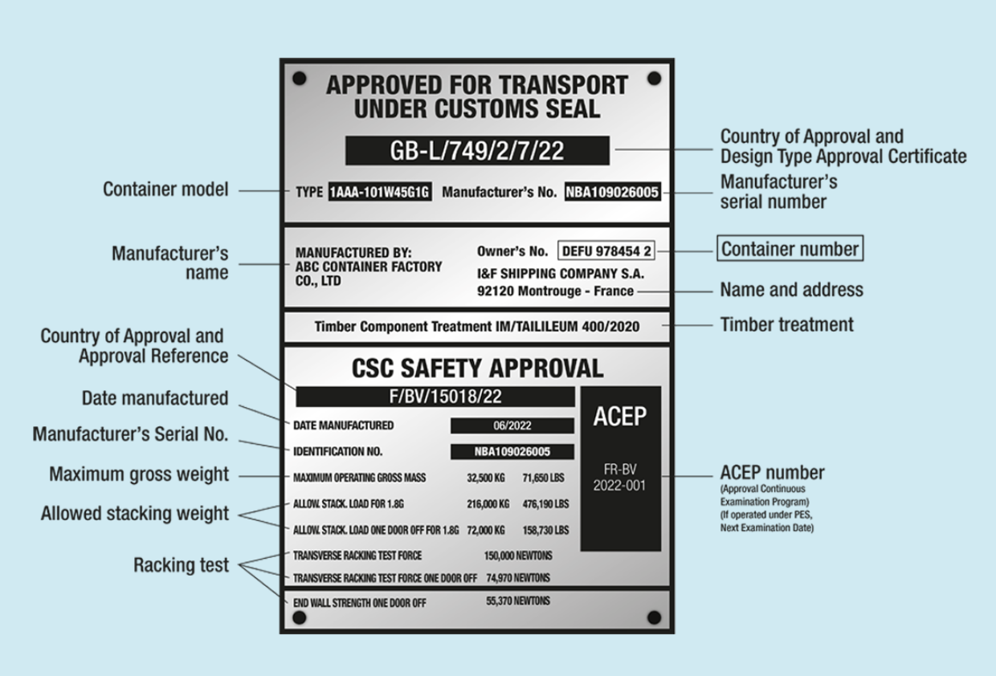
Fig. 1. Container Safety Convention (CSC) plate from Bureau International des Containers (BIC)
https://www.bic-code.org/csc-combined-data-plate/

Load stowed along the length of the container or the ship. Containers are whenever possible to be stowed with the doors facing aft (DOORS AFT). However, reefer containers can be stowed doors facing forward as per plug socket arrangements on a case by case basis.
Under deck operations. The container is lifted aboard and placed in its stowage position, the ship supervisor confirms its stowage by ticking the sequence sheet and/or possibly also the bay plan.
When a tier has been completed under deck on a vessel, the ship gang moves into place to install the securing devices, while the crane pauses; it must not lift a container aboard while people are working below it. At the appropriate times, shifts and restows are returned to the crane for lifting aboard into their new or original locations. When under-deck stowage is complete, the top tiers are secured to the hatch coamings and the gang moves away to allow the hatch cover(s) to be fitted. In the case of a cellular vessel, labour is not needed unless refrigerated containers have been loaded and need connection or there is non- containerized cargo to secure.
Whenever possible, open-top containers on deck are to be stowed in such a position (OPEN TOPS); a standard container can be stowed on top of them. If this is not possible, due to overweights, or any other peculiarities, consideration is given to stowing them with the maximum shelter and all tarpaulin lashings checked and tightened by the stevedores.
Deck Containers. Deck containers should be stowed and secured taking account of the following (House, 2020):
- Containers should preferably be stowed in a fore and aft direction.
- They should be stowed in such a position as not to deny safe access to those personnel necessary to the working of the vessel.
- They should be effectively secured in such a manner that the bottom corners will be prevented from sliding and the top corners will be restrained to prevent tipping.
- The unit should stowed in a manner that it does not extend over the ships side (many containers are stowed part on the hatch top and part on extending pedestal supports, but the perimeter of the unit is kept within the fine lines of the vessel).
- Deck containers should be carried at a single height (one high). However, this may be increased if twist-locks are used to secure the bottom of the container to a fabricated deck stool.
- Deck loads should not overstress the deck areas of stowage. Where units are on hatch tops, these hatch covers must be secured to the vessel.
- No restraint system should cause excessive stress on the container.
- Restraint systems and securings should have some means of tightening throughout the voyage period.
Container decks, and reinforced pontoon hatch tops to take the deck load capacity, are generally constructed with increased scantlings to satisfy Classification and Construction Regulations. Both open decks and the pontoon hatch cover, when fitted, are usually equipped with container feet to permit the ‘boxes’ to be locked into position. The first tier, being the foundation for second and subsequent tiers, would be stowed on top.
Ship’s crew should check and test during discharge and loading:
- regularly examine lashing components that look for wear and tear, as well as damage or distortion. Check that left-hand and right-hand locking twist locks are not being mixed in the same storage bin. Remove from the ship any lashing component found to be worn, damaged or distorted
- make arrangements for some damaged or distorted lashing components to be sent for non-destructive testing. It will determine their strength and help to establish replacement criteria
- carefully check twist locks that stevedores return to the ship as the locks might not originate from own ship, that is, their strength and locking direction could differ
- discourage stevedores from treating lashing equipment roughly as this can induce weakness
- examine dovetail foundations, D rings and pad-eyes for damage. Repair if the damage is found
- observe the loading of containers to determine if stowage is in accordance with the stowage plan and that best practice is always followed
- observe the application of lashings to make sure that they are correctly applied in accordance with the requirements set out in the Cargo Securing Manual

It is essential that before proceeding to sea, all cargo on board is adequately secured to prevent it moving and endangering the safety of ship and crew. Particular shipments and specific ship types may require specialized securing and the IMO Code of Safe Practice for Cargo Stowage and Securing, 2011, (CSS Code) guides stowage and ensuring of particular commodities (e.g., portable tanks, wheeled cargo, locomotives, coiled sheet steel, metal scrap in bulk, logs, etc.
Additionally, the Code provides guidelines for the preparation of a Cargo Securing Manual "... appropriate to the characteristics of the ship and its intended service..." This means that each ship must be provided with a manual that is written for that particular ship. Information in the manual must include:
a. details of fixed securing arrangements and their locations;
b. locations and stowage of portable securing gear;
c. details of portable securing gear including an inventory;
d. examples of the correct application of such gear;
e. indication of the transverse, longitudinal and vertical accelerations to be expected in various positions on board the ship.

Securing Containers. It is not possible for ships' staff to examine or monitor the securing of cargo within a container although the Master has the right to open a container for inspection should he suspect that all may not be well within. Cargo which is visible (such as that on flatracks) can be examined prior to loading and any lashing arrangements which are suspect may be adjusted or the unit rejected until properly secured.
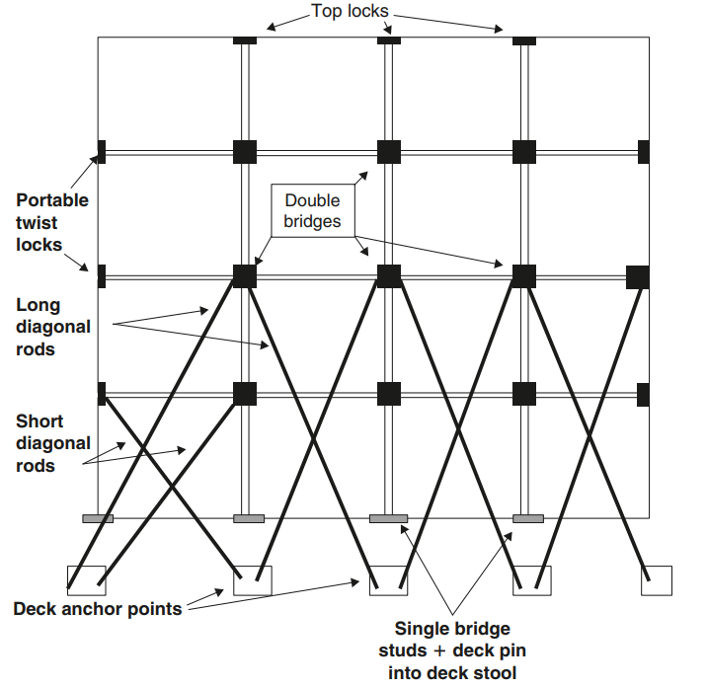
Fig. 2. Container lashing system

A container securing system typically consists of the permanent fittings such as cell guides, lashing bridges, twistlock sockets, shoes, lashing plates; and loose equipment such as twistlocks and lashing bars (fig. 2). A combination of all of this equipment should represent an overall container stowage solution.
If the weights of individual container stacks are exceeded beyond permissible limits, this can lead to failure of the containers in the lower tiers of the stack. Most ISO containers are designed to withstand stacking up to 13 high based on the allowable stacking weight (see fig. 1) but non-ISO containers tend to have a reduced capacity for stacking and their limits must be checked individually.
In accordance with ‘The SOLAS Container Weight Verification Requirement’, the responsibility of documenting the verified gross mass of a container lies with the shipper. The regulation states: ‘A container should not be loaded unless the Master or his representative have obtained, in advance of vessel loading, the verified actual gross mass of the container’.
Furthermore, the container can be seen as a weak box loaded with heavy cargo. The mass of the cargo is accelerated by the six types of movement of a ship in response to sea conditions, and by additional forces from wind and green seas. The mass of the cargo will be accelerated by the movement of the ship in response to sea conditions. The container is the weakest link in the lashing system. The CSM details how the container should be secured with turnbuckles, lashing bars, twistlocks and cell guides. The vessel’s CSM is the core reference document governing how containers should be stowed and secured. In addition, the Master and deck officers should be familiarised with the manufacturer’s instructions on the proper use and care of securing equipment.
The loading and securing of containers are usually performed by the port stevedores. A concern during loading is that stevedores secure containers with lashing equipment that has deteriorated. It is important that all lashing equipment is in good condition and that any items in poor condition are removed to prevent further use. The Master is responsible for the safe loading of the vessel in accordance with ISM and SOLAS regulations. Before departure, the crew should also verify that the cargo has been secured correctly.
When containers are carried below deck, the containers are slotted into cell guides on a cellular container ship. When carried within a cell guide framework, no further external support is generally required.
When 20' containers are stowed below deck in 40' cell guides, it may be necessary to over-stow the 20' containers with a 40' container. The Cargo Securing Manual should be consulted before loading.
Containers stowed on deck require particular care in stowage and securing while also affording adequate access to sounding pipes, fire hydrants, etc., and to the ship's side should the need to jettison arise. At sea, all containers on deck should be inspected daily, and lashings tightened when required. In general, it is not desirable to carry steel cargoes on deck (including in flat rack containers) as they are particularly susceptible to the moist salt air and maintaining covering in heavy weather often proves impractical.
When containers are carried on deck, the ship is required to be approved for that purpose; and containers themselves are fastened with twist locks and lashings. These usually consist of steel rods and turnbuckles. Lashing design to be followed on board is detailed in the vessel's cargo securing manual.

Container loss prevention advice
• The CSM should be approved by the vessel’s Classification Society and/or the Flag State Administration.
• There should be procedures in place for calibrating the loading computer.
• The loading computer should include a lashing module. This is obligatory if Classification Society route specific lashing rules apply.
• The CSM is not accurate if the actual GM significantly exceeds the design GM. The CSM will specify a maximum GM for a vessel, which should not be exceeded.
• Sailing with an excessive GM i.e. in a ‘stiff’ condition, results in increased acceleration forces and more violent rolling motion.
• If the maximum GM is exceeded this could result in:
• Higher transverse acceleration
• Overstressing stowage and securing devices
• Overstressing the ship’s structure
• Damaging containers
• Sailing with a very low GM should also be avoided to ensure positive stability is maintained throughout the voyage and during cargo operations.
• Before loading, the Master should ensure that the container weights are declared as per SOLAS requirements and that the maximum stack weight and height limits are not exceeded.
• Unusual stowage plans, loading conditions or voyages that may not be allowed for in the CSM require particular attention and it is essential that the cargo planner discusses the stowage plan with the Master to identify any potential problems.
• Avoid loading heavy containers above light containers, particularly in the upper tiers, unless permitted by the CSM and subject to forces being checked on the loading computer.
• Lashing plans provided to stevedores should be checked against the CSM at each loading.
• Instructions relating to the correct application of the lashing arrangements should be available to the stevedores at every bay
• It is important that the verified gross mass established for each container is applied to the vessel’s loading plan.

References:

- Swedish Club (2020). Container focus. Preventing the loss of containers at sea. https://www.swedishclub.com/media_upload/files/Publications/TSC-Container%20focus-2020_WEB.pdf
- Ships Business (n.d). General guidance for Containership Cargo Operation. hipsbusiness.com/container-ship-handling.html
- Ships Business (n.d). Container Ship Cargo Stowage and Planning Procedures. http://shipsbusiness.com/contcgstwg.html
- House, D. (2015). Cargo Work for Maritime Operations. 8th ed. Elsevier
- 2014 IMO/ILO/UNECE Code of Practice for Packing of Cargo Transport Units (CTU Code)
- IMO (1972). International Convention for Safe Containers (CSC)
- Barrass, C.B. and Derrett, D.R. (2012). Ship Stability for Masters and Mates. Elsevier.

