Cargo Plan Preparation and Stability Calculation
The ability of a vessel to return to an upright position when heeled by some external force, such as the action of waves, is a measure of her stability. The force of gravity acting downwards and the buoyancy force acting in opposition cause a righting lever which returns the ship to the upright when heeled.
The magnitude of this lever is determined by the position of the Centre of Gravity within the ship which is itself affected by the disposition of cargo, fuel, ballast, fresh water, etc. Broadly speaking, the lower the weights in the ship, the lower the Centre of Gravity; the lower the Centre of Gravity, the larger will be the righting lever at successive angles of heel (i.e., the greater the ship's ability to return to the upright) (fig. 1).
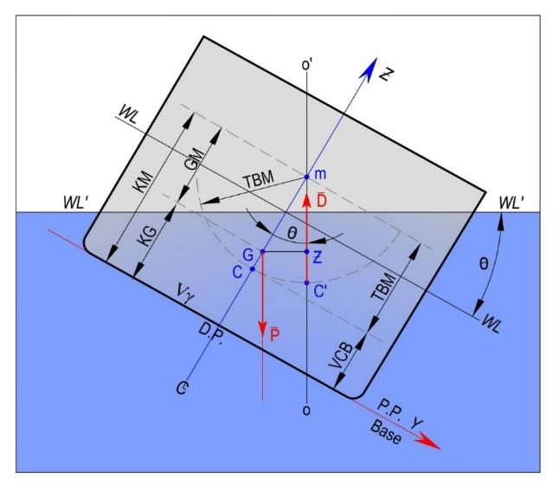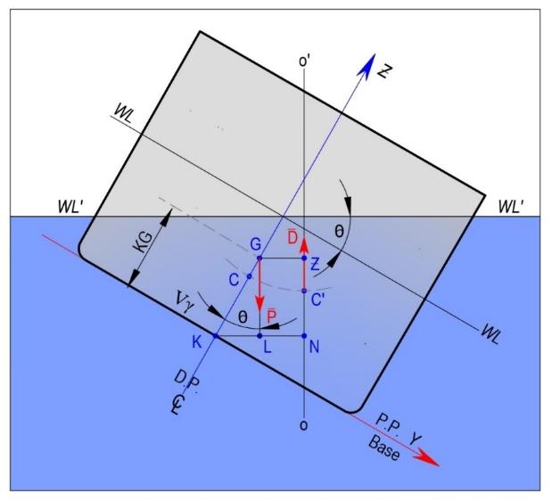
Fig.1. Initial Transversal Stability (a) and Transversal Stability on Significant Angle of Heel (b)
For each step of the loading operation the loading plan should also show the amount of ballast and the tanks to be deballasted, the ship's draught and trim, and the calculated shear stress and bending moments.Exceeding the permissible limits specified in the ship's approved loading manual will lead to over-stressing of the ship's structure and may result in catastrophic failure of the hull structure.
It is imperative to carry out draft checks at regular intervals during the loading, and particularly when between about 75-90% of the cargo is loaded. The tonnage loaded should be compared with the terminal's weight figure, and adjustments to the final trimming figures determined and agreed accordingly.
Any changes to the loading plan required by either terminal or ship should be made known as soon as possible and agreed by the master and terminal representative. Stresses resulting from any changes must remain within the ship's hull stress limitations.High impact cargo drops and exceeding maximum load limits on tanks tops should be avoided.
To avoid over-stressing the ship:
a) Cargo should be distributed evenly within each hold and trimmed to the boundaries of the cargo space to minimize the risk of it shifting at sea.The quantity of cargo to be trimmed into the fore and aft holds should be delivered exactly as required to ensure the ship finishes with the required fore and aft draughts and trim. This will ensure it will be able to depart from the load port and proceed to and arrive at its unloading port safely and with the required under keel clearance.
b) Cargo should not be loaded high against one hold bulkhead or one side, and low against the other.
c)Each hold should be loaded using at least two separate pours per hold.
d) The terminal should maintain an accurate record of the tonnages loaded in each pour into each hold.
e) Sudden increases in the loading rates causing significant overloading should be avoided.
The amount of cargo remaining on the belts depends on the loading rate at the time. This should be known by the loader operator and the terminal representative. Ship/shore communications arrangements should be confirmed when completing the ship/shore safety checklist, giving all necessary details and contact details for both ship and terminal.
Agreeing the unloading plan prior to arrival simplifies matters for all concerned when the ship does arrive, as there usually is little time for the master to re-calculate the unloading plan after the ship has arrived and is ready to commence unloading.
Master should ensure that the terminal representative is provided with accurate information in good time so as the loader/ unloader operator can be notified of the ship's requirements.
There are two stages in the development of a safe plan for cargo loading or unloading:
a) Step 1: Given the intended voyage, the amount of cargo and/or water ballast to be carried and imposed structural and operational limits, devise a safe departure condition, known as the stowage plan.
b) Step 2: Given the arrival condition of the ship and knowing the departure condition (stowage plan) to be attained, devise a safe loading or unloading plan that satisfies the imposed structural and operational limits.
In the event that the cargo needs to be distributed differently from that described in the ship's loading manual, stress and displacement calculations are always to be carried out to ascertain, for any part of the intended voyage, that:
a) The still water shear forces and bending moments along the ship's length are within the permissible Seagoing limits.
b) If applicable, the weight of cargo in each hold, and, when block loading is adopted, the weights of cargo in two successive holds are within the allowable Seagoing limits for the draught of the ship. These weights include the amount of water ballast carried in the hopper and double bottom tanks in way of the hold(s).
c) The load limit on the tanktop and other relevant limits, if applicable, on local loading are not exceeded.
The consumption of ship's bunkers during the voyage should be taken into account when carrying out these stress and displacement calculations.
Whilst deriving a plan for cargo operations, the officer in charge must consider the ballasting operation to ensure:
a) Correct synchronisation with the cargo operation.
b) That the deballasting/ballasting rate is specially considered against the loading rate and the imposed structural and operational limits.
c) That ballasting and deballasting of each pair of symmetrical port and starboard tanks is carried out simultaneously.
During the planning stage of cargo operations, stress and displacement calculations should be carried out at incremental steps commensurate with the number of pours and loading sequence of the proposed operation to ensure that:
1) The SWSF and SWBM along the ship's length are within the permissible Harbour limits.
2) If applicable, the weight of cargo in each hold, and, when block loading is adopted, the weights of cargo in two adjacent holds are within the allowable Harbour limits for the draught of the ship. These weights include the amount of water ballast carried in the hopper and double bottom tanks in way of the hold(s).
3) The load limit on the tanktop and other relevant limits, if applicable, on local loading are not exceeded.
4) At the final departure condition, the SWSF and SWBM along the ship's length are within the permissible Seagoing stress limits.
During the derivation of the cargo stowage, and the loading or unloading plan, it is recommended that the hull stress levels be kept below the permissible limits by the greatest possible margin. A cargo loading/unloading plan should be laid out in such a way that for each step of the cargo operation there is a clear indication of:-
i) The quantity of cargo and the corresponding hold number(s) to be loaded/unloaded.
ii) The amount of water ballast and the corresponding tank/hold number(s) to be discharged/loaded.
iii) The ship's draughts and trim at the completion of each step in the cargo operation.
iv) The calculated value of the still water shear forces and bending moments at the completion of each step in the cargo operation.
v) Estimated time for completion of each step in the cargo operation.
vi) Assumed rate(s) of loading and unloading equipment.
vii) Assumed ballasting rate(s)
The loading/unloading plan should indicate any allowances for cargo stoppage (which may be necessary to allow the ship to deballast when the loading rate is high), shifting ship, bunkering, draught checks and cargo trimming.
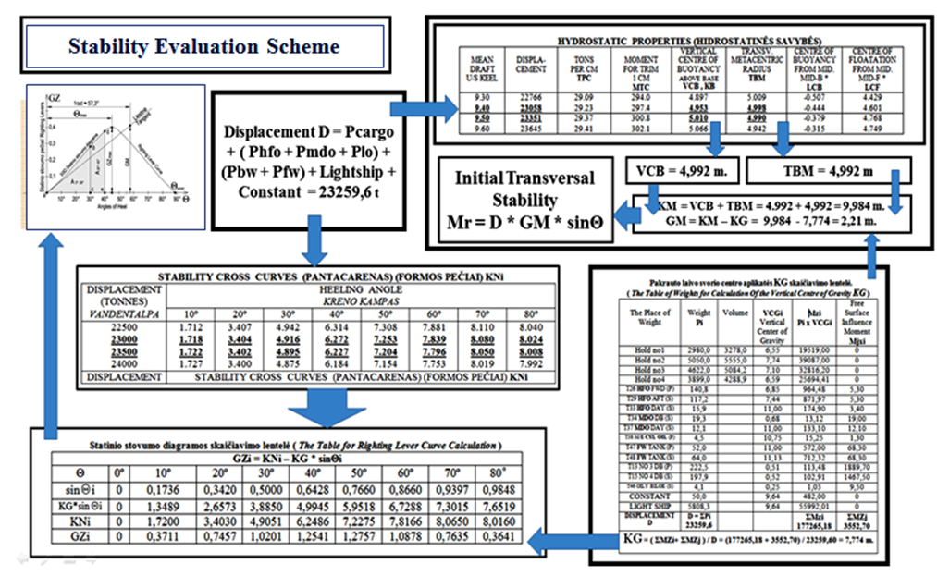
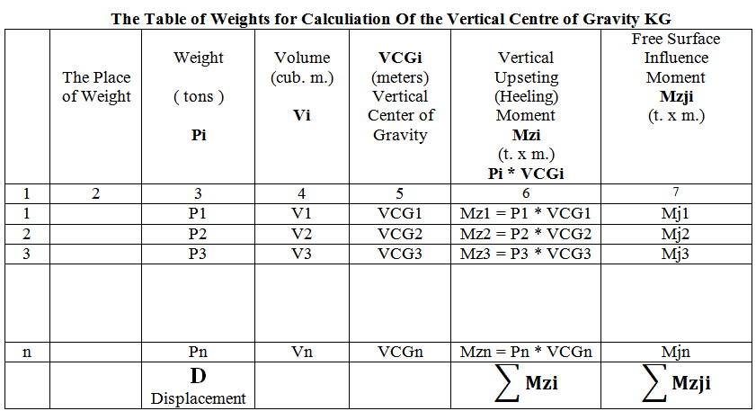
Righting Moment M_{r} = D·GM·sinΘ
Righting Lever GZ_{i} = KN_{i} – KG · sinΘ_{i}

$KG=\frac{\left(P1*VCG1+P2*VCG2+…+Pn*VCGN\right)}{D}+\frac{\left(Mzj1+Mzj2+…+Mzjn\right)}{D} = = \left(\sum{}Mzi+\sum{}Mzji\right)/D$

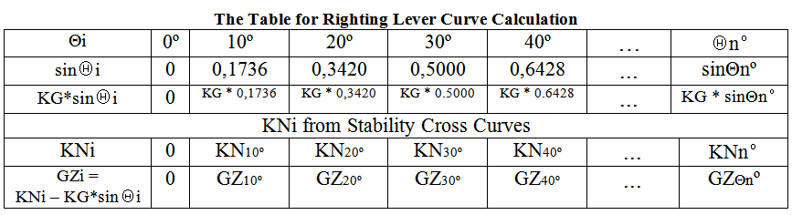
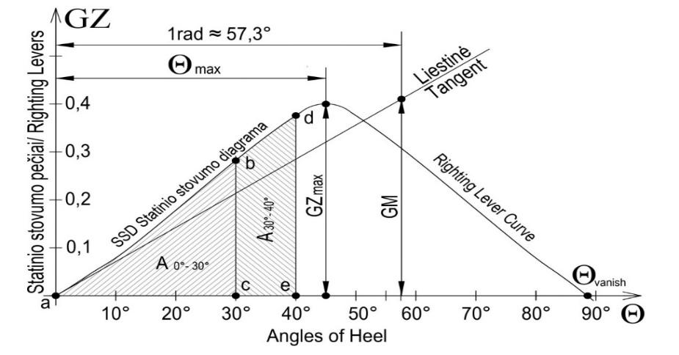

According to the International Code on Intact Stability, 2008, the following Criteria are mandatory for Passenger and Cargo Ships
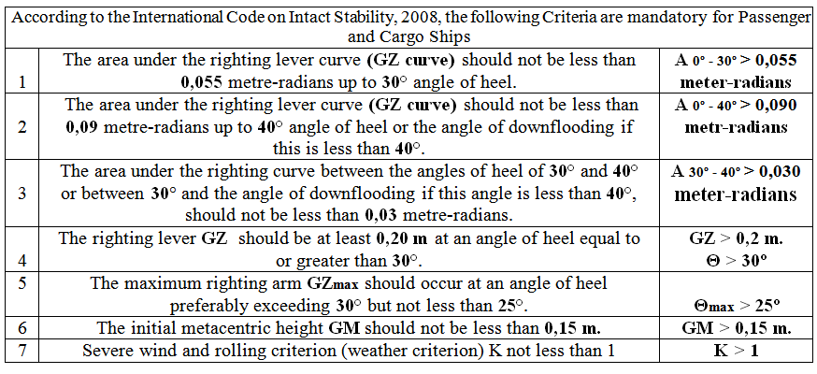
When drawing up a loading plan, it is necessary to fulfill:
1) Apply all work and fire safety measures
2) Without violating the requirements of international conventions, to accommodate the entire amount of cargo specified in the voyage assignment.
3) Evaluate the order of loading - unloading ports (Port Sequence)
4) Loading – Unloading Sequence
5) Carry out loading operations with minimum working time costs
6) Cargo Grades not mixed and separated
7) Do not exceed the permissible (Load Limit) load on one square meter of the bottom of the hold (Tank Top)
8) Do not exceed the permissible bending moments and "shearing" forces of the ship's hull (Limits of Bending Moments and Shearing Forces)
9) Do not violate the load mark convention requirements (Meet LL-69 Convention Requirements)
10) Calculate the stability of the loaded - unloaded ship and check whether the stability criteria meet the IMO requirements (International Code on Intact Stability, 2008 )
11) Submit the cargo securing scheme and specify the securing equipment that meets the requirements of the Ship's Cargo Securing Manual and CSS (Code of Safe Practice for Cargo Stowage and Securing).
12) Cargo operations must comply with IMDG Code requirements.

