**PROPULSION SYSTEMS**

**THE TRANSMISSION OF POWER TO THE PROPULSION SYSTEM**

**Basic Definitions**

**'Indicated power'** is defined as the actual power developed in the cylinders, derived from the high pressure, hot gases acting on the piston area.

Indicated power is usually measured daily by the engineering officers to ensure satisfactory performance of all cylinders.

**'Shaft power'** is defined as that power available at the engine output shaft, used to drive the propeller or machinery.

Shaft power will always be less than indicated power because of friction and heat losses that occur within the engine.

**'Propeller power'** is defined as the actual power developed by the propeller due to the revolutions and the pitch angle of the propeller blades.

*Propeller power will always be less than the 'shaft power' because of friction from bearings and stern tube construction and 'blade slip' in the water.*

taslak, diyagram, çizim, teknik çizim içeren bir resim

Açıklama otomatik olarak oluşturuldu

In physics, power (P) is the rate at which work is performed or energy is transferred. In the SI system of measurement, power is measured in watts (W). As a rate of change of work done, power is:

P=\frac{W}{t} = \frac{E}{t}

W and E are, respectively, the work done, or energy transferred in time t.

**Units**

The units of power are units of energy divided by time. The SI unit of power is the watt, which is equal to one joule per second. Non-SI units of power include horsepower (HP). One unit of horsepower is equivalent to 33,000 foot-pounds per minute, or the power required to lift 550 pounds one foot in one second and is equivalent to about 746 watts.

**Mechanical work**

  In physics, mechanical work is the amount of energy transferred by a force. When the force is constant and along the same line as the motion, the work can be calculated by multiplying the force by the distance:

W = FD

F : portion of the force acting in the same direction as the motion,

D : distance travelled by the object.

**Mechanical Energy**

The mechanical energy of a body is that part of its total energy which is subject to change by mechanical work. It includes kinetic energy and potential energy.

 In physics, torque (moment) can informally be thought of as "rotational force" or "angular force" which causes a change in rotational motion. This force is defined by linear force multiplied by a radius. The SI units for torque are newton metres.

 A very useful special case, often given as the definition of torque in fields other than physics, is as follows:

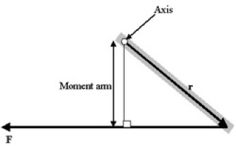T = moment arm X force

Machine torque

Torque is part of the basic specification of an engine: the power output of an engine is expressed as its torque multiplied by its rotational speed

Understanding the relationship between torque, power and engine speed is vital in mechanical engineering, concerned as it is with transmitting power from the engine through the drive

train to the propellers. Typically, power is a function of torque and engine speed. The gearing of the drive train must be chosen appropriately to make the most of the motor's torque characteristics.

The transmission of power

Machine torque

Torque is part of the basic specification of an engine: the power output of an engine is expressed as its torque multiplied by its rotational speed

Power = torque X angular speed

Understanding the relationship between torque, power and engine speed is vital in mechanical engineering, concerned as it is with transmitting power from the engine through the drive train to the propellers. Typically, power is a function of torque and engine speed. The gearing of the drive train must be chosen appropriately to make the most of the motor's torque characteristics.

**Conversion to other units**

For different units of power, torque, or angular speed, a conversion factor must be inserted into the equation. Also, if rotational speed (revolutions per time) is used in place of angular speed (radians per time), a conversion factor of 2π must be added because there are 2π radians in a revolution:

Power = torque X 2pi X rotational speed

where rotational speed is in revolutions per unit time.

Useful formula in SI units

\mbox{Power (kW)} = \frac{ \mbox{torque (Nm)} \times \pi \times \mbox{rotational speed (rpm)}} {30000}

Transmission

 In mechanics, a transmission or gearbox, is the system of gears and/or the hydraulic system that transmits mechanical power from a prime mover to some form of useful output device, normally rotary in form, and generally at a reduced rate of angular speed but at a higher motive torque.

|  |
| --- |
| Transmission types |
| Manual  Automatic  Tiptronic  Semi-automatic  Twin-clutch Gearbox  Saxomat  Continuously-variable  Multitronic Derailleurgears Hub gears |

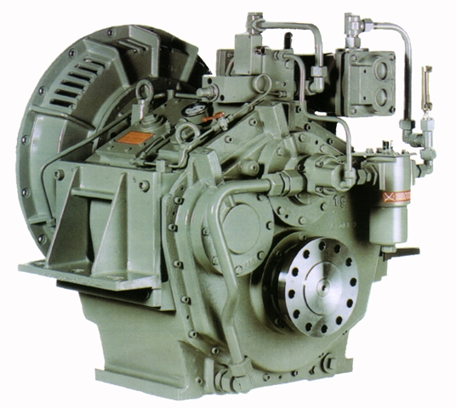

**Driveshaft**

A driveshaft is a mechanical device for transferring power from the engine or motor to the point where useful work is applied. Most engines or motors deliver power as torque through rotary motion extracted from the linear motion of pistons in an engine.

**Marine drive shafts**

On a power-driven ship, the driveshaft, or propeller shaft, usually connects the transmission inside the vessel directly to the propeller, passing through a stuffing box or other seal at the

point it exits the hull.

As the rotating propeller pushes the vessel forward, the marine driveshaft is also subject to compression, and when going reverse, to tension.

The propeller shaft should always be connected with a flexible coupling to eliminate all the vibrations.

Stuffing box

Stuffing box is a type of seal placed around a propeller shaft at the point it exits a boat's hull underwater. It is the most common method for preventing water from entering the hull while still allowing the propeller shaft to turn.

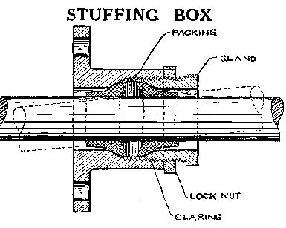

**Propeller pitch**

A **controllable pitch propeller** (CPP) or variable pitch propeller is a special type of propeller with blades that can be rotated around their long axis to change their pitch. If the pitch can be set to negative values, the reversible propeller can also create reverse thrust for braking or going backwards without the need of changing the direction of shaft revolutions.

Controllable pitch propellers (CPP) for marine propulsion systems have been designed to give the highest propulsive efficiency for any speed and load condition. When the vessel is fully loaded with cargo the propulsion required is much higher than when the vessel is empty. By adjusting the blade pitch, the optimum efficiency can be obtained and fuel can be saved

While it is true that a fixed pitch propeller (FPP) can be more efficient than a controllable pitch propeller, it can only be so at one rpm and the designed load condition. At that one rpm and load, it is able to absorb all the power that the engine can produce. At any other rpm, or any other vessel loading, the FPP cannot, either being over pitched or under pitched. A correctly sized controllable pitch propeller can be efficient at a wide rpm range, since pitch can be adjusted to absorb all the power that the engine is capable of producing at nearly any rpm.

The CPP also improves manoeuvrability of a vessel. When manoeuvring the vessel the advantage of the CPP is the fast change of propulsion direction. The direction of thrust can be changed without slowing down the propeller and depending on the size of the CPP can be changed in approximately 15 to 40 seconds. The increased manoeuvrability can eliminate the need for docking tugs while berthing

A reversing gear or a reversible engine is not necessary anymore, saving money to install and service these components. Depending on the main engine rpm and the size of the CPP a reduction gear may still be required. A CPP does require a hydraulic system to control the position of the blades. A CPP does not produce more or less wear or stress on the propeller shaft or propulsion engine than a FPP. Therefore, this will not be an argument to choose between a FPP and CPP.

Most ships that would not take a CPP are large vessels that make long trips at a constant service speed, for example, crude oil tankers or the largest container ships which have so much power that a CPP is not yet designed for them. A CPP can mostly be found on harbour or ocean-going tugs, dredgers, cruise ships, ferries and cargo vessels that sail to ports with limited or no tug assistance.