Bilge oil/water separator
An oil-contaminated water drainage system is a system that serves the engine room and other areas where oil-contaminated materials are likely to leak. This system must be isolated from the main bilge water system. Typically, this is a low-power system that uses low-performance pumps with good suction parameters. The water pumped from the wells of this system enters bilge water bilge tank.
About 1% of all ship fuel consumption is waste. There are usually two types of oily waste on board: oily waste in the bilge (also known as oily water from the engine room) and oily sludge-type waste from fuel cleaning plants.
There are two ways to deal with this waste generated during the operation of a ship:
Store them on board in appropriate containers and deliver to port waste reception facilities.
Pump oily mixtures through the oily water filtration system into the marine environment.
NOTE: Oil-contaminated water filtration system is a special equipment designed to separate oil products and water, leaving up to 15ppm of oil particles, which must comply with international standards.
The ship should be provided with containers of sufficient size to allow the waste generated to be stored throughout the ship's voyage and pumped to reception facilities on shore. However, the water content of such oily mixtures is usually quite high, so its delivery to the port reception facility is often not financially viable. Therefore, to reduce the amount of oily water, it is pumped to the oily water storage tank in the bilge, where the oil is separated and begins to float on the surface of the water. This oil is pumped out and placed in a separate bilge oil storage tank and delivered to waste reception facilities in the port. The remaining water in the bilge oil storage tank is pumped into the oil water filtration system.
The amount of oil discharged from the filtration system into the marine environment must not exceed 15 ppm. Thus, the filtration system must be fitted with a stopping device to ensure that emissions are automatically stopped when the oil content of the effluent exceeds 15 ppm. The oil remaining in this equipment also travels to a separate bilge oil storage tank. Part of this oil may be incinerated at the ship's fuel incineration plant and the remainder must be delivered to port reception facilities.
When an oil-water separator and its automatic equipment system controlling the discharge of treated effluent overboard must be recorded in the oil record book, indicating the date, quantity and location of the discharge.
All pumping operations and discharges shall comply with the latest MARPOL regulations, Regulations 9, 10, 11 and 16 of Annex I.
The oily water separator operates automatically, ie it discharges the purified water overboard and the separated oil products into the oil collection tank.
Oil-contaminated water from the drainage system is sucked into the oily water separator by an integrated pump. Where oil-contaminated water passes through a two-stage separation process. The separator uses the difference between oil and water density and surface tension. Separation is performed in two stages, which take place in separate vessels and involves:
1. stage – HEC (High Efficiency Coalescer) hull (see the Figure);
2. stage – HS (Hydrocarbon Separator) hull (see the Figure).
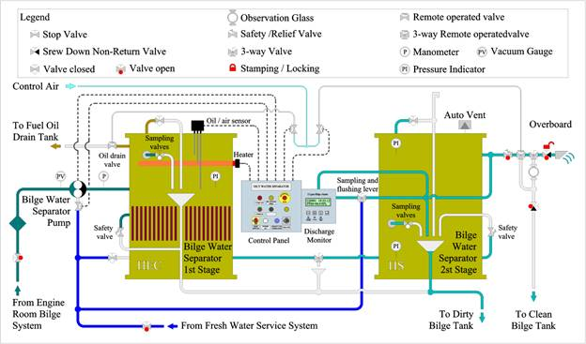
Example of an oily water separator
Before the oil-contaminated water is introduced into the separator, it is first filled with clean water. The integrated separator bilge water pump is then started, which feeds the oil-contaminated water into the HEC housing, where most of the oil is trapped. The oil droplets are attracted to the surface of the coalescer and form into larger and larger droplets until, due to the different densities, the lifting force rises and collects in the oil collection chamber.
The coalescer filter has a very large open pore surface area and very low pressure difference loss and is resistant to substances in the water emulsion, so the particles in the leachate do not have a detrimental effect on the coalescer filter. This means that the coalescer will continue to operate effectively, even when heavily polluted.
After the first stage of purification in the HEC chamber, the effluent water, which is now very low in oil, enters the second stage HS chamber. This chamber has a second coalescence filter to separate the remaining oil particles. After this stage, the treated effluent can be discharged overboard. HS filter elements have a limited service

life and should be replaced when the pressure difference in the unit exceeds the limit set by the manufacturer (approximately 0.14 MPa).
At the top of the first stage (HEC) chamber is the capacity of Oil/air sensor continuously monitors the oil level in the separator and the length of the probe electrode determines the operating range. When oil (or air) is detected, the Oil drain valve is opened and the second stage (HS) chamber pressure relief valve closes and the collected oil is discharged to the oil collection tank. The integrated separator feed pump is running all the time. When most of the collected oil is removed from the oil collection chamber and the oil sensor is re-immersed in the water, the separator control system resumes the sewage treatment mode.
Heater can be used to improve separation, but the heater will only operate when the separator is full of liquid. The heater must be used if the oil-contaminated water contains products of heavy oil fractions. Without a heater, the removal of viscous oil from the separator will be difficult. The separator has sampling valves that allow oil to be sampled and the level of oil and water separation determined. Both housings are designed as pressure vessels and each has safety valves that open at a pressure of 0.25 MPa.
CAUTION: An oil-contaminated water separator is used to separate oil from water, not water from oil. Therefore, if there is too much bilge water in the separator, the equipment will not work, and the normal operation of the equipment will be disrupted. As a result, additional maintenance will be required to restore the separator to proper operation.
When treating oil-contaminated water, the maximum recommended flow must not be exceeded, as excess flow will reduce the separation efficiency. The filtration sieve of the bilge water pumps must be kept clean to prevent large particles from entering the separator, as this will adversely affect the separation process.

