STEERING GEAR MACHINERY & ACCESSORIES
Hydrolic & Electrical Steering Systems

We are all familiar with the use of a rudder, which helps in turning a ship as and when required. Rudders are the principal system for the entire motion and control of the ships. But we mustn’t forget that the entire rudder action is dependent on another pivotal system called the Steering Gear.
Steering Gear integrated with the rudder system defines the complete ‘turning mechanism’ mandatory for each and every ship irrespective of size, type and operation.
The steering gear system has been an indispensable part of the ship’s machinery since the advent of the very early ships, which were operated by hand.

PUMPS
The pumps are usually positive-displacement pumps. In a simple system, a fixed-delivery pump of the screw, gear, or vane type (see Chapter 20) runs continuously, but until called upon to operate the actuator, the oil discharged by the pump passes through an unloading valve back to the pump suction.
Sliding Spool Valve

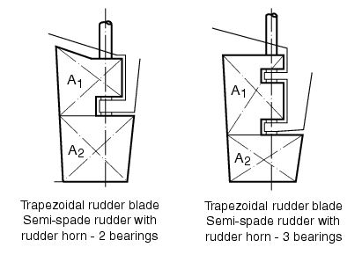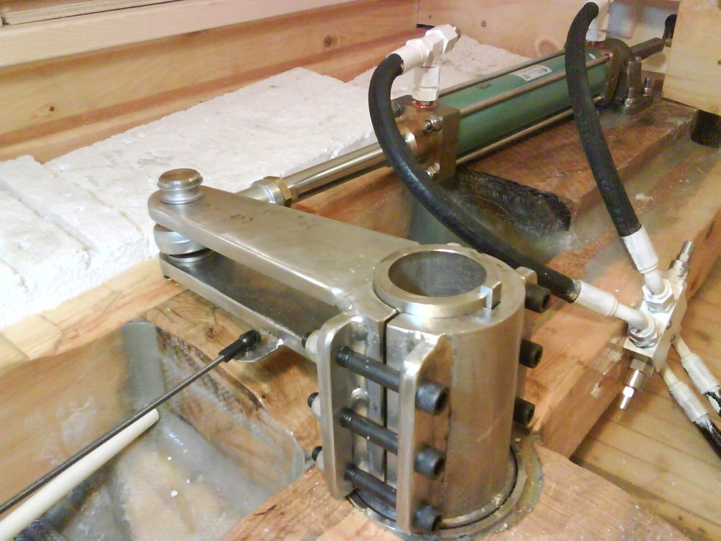

Hydraulic Systems

- Hydraulic systems are compact yet capable of very high forces, are very reliable, and are far more resistant to weather and moisture damage than electric systems .
- They are quickly started, offer high torque on demand, are easily controlled, and lend themselves well to automation.

Steering Gear
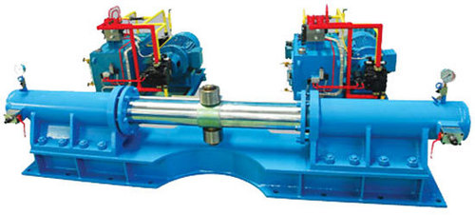
- When a rudder movement is required oil from the pump, typically at 1500 to 2500 psi (100 to 175 bars), passes through control valves to two diametrically opposed cylinders (while exhausting from the other two cylinders) to move the rams in opposite directions. The rams act through the trunnion, trunnion block, and yoke (which serves as the tiller) to turn the rudderstock. Because of the arrangement of the trunnion block in the slot of the yoke, this type of steering gear is called Rapson-slide steering gear.

Rotary Vane Steering Gear

Rotary-vane actuators are more compact than ram types, are suitable for lower operating pressures , generally 850 to 1450 psi (60 to 100 bars)

INTERNATIONAL AGREEMENT ON STEERING GEAR CAPABILITIES AND OPERATION

Requirements for the operation of steering gear are also set out in SOLAS, generally as follows:
• Where navigation requires special care both power units shall be in use.
• Within 12 hours prior to departure, the steering gear and linkage shall be inspected and tested over the full movement of the rudder. For ships engaged in short voyages these inspections and tests shall be conducted weekly.
• Operating instructions with a block diagram showing emergency procedures shall be permanently displayed on the bridge and in the steering gear compartment. Drills shall be conducted at least every three months, and shall include direct control from the steering gear location, and the use of alternative power supplies.
• Checks, tests, and drills shall be recorded in the logbook.

WINDLASSES, WINCHES, and CAPSTANS

Windlasses are used to raise and lower ships' anchors. Winches and capstans are used to handle wire or rope lines. These machines have some features in common: a prime mover, which may be a hydraulic or electric motor, a speed-reducing gear, and a drum or head to haul on the chain or line.

In operation, with the clutch disengaged, the anchor will fall under its own weight as the chain turns the wildcat, until the brake is used to control the fall. To hoist the anchor, or to lower the anchor under power, the clutch is engaged. The windlass is not used to secure the anchor at sea: once the anchor is heaved up and firmly seated at the foot of the hawsepipe, a chain stopper is used to lock the chain in place.

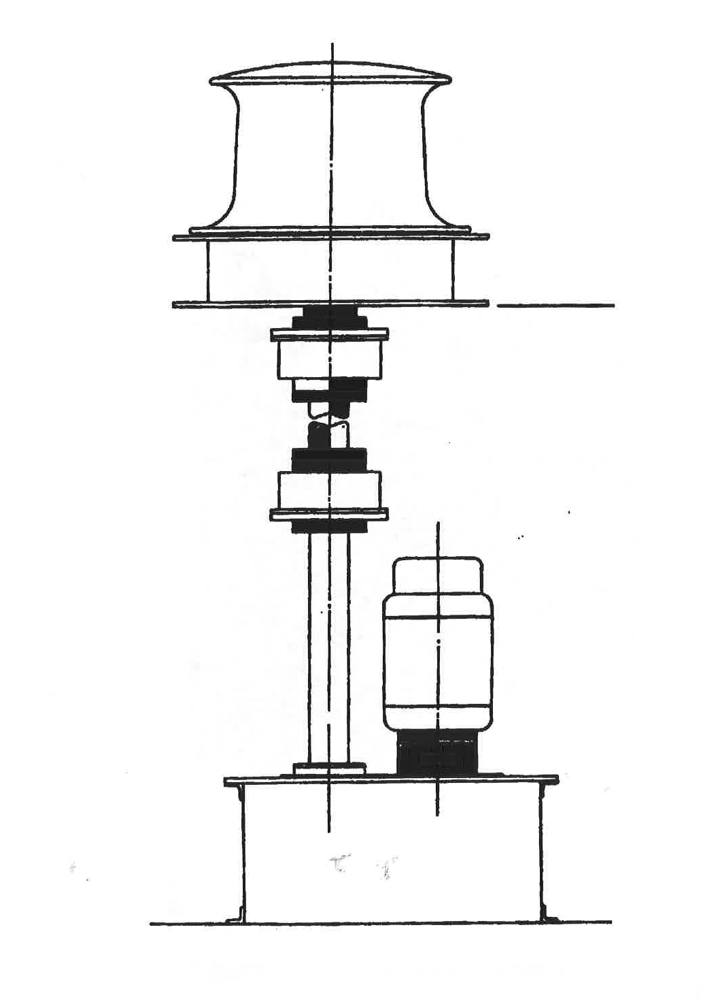
Capstans and warping heads (gypsy heads)
