RADAR OBSERVATION

Exercise 1. Radar Observation

Objective:
The objective of this exercise is to familiarize participants with radar observations and enhance their understanding of the principles, techniques, and applications of radar technology in various fields.

Materials Needed:
• Radar system (real or simulated)
• Radar data processing software
• Computer with appropriate software installed
• Training data sets scenario (if using simulated radar)

Duration:
The exercise is designed to be completed within a two-hour workshop, comprising theoretical instruction, hands-on practice and discussion. The duration may vary depending on the level of expertise of the participants.

Exercise Steps:
1. Introduction to Radar Technology:
◦ Provide a brief overview of radar technology, including its basic principles, components, and terminology.
◦ Explain the different types of radar systems (e.g., weather radar, air traffic control radar, ground-penetrating radar) and their applications.
2. Radar Data Acquisition:
◦ Familiarize participants with the process of radar data acquisition, including the transmission and reception of radar signals.
◦ Discuss the factors affecting radar data quality, such as range resolution, azimuth resolution, and beam width.
3. Radar Signal Processing:
◦ Introduce participants to radar signal processing techniques, including pulse compression, Doppler processing, and clutter suppression.
◦ Explain the importance of signal processing in enhancing radar performance and extracting useful information from radar echoes.
4. Radar Observables:
◦ Discuss the different observables obtained from radar observations, such as range, azimuth, elevation, velocity, and reflectivity.
◦ Explain the interpretation and significance of each observable in various applications.
5. Radar Applications:
◦ Present examples of radar applications in different domains, such as weather forecasting, surveillance, navigation and remote sensing.
◦ Highlight the unique capabilities and limitations of radar systems in each application.
6. Hands-on Radar Data Analysis:
◦ Provide participants with radar data sets (either real or simulated) and guide them through the process of data analysis.
◦ Demonstrate the use of radar data processing software to visualize and interpret radar echoes.
◦ Assign specific tasks or scenarios to participants to encourage active engagement and problem-solving.

Theoretical Part: Radar Observation

1. Introduction:
Radar (Radio Detection and Ranging) is a technology used to detect and track objects by transmitting electromagnetic waves and analyzing the echoes reflected from those objects. Radar observations have a wide range of applications, including weather forecasting, air traffic control, maritime navigation, surveillance, and remote sensing. Understanding the principles and techniques of radar observations is essential for accurately interpreting radar data and extracting meaningful information.
2. Basic Principles of Radar:
Radar operates based on the principles of electromagnetic wave propagation and reflection. A radar system consists of a transmitter that emits short pulses of electromagnetic waves, an antenna that radiates these waves into space, and a receiver that captures the echoes reflected by objects in the radar's field of view. When a radar pulse encounters an object, such as an aircraft, ship, or weather phenomenon, a portion of the energy is scattered back towards the radar antenna. This reflected energy, known as the radar echo, contains valuable information about the object's location, motion, and properties.

3. Radar Data Acquisition:
Signal Transmission: The radar system transmits electromagnetic pulses in the form of radar waves, typically in the microwave frequency range. These pulses are directed towards the target area or objects of interest.
Signal Reception: When the transmitted radar waves encounter objects in their path, they are partially reflected back towards the radar system. The radar antenna receives these reflected signals, known as echoes, which contain valuable information about the detected targets.
Analog-to-Digital Conversion: The received analog echo signals are converted into digital format using an analog-to-digital converter (ADC). This conversion allows for further processing and analysis of the signals using digital signal processing techniques.
Pre-processing: In this stage, various pre-processing techniques are applied to the digitized signals to enhance the quality and extract relevant information. This may include filtering out noise, removing clutter caused by land or sea returns, and compensating for any system-induced distortions.
Range Determination: By measuring the time it takes for the radar pulse to travel to the target and back, the range to the detected objects can be determined. This is done by correlating the received signal with the transmitted pulse and extracting the time delay between them.
Doppler Processing: Doppler processing is employed to measure the radial velocity of the targets. The Doppler effect causes a change in frequency of the received signal relative to the transmitted frequency, and by analyzing this shift, the velocity of the targets towards or away from the radar can be determined.
Target Extraction: Once the range and velocity information is obtained, the radar system identifies and extracts targets of interest from the received signals. Various algorithms and techniques are employed to differentiate between different targets, suppress unwanted returns, and track the detected objects over time.
Visualization and Display: The processed radar data is presented to the user in a human-readable format. This may involve generating a radar image or display that represents the detected targets, their positions, velocities, and other relevant information. Different visualization techniques, such as plan position indicator (PPI) or head-up display (HUD), are commonly used.

4. Radar Signal Processing Techniques:
Radar signal processing techniques play a crucial role in extracting useful information from radar signals. These techniques aim to enhance the quality of the received signals, extract relevant features, and enable target detection, tracking, and classification. Here are some common radar signal processing techniques:
Pulse Compression: Pulse compression techniques are used to achieve high-resolution range measurements in radar systems. By transmitting long-duration pulses and using matched filters in the receiver, the received echoes can be compressed to improve range resolution, allowing the detection of small targets.
Doppler Processing: Doppler processing is employed to measure the radial velocity of targets. It involves analyzing the frequency shift of the received signal caused by the relative motion between the radar and the target. Doppler processing techniques, such as Fast Fourier Transform (FFT), can estimate the velocity and direction of moving targets.
Clutter Rejection: Radar signals can be contaminated with unwanted clutter, such as reflections from the ground, sea, or buildings. Various clutter rejection techniques, including Moving Target Indication (MTI) and Constant False Alarm Rate (CFAR), are used to suppress clutter and improve target detection in cluttered environments.
Moving Target Detection and Tracking: Moving target detection and tracking techniques are used to identify and track targets in radar observations. These techniques involve analyzing the time-varying properties of radar returns, such as Doppler frequency and range rate, to distinguish moving targets from stationary clutter.
Adaptive Beamforming: In radar arrays with multiple antennas, adaptive beamforming techniques are used to steer and focus the radar beam towards the desired direction while suppressing interference and clutter from other directions. Adaptive algorithms, like Minimum Variance Distortionless Response (MVDR), optimize the antenna weights to achieve the desired beam pattern. Target Classification: Radar signal processing can involve classification techniques to identify and classify different types of targets based on their radar signatures. Pattern recognition algorithms, statistical techniques, and machine learning approaches are used to analyze the radar observables, such as radar cross-section, Doppler signature, and polarization properties, for target classification.
Synthetic Aperture Radar (SAR) Imaging: SAR processing techniques are used in remote sensing applications to generate high-resolution images of the Earth's surface. SAR exploits the motion of the radar platform to synthesize a large antenna aperture, providing fine spatial resolution. SAR processing involves motion compensation, range compression, and image formation algorithms.

5. Radar Observables:
Radar observations provide various measurable quantities, known as observables, that describe the characteristics of detected objects. The primary observables obtained from radar data include:
Range: The distance between the radar and the target, determined by measuring the time it takes for the radar pulse to travel to the target and back.
Azimuth: The horizontal angle between the radar's reference direction (e.g., true north) and the target's direction, indicating the target's left or right position relative to the radar.
Elevation: The vertical angle between the radar's reference plane (e.g., the horizon) and the target, indicating the target's height or altitude.
Velocity: The rate of change of the target's range over time, providing information about the target's speed towards or away from the radar.
Reflectivity: The measure of the strength of the radar echo reflected by the target, indicating the target's reflective properties or surface roughness.

6. Applications of Radar Observations:
Weather Forecasting: Radar systems, such as weather radars, are used to monitor and forecast precipitation patterns, storm systems, and severe weather phenomena.
Unique Capabilities: Weather radar can provide real-time information about the location, intensity, and movement of precipitation. It can detect the presence of severe weather features like thunderstorms, tornadoes, and hail.
Limitations: Radar beams have a limited range and can be attenuated by heavy precipitation, leading to reduced accuracy and coverage in regions with intense rainfall or obstructed terrain. Additionally, radar cannot directly measure temperature, humidity, or wind, which are important parameters for comprehensive weather forecasting.
Surveillance and Security: Radar systems are employed for border surveillance, airspace monitoring, maritime security, and perimeter protection.
Unique Capabilities: Radar can operate in various weather conditions, including fog, rain, and darkness, making it suitable for continuous monitoring. It can detect and track moving objects like vehicles, aircraft, or boats, providing situational awareness and early warning.
Limitations: Radar may struggle with target identification, especially in complex environments with multiple reflections or clutter. The detection range and resolution can be affected by terrain, vegetation, and other obstacles.
Navigation and Collision Avoidance: Radar is crucial for marine and air navigation, providing information for collision avoidance and safe maneuvering.
Unique Capabilities: Radar can detect other vessels or aircraft, even beyond the visual line of sight. It provides range, bearing, and velocity information for situational awareness and collision risk assessment.
Limitations: Radar may encounter difficulties in distinguishing small objects or targets with low radar cross-section (RCS). It may have limitations in detecting stationary objects, and clutter from land or sea returns can affect target identification.
Remote Sensing and Earth Observation: Radar systems, including synthetic aperture radar (SAR), are used for remote sensing of the Earth's surface, such as mapping, land cover classification, and disaster monitoring.
Unique Capabilities: Radar can operate day and night and is not affected by cloud cover, allowing continuous monitoring. SAR can penetrate vegetation and cloud cover, providing insights into surface properties and changes.
Limitations: Radar has limited spatial resolution compared to optical sensors. SAR data processing can be complex and computationally demanding. Surface roughness and complex topography can impact data interpretation and mapping accuracy.

7. Training data set:
Navigation via cape “Kaliakra”, North Coast of Bulgaria

First leg Second leg
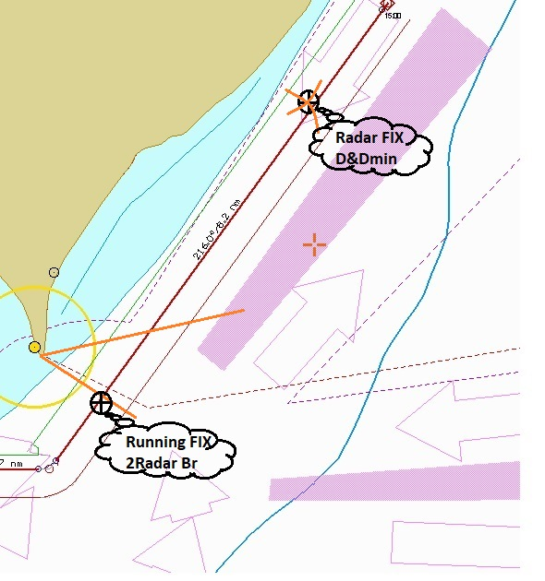
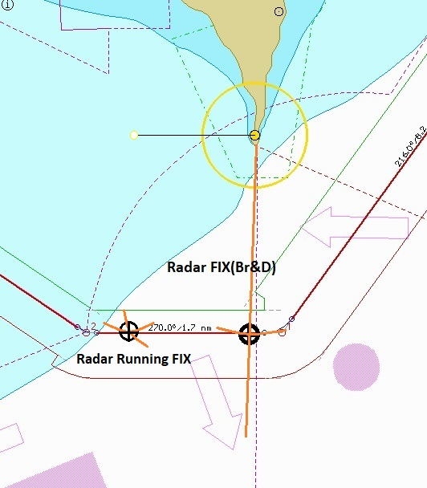
Third leg
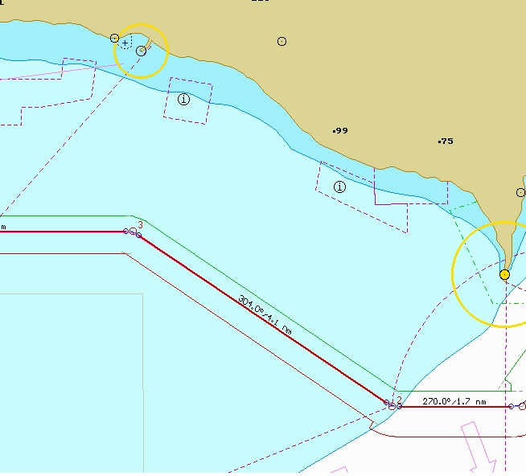

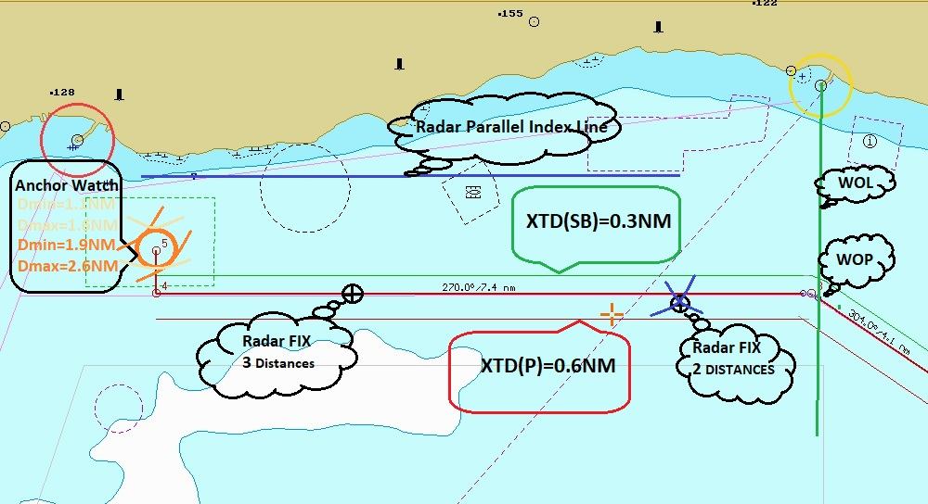
Fourth leg

Area Bulgaria/North coast
Vessel „Alpha”
MMSI 244711569
IMO No 4382286
Flag Greece
Call Sign BZERS
Type Car Carrier
Dis. 450 830 t
Underway using engine
Destination port Balchik
Crew member 19

Start Тime=12:00 vessel “Alpha” in position  = 43 26.6 N = 28 34.6 E. Planned Speed = 11.0 kn. HDGTrue=216 Wind Е-7 m/s Sea – 2 Cloud cover – 4. Visibility -8 n.mi. Current W – 1.5 kn Rainy.

- Characteristics of own ship – according “Pilot card” (see file “Ship’s Model”). Radar – “Bridge Master E” (see file “Bridge Master E Manual). XTE_{limit} – (see files “..leg”)
Safety contour = 1.3*Draft (D)
Safety depth = Draft(D)
Shallow contour = Draft(D)
Deep contour = 2.5*Draft(D)
Safety frame time = 6 min.
Alert zone: SB= 400 m, Port = 200 m
The exercise will start 15 minutes after beginning. Ships is on “manual steering” Autopilot track control is forbidden. No communication. GPS – fault.
- Use only radar fix position to steer the vessel according voyage planning:
- Two distances (including minimum Distance)
- Three distances
- Bearing and distance
- Running fix (bearings and/or distances)
- Parallel Line (Index line)
- Control Bearing (Distance) as WOL
- Anchor watch (control parameters)

Common plan
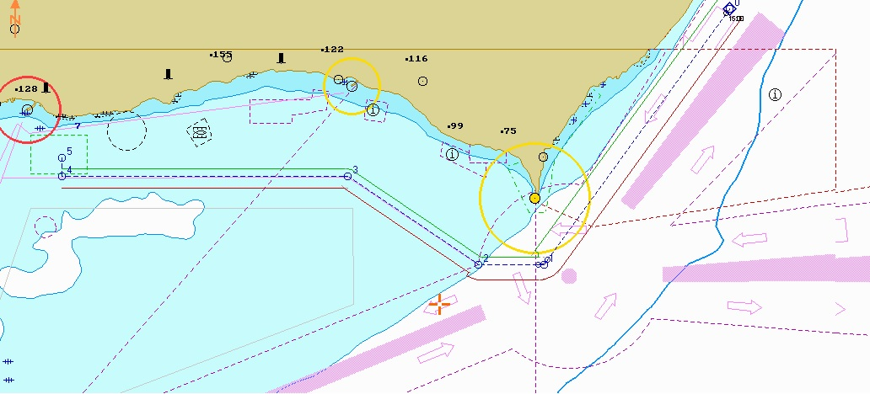

Procedure:
Familiarize yourself with the nautical charts or digital navigation tools covering the area around Cape Kaliakra. Identify the key landmarks, navigational aids, and any potential hazards such as shallow areas, rocks, or wrecks.
Set up the radar display or simulator, ensuring it accurately represents the ship's position and surroundings. Adjust the range scale to cover an appropriate area for your ship's current position and speed.
Begin the exercise by assuming that you are approaching Cape Kaliakra on a ship. Determine your ship's current position using available navigation methods such as GPS, chart plotting, or dead reckoning. Enter this position into the radar display or simulator.
Monitor your ship's progress on the radar display. Identify the radar signatures of prominent features of Cape Kaliakra, such as cliffs, headlands, or distinctive topographical formations. Take note of their relative positions and distances from your ship.
Use the radar display to measure and confirm your ship's distance off the coast of Cape Kaliakra. Identify a specific point or feature on the radar display that corresponds to the charted position of the cape.
Mark your ship's position on the radar plotting sheet, if using one. Plotting your radar observations can help visualize the ship's track and detect any deviations from the planned course.
Compare your ship's position on the radar display with the information on the nautical chart or digital navigation tools. Confirm that you are on track and have a clear understanding of the course to be followed.
Monitor the movement of your ship relative to the radar signatures of Cape Kaliakra. Pay attention to any changes in distance, bearing, or relative motion to gauge your progress along the coast.
Identify any navigational aids, such as buoys or beacons, that may assist in ensuring safe passage. Verify their positions on the radar display and cross-reference them with the nautical chart or digital navigation tools.
Practice making course adjustments based on radar observations. Consider factors such as avoiding shallow areas, maintaining a safe distance from hazardous features, and optimizing the ship's track for efficiency and safety. Use the radar display to monitor the effect of your course changes on the ship's track.

Continuously update your ship's position on the radar display and cross-reference it with other navigation instruments or methods available onboard.
As you pass Cape Kaliakra, observe any changes in radar signatures, such as the fading of certain features or the emergence of new ones. Take note of these changes for future reference and situational awareness.
Periodically update your position on the radar plotting sheet, if using one, to visualize the ship's track and any deviations.
Review your radar observation and navigation decisions after completing the exercise. Reflect on the accuracy of your observations, the effectiveness of your course adjustments, and any areas that may require improvement.
Remember to always prioritize safety and refer to official navigation resources and procedures while operating a ship in real-world scenarios. Regular practice of radar observation and navigation skills will help improve your situational awareness and decision-making abilities.
Navigating as in the tutorial in four legs typically refers to dividing a journey or passage into four distinct segments or legs. Each leg represents a specific course or heading to be followed to reach the destination. Here's a general description of the navigating procedure in four legs:

Leg 1: Departure Leg
The departure leg is the initial segment of the journey, starting from the point of departure.
Determine the desired course and set it on the ship's navigation instruments, such as the compass or GPS.
Maintain a constant heading, adjusting for any wind or current effects, to keep the ship on track towards the next waypoint or destination.

Leg 2: Transit Leg
The transit leg is the intermediate segment that connects the departure point to a significant waypoint or landmark.
Monitor the ship's progress by referencing navigation aids, such as buoys, beacons, or radar observations.
Make necessary course adjustments to account for any changes in wind, current, or traffic conditions.
Continuously cross-reference the ship's position with the intended track and adjust the heading as needed to stay on course.

Leg 3: Turning Leg
The turning leg is the segment where the ship changes its course or heading to align with a new direction towards the destination.
Identify the turning point or waypoint where the change of course is planned.
Gradually alter the ship's heading, considering factors like traffic, obstructions, and navigational rules.
Maintain situational awareness and monitor the ship's position and heading during the turning maneuver.

Leg 4: Approach Leg
The approach leg is the final segment leading to the destination or intended arrival point.
Set the new course towards the destination, considering any navigational hazards, traffic separation schemes, or local regulations.
Use navigation aids, charts, and instruments to monitor the ship's position and progress.
Make small course adjustments as necessary to maintain the desired track and approach the destination safely.
Throughout each leg, it's essential to maintain a continuous watch, update navigation instruments, cross-reference positions, and communicate with the bridge team. Regular monitoring of weather conditions, traffic, and navigational warnings is crucial to ensure a safe and efficient passage.
Please note that the specific navigating procedure can vary depending on the vessel, type of voyage, and navigational requirements. It's always important to follow the appropriate navigation procedures and regulations applicable to your specific situation.

