UNDERSTANDING RADAR NAVIGATION AIDS

Radar technology is fundamental to modern navigation, operating on the principle of emitting radio waves and detecting their reflections. This process allows for the determination of range, bearing, and elevation of objects in the vicinity. The importance of radar in navigation lies in its ability to provide real-time information, aiding in collision avoidance and safe navigation, especially in adverse weather conditions.
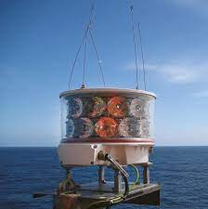
Types of Radar Systems for Navigation
Maritime radar systems are diverse tools crucial for safe navigation at sea, employing various frequency bands and technologies to meet specific operational requirements. X-Band radar, operating at 8-12 GHz, is widely utilized for its high resolution and effectiveness in collision avoidance. S-Band radar, with a frequency range of 2-4 GHz, complements X-Band systems, offering reliable performance in adverse weather conditions. Meanwhile, L-Band radar, operating at 1-2 GHz, provides long-range surveillance capabilities but sacrifices some resolution. Ku-Band radar, between 12-18 GHz, strikes a balance with higher resolution suitable for short to medium-range navigation. Coastal surveillance radar specializes in monitoring activities along coastlines, integrating various radar technologies and sensors to detect vessels and monitor illicit activities. Phased array radar, often found on naval vessels, employs electronic beam steering for rapid scanning and enhanced situational awareness.
Pulse radar, emitting short energy pulses and measuring return time, is effective for short-range navigation and precise distance measurements. Continuous Wave (CW) radar uses a continuous radio frequency wave and leverages the Doppler effect to detect moving targets, commonly employed for speed measurement across varying ranges. As technology advances, maritime radar systems incorporate features like automatic target tracking, collision avoidance algorithms, and integration with navigation systems, contributing to improved safety and efficiency at sea. These diverse radar technologies collectively play a vital role in maritime navigation, helping vessels navigate through different weather conditions, detect obstacles, and prevent collisions, ultimately ensuring the overall safety and security of maritime operations.

Types of Radar Navigation Aids

Collision Avoidance Radar: This type of radar is designed specifically to detect nearby vessels and obstacles, helping mariners avoid collisions. It operates in different frequency bands such as X-Band and S-Band, providing a balance between resolution and range. Advanced collision avoidance radars may incorporate automatic target tracking and alert systems to enhance the crew's ability to navigate safely in congested waters.
Automatic Radar Plotting Aid (ARPA): ARPA systems process radar data to automatically track the movements of nearby vessels. These systems calculate the predicted future positions of these vessels, providing valuable information for collision avoidance. ARPA enhances situational awareness by continuously updating vessel trajectories and displaying them on navigation screens, enabling mariners to make informed decisions.
Radar Transponders (SART and AIS):Search and Rescue Transponders (SART) and Automatic Identification System (AIS) are radar navigation aids that enhance vessel visibility. SARTs are designed to respond to radar signals, helping search and rescue teams locate distressed vessels, while AIS transponders broadcast a vessel's identity, position, course, and speed to other vessels and shore stations, facilitating efficient traffic management.
Radar Beacon (RACON):RACONs are radar beacons installed on navigational aids such as buoys and lighthouses. They emit distinctive radar signals that appear on a ship's radar display, providing additional navigational information. RACONs help mariners confirm their position and navigate safely through channels and waterways.
Parallel Indexing Radar:Parallel Indexing is a radar navigation aid that assists vessels in maintaining a safe course parallel to a navigation channel. It provides visual cues on the radar display, helping mariners align their vessel with the intended course and avoid straying into shallow or hazardous areas.
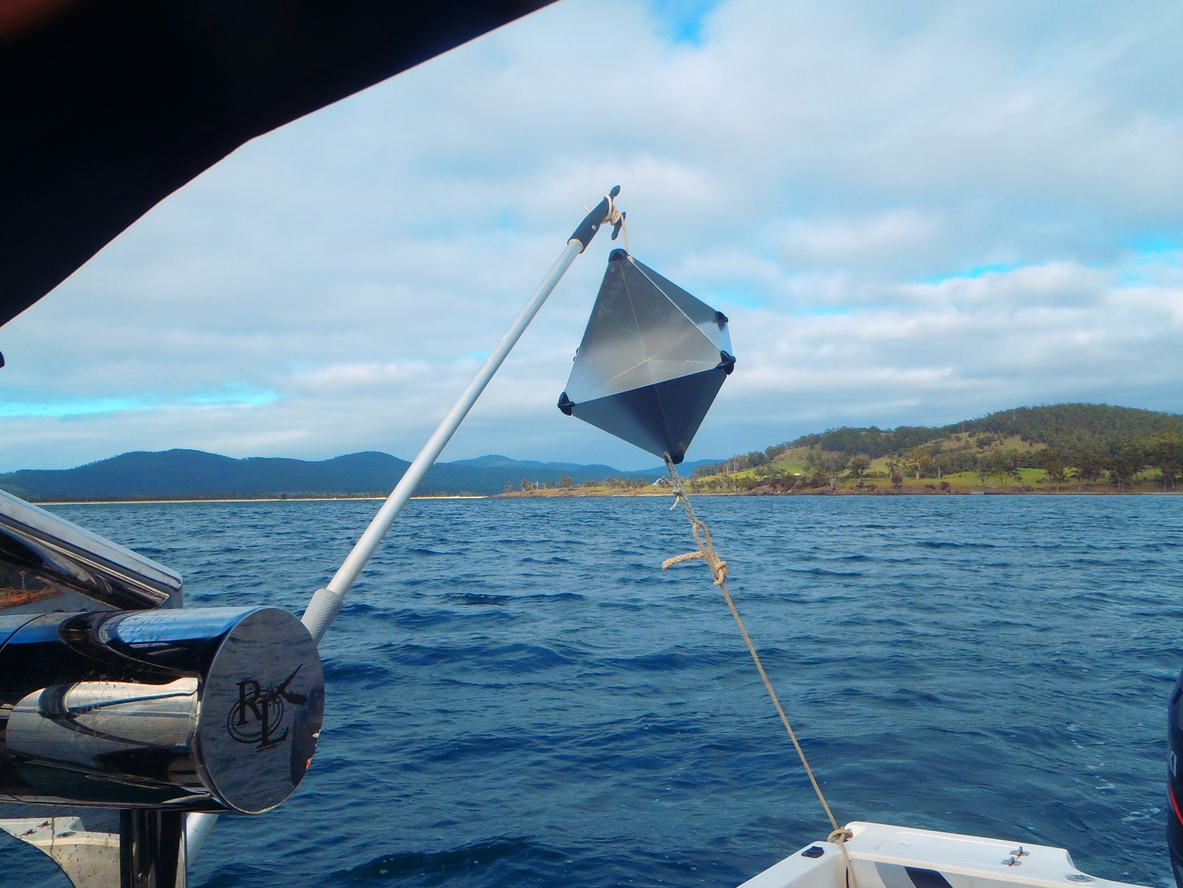

Collision Avoidance Strategies with Radar Navigation Aids

Collision avoidance strategies employing radar navigation aids are fundamental to ensuring the safety of maritime operations. Radar systems play a pivotal role in detecting and tracking vessels and obstacles, offering mariners crucial information for making informed navigation decisions. One key strategy is the use of multiple radar frequency bands. X-Band radar is commonly employed for its high resolution in short to medium-range navigation, while S-Band radar provides reliable performance in adverse weather conditions. Integrating these bands enhances overall situational awareness, allowing mariners to effectively navigate through congested waterways and dynamically changing environments.
Another essential collision avoidance strategy involves the integration of radar data with other navigation aids and technologies. Combining radar information with Automatic Identification System (AIS) data, Electronic Chart Display and Information System (ECDIS), and gyrocompass data provides a comprehensive and real-time understanding of the vessel's surroundings. This integrated approach enables mariners to assess potential collision risks, calculate safe navigation paths, and take timely evasive actions. The synergy between radar and modern navigation aids significantly reduces the likelihood of collisions and enhances overall navigation efficiency, especially in busy shipping lanes or areas with limited visibility.
Furthermore, advanced collision avoidance systems incorporate artificial intelligence and automation. These systems leverage radar data to implement predictive algorithms that assess the trajectory and behavior of surrounding vessels. By anticipating potential collision scenarios, these systems can issue early warnings to the crew and, in some cases, autonomously execute collision avoidance maneuvers. The integration of radar with smart technologies not only improves the efficiency of collision avoidance but also reduces the reliance on human response time, providing an additional layer of safety in maritime navigation. In summary, collision avoidance strategies with radar navigation aids involve the use of multiple frequency bands, integration with other navigation technologies, and the incorporation of artificial intelligence for predictive and automated responses, collectively contributing to safer and more efficient maritime navigation.

