RADAR TARGETS AND ECHOES

Radar Targets

Radar targets refer to objects or entities that reflect or scatter radio waves when exposed to radar signals. These targets can be various objects, and the radar system uses the echoes or reflections of the transmitted signals to detect, locate, and track these objects. Here are some common types of radar targets:
Surface Targets:
Ships and Boats: Large metal structures of ships provide a significant radar cross-section, making them easily detectable.
Buoys: Floating devices equipped with radar reflectors to enhance visibility.
Air Targets:
Aircraft: Radar is crucial for air traffic control and military surveillance. Aircraft, with their metal structures, reflect radar signals effectively.
Drones: Unmanned aerial vehicles can also be radar targets, depending on their size and materials.
Land Targets (Coastal Targets):
Land Masses: Coastal areas and cliffs can reflect radar signals, especially if they have steep or irregular surfaces.
Icebergs: In polar regions, radar is used to detect and track icebergs to avoid collisions.
Mixed Targets:
Oil Rigs and Platforms: Large structures in the water can be radar targets, especially if they have metal components.
Radar Reflectors:
Man-Made Reflectors: Some objects in the maritime environment are equipped with radar reflectors to enhance their visibility to radar systems. These are often used on small boats or structures.

It's important to note that the radar cross-section (RCS) of a target plays a crucial role in determining how easily it can be detected by a radar system. RCS is a measure of how much radar energy is reflected back to the radar antenna. Factors such as the size, shape, and material composition of a target influence its RCS. Targets with larger RCS values are generally more easily detectable by radar systems.

Echoes and Radar Reflection

In the context of radar, echoes and radar reflection are fundamental concepts that involve the transmission and reception of radio waves for the purpose of detecting objects. Let's delve into each of these concepts:
- Echoes:
In radar terminology, an "echo" refers to the return of a radar signal that has bounced off a target object. It's the reception of the reflected radio waves by the radar system.
When a radar system transmits a pulse of electromagnetic energy, it travels through space until it encounters an object. Upon striking the object, some of the energy is reflected back towards the radar antenna.
Role in Radar Operation: Echoes are the basis for radar detection. By analyzing the time it takes for the transmitted signal to return and the characteristics of the returned signal, the radar system can determine the range, bearing, and sometimes the relative velocity of the target.
- Radar Reflection:
Radar reflection involves the redirection of radio waves when they encounter an object. This redirection can occur through several mechanisms, including reflection, scattering, and diffraction.
The primary mechanism is reflection, where the incident electromagnetic waves bounce off the target's surface, much like light reflecting off a mirror. The nature of this reflection is influenced by the target's composition, shape, and size.
Scattering occurs when the incoming radar wave interacts with irregularities or smaller structures on the target's surface, causing the energy to be scattered in various directions. Diffraction involves the bending of waves around obstacles, which can contribute to the radar signature of a target. Fig. 1 shows a radar picture that depicts a ship passing near Cape Kaliakra, Bulgaria.
Radar Cross Section (RCS): The effectiveness of a target in reflecting radar waves is quantified by the Radar Cross Section (RCS). RCS is a measure of how well a target reflects radar signals and is influenced by the target's physical characteristics.
- Factors, influencing Echo Formation:
Different materials reflect radar waves to varying degrees. Metal surfaces, for example, are highly reflective.The geometry of the target influences how radar waves interact with it. Larger objects generally have a larger RCS. The angle at which the radar beam strikes the target, known as the aspect angle, affects the strength of the reflected signal.
Understanding echoes and radar reflection is crucial for radar operators and engineers in optimizing radar performance, mitigating false returns, and identifying and tracking targets accurately. Additionally, it plays a key role in radar signature analysis for stealth technology and electronic warfare.

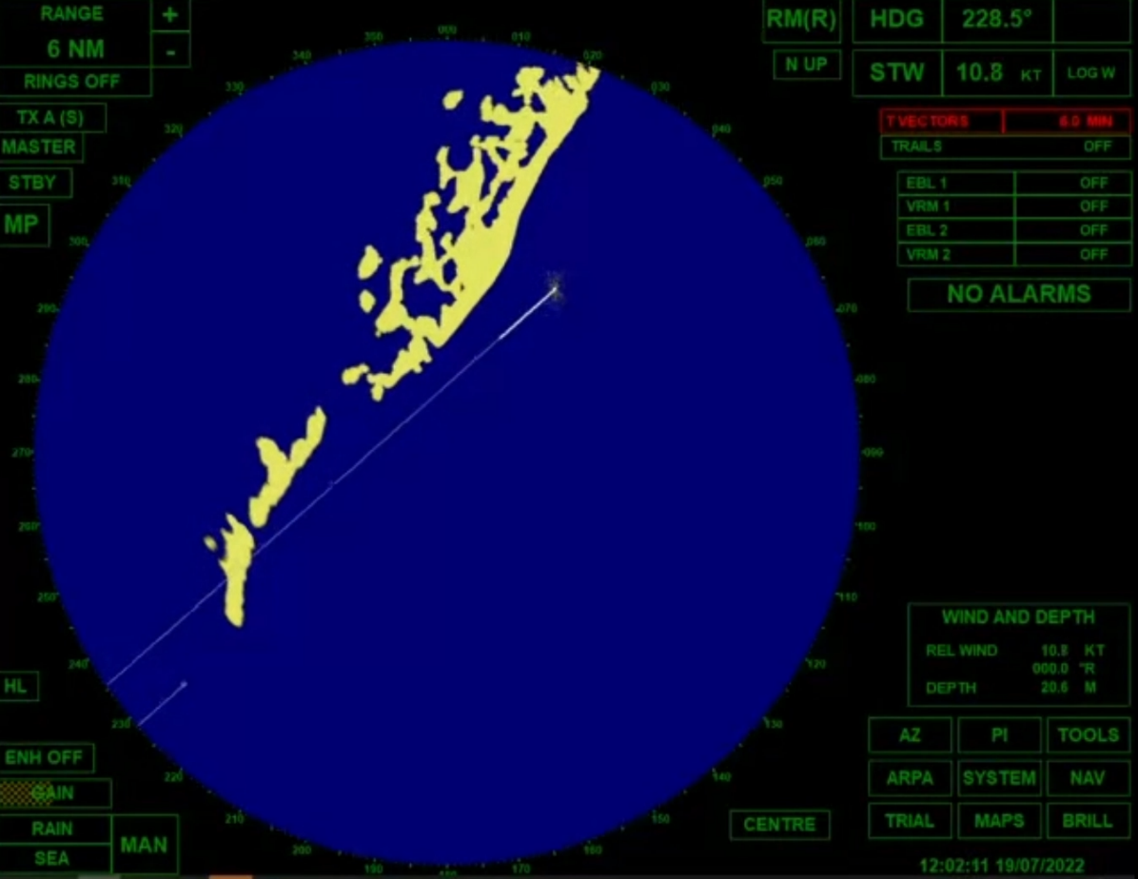
Fig.1 Radar picture of ship passing near Cape Kaliakra

Identification of targets

Identifying targets accurately is a critical aspect of radar systems, ensuring that operators can distinguish between different objects and make informed decisions. The identification process involves analyzing the radar echoes or returns to determine the nature of the detected targets. Here are key aspects of the identification of radar targets:
Radar Signatures. A radar signature is the unique pattern or combination of characteristics in the radar echoes produced by a specific target.
Types of Signatures
Primary Returns: Direct reflections from the target surface.
Secondary Returns: Additional echoes resulting from reflections off nearby surfaces or atmospheric conditions.
Different types of targets exhibit distinct radar signatures. Analyzing these signatures helps in target classification.
Signature Recognition:
Pattern Analysis: Operators learn to recognize patterns in radar returns associated with specific targets. This involves training and experience.
Database Comparison: Some radar systems compare received signatures with a database of known signatures for identification.
False Targets and Clutter:
Weather Conditions: Adverse weather conditions such as rain, snow, or fog can create false returns. Radar systems need mechanisms to distinguish between real targets and environmental effects.
Sea Clutter: Radar signals can be reflected off the sea surface, creating clutter. Advanced signal processing helps filter out false readings.
Target Database and IFF (Identification Friend or Foe):
Database Integration: Modern radar systems may integrate databases containing information about friendly and enemy targets, aiding in identification.
IFF Systems: Military applications often use IFF systems, where transponders on friendly vehicles respond to specific radar interrogations, providing positive identification.

Multisensor Fusion:
Integration with Other Sensors: Combining radar data with information from other sensors, such as infrared or visual cameras, enhances identification accuracy.
Data Fusion Algorithms: Sophisticated algorithms merge data from multiple sensors to improve the overall understanding of the environment.
Electronic Support Measures (ESM):
Signal Intelligence: ESM systems can analyze electronic emissions from targets, helping in target identification based on their electronic signature.
Classification Algorithms:
Machine Learning: Advanced radar systems may employ machine learning algorithms for real-time classification of targets based on historical data and training.
Human-in-the-Loop:
Operator Expertise: Despite technological advances, human operators play a crucial role in the identification process, especially in complex or ambiguous situations.
Challenges:
Stealth Technology: Targets designed to minimize radar cross-section present challenges in identification.
Electronic Countermeasures: Jamming and electronic warfare techniques can complicate identification.
Identifying targets accurately is a dynamic and evolving field, influenced by technological advancements and the changing nature of threats. Continuous improvement in radar technology and signal processing capabilities contributes to more effective target identification in various operational scenarios.
Detection and Tracking

A. Detection of Targets 1. Thresholds and sensitivity 2. Signal processing and filtering techniques
B. Tracking of Targets 1. Prediction algorithms 2. Multi-sensor integration for improved tracking accuracy
Detection and tracking are essential functions of radar systems that enable them to locate and monitor targets in various environments. These processes involve analyzing radar echoes to determine the presence, location, and movement of objects. Here's an overview of detection and tracking in radar systems:
1. Detection: Detection is the process of identifying the presence of a target based on the analysis of radar echoes or returns.
Thresholds and Sensitivity: Radar systems have sensitivity thresholds, and signals above this threshold are considered detections. Setting the right sensitivity is crucial to avoid missing small targets or being overwhelmed by noise.
Detection Range: The distance at which a radar system can detect a target depends on factors like the power of the transmitted signal, the size and radar cross-section of the target, and environmental conditions.
2. Signal Processing for Detection:
Pulse Compression: Techniques like pulse compression help improve the radar's ability to detect targets by compressing the pulse duration, allowing for better resolution.
Doppler Processing: Analyzing the Doppler shift in radar returns enables the detection of moving targets, aiding in distinguishing between stationary and moving objects.
3. False Alarm Mitigation:
Clutter Rejection: Advanced signal processing algorithms filter out unwanted echoes caused by environmental clutter such as rain, sea waves, or ground reflections.
Moving Target Indication (MTI): MTI techniques help distinguish between stationary and moving targets, reducing false alarms.
4. Tracking:
Definition: Once a target is detected, tracking involves continuously monitoring its position and, in some cases, its velocity over time.
Prediction Algorithms: Tracking algorithms predict the future position of a target based on its current state and velocity. Kalman filters and other prediction methods are commonly used.
Multi-Target Tracking: Radar systems often need to track multiple targets simultaneously. Data association algorithms help assign radar returns to specific targets.
Track Fusion: Integrating radar data with information from other sensors enhances tracking accuracy. This is known as multisensor fusion.
5. Radar Tracking Modes:
Single-Target Track: Following and predicting the movement of a single target.
Multiple-Target Track: Simultaneously tracking multiple targets within the radar's coverage area.
Track While Scan (TWS): A mode where a radar alternates between searching for new targets and tracking existing ones.
6. Tracking Challenges:
Target Maneuvering: Rapid changes in target direction or speed can challenge tracking algorithms.
Sensor Fusion: Integrating data from different sensors requires advanced algorithms to maintain a cohesive and accurate track.
7. Tracking in Electronic Warfare:
Anti-Radar Tactics: Some targets employ tactics to evade radar detection and tracking, such as jamming or deploying decoys.
Counter-Tracking Measures: Sophisticated radar systems may incorporate counter-tracking measures to resist jamming and deception.
8. Human-in-the-Loop:
Operator Intervention: In many systems, human operators play a role in confirming tracks, resolving ambiguities, and making decisions based on the tracking data.
9. Continuous Improvement:
Advancements in Algorithms: Ongoing research leads to improved tracking algorithms, often incorporating machine learning for adaptive and predictive tracking.
Detection and tracking capabilities are crucial for applications ranging from air traffic control and defense to maritime navigation and search and rescue. Advances in technology continue to enhance the accuracy and efficiency of these processes, making radar systems more capable in dynamic and complex operational scenarios.

Challenges and future development
Stealth Technology:
Advances in stealth technology make it increasingly difficult for radar systems to detect and track certain targets. Continuous research into counter-stealth technologies and improved radar signal processing techniques.

Electronic Countermeasures:
Electronic warfare tactics, such as jamming and spoofing, can disrupt radar signals and compromise detection and tracking. Development of robust electronic counter-countermeasures (ECCM) and adaptive radar systems.
Clutter and False Returns: Environmental conditions, such as rain, snow, and sea clutter, can lead to false radar returns, impacting detection accuracy. Advanced signal processing algorithms to distinguish between genuine targets and environmental noise.
Target Maneuverability: Targets that can rapidly change direction or speed pose challenges for tracking algorithms. Improved prediction algorithms and adaptive tracking strategies to handle agile targets.
Integration with Other Sensors: Coordinating information from multiple sensors, such as radar, infrared, and visual systems, can be complex. Continued development of multisensor fusion techniques for a more comprehensive and accurate understanding of the environment.
Data Overload:Tracking multiple targets in real-time generates large amounts of data, leading to information overload for operators. Artificial intelligence and machine learning applications to automate data analysis and enhance decision support.

Future Developments in Radar Technology

Adaptive and Cognitive Radar: Integration of machine learning and artificial intelligence to create radar systems that can adapt to changing environments and learn from experience.
Quantum Radar: Exploration of quantum radar technology for improved sensitivity and detection capabilities, leveraging quantum entanglement principles.
Wideband and Cognitive Radar:
Implementation of wideband radar for improved resolution and cognitive radar systems that dynamically adjust parameters based on the operational environment.
Metamaterials for RCS Reduction: Research into metamaterials to design radar-absorbing materials, reducing the radar cross-section of objects and enhancing stealth capabilities.
Swarm Radar Systems: Exploration of radar systems that operate collaboratively in swarms, sharing information and improving coverage and redundancy.
3D Radar Imaging: Advancements in radar imaging techniques to provide three-dimensional reconstructions of the environment, enhancing situational awareness.
Integrated Passive Radar: Use of passive radar systems that exploit existing signals (e.g., TV or radio broadcasts) for target detection, offering a lower probability of interception.
Bi- and Multi-Static Radar Systems: Increased use of bi-static and multi-static radar configurations to improve detection capabilities and counter stealth technologies.
Space-Based Radar: Exploration of space-based radar systems for global surveillance, enabling continuous monitoring of large areas.
5G Integration: Integration of radar systems with 5G technology to enhance data transfer speeds and communication between radar sensors.

These challenges and future developments highlight the dynamic nature of radar technology, driven by a need for increased sensitivity, adaptability, and the ability to overcome emerging threats and environmental conditions. Continued research and innovation in radar systems will play a crucial role in addressing these challenges and shaping the future of radar technology.

Points to remember

- Radar targets and echoes constitute the backbone of radar technology, crucial for diverse applications. Radar operates by emitting pulses and analyzing echoes, with key components including the transmitter, antenna, receiver, and signal processor.
- The echoes, characterized by features like amplitude, frequency, and phase, convey vital information about the nature and location of objects. From surface targets like ships to airborne entities such as aircraft, and mixed targets like oil rigs, radar echoes play a pivotal role in navigation, collision avoidance, and harbor safety.
- Challenges like countering stealth measures and adverse weather conditions underscore ongoing research, while emerging trends focus on advanced target discrimination and adaptive radar systems.
- Integrated with electronic charts, radar echoes contribute to real-time decision-making, enhancing situational awareness across maritime, aviation, and defense sectors.

