RADAR WAVES AND PROPAGATION

Understanding Radar Waves

Radar waves are fundamental to the functioning of radar technology, serving as the backbone of systems crucial for applications ranging from military defense to weather monitoring. In this segment, attendees will gain insights into the electromagnetic spectrum and the unique properties of radar waves. The discussion will cover different frequency bands and their specific applications, providing a foundational understanding of how radar waves operate in various contexts. From the basics of wave propagation to the intricacies of radar signal transmission, participants will leave with a comprehensive overview of the core principles governing radar technology.
Radar Waves Propagation Principles
The radar propagation principles segment carves into the complex dynamics of how radar waves travel through different mediums. Participants will explore the phenomena of reflection, refraction, and diffraction, understanding how these interactions influence radar signal behavior. Moreover, the discussion will extend to absorption and scattering, shedding light on the challenges posed by these factors in real-world scenarios. A detailed examination of atmospheric effects on radar propagation, including the impact of rain, snow, and turbulence, will provide attendees with a holistic understanding of the variables that shape the reliability and accuracy of radar systems in diverse environments. This segment aims to equip participants with the knowledge to navigate the intricacies of radar wave propagation in both controlled and unpredictable conditions.

Advanced Radar Technologies

The exploration of advanced radar technologies will uncover the forefront of innovation in the field. Participants will delve into the realm of phased array radar systems, understanding how these systems leverage electronic steering for enhanced performance and adaptability. The Synthetic Aperture Radar (SAR) discussion will focus on its role in high-resolution imaging, remote sensing, and environmental monitoring. Additionally, the session on Over-the-Horizon Radar (OTHR) will provide insights into the capabilities and limitations of these systems, shedding light on their importance in long-range surveillance. Attendees will leave with a grasp of the latest breakthroughs that are reshaping radar technology, paving the way for more versatile and powerful applications.
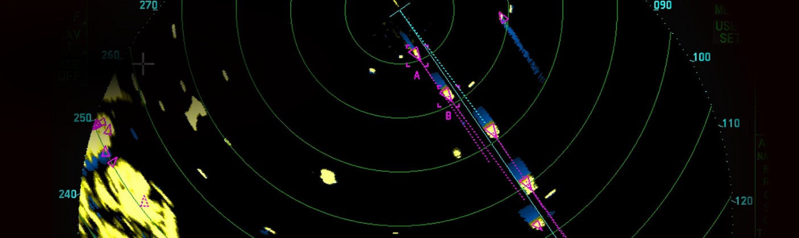

Applications of Radar Technologies

The diverse applications of radar technology will be highlighted, showcasing its impact across various sectors. In military and defense, attendees will gain an understanding of how radar systems contribute to advancements in target tracking and threat detection. The segment on weather monitoring and forecasting will emphasize the pivotal role radar plays in providing accurate and timely weather information. The aerospace and aviation discussion will explore the integration of radar into air traffic control and collision avoidance systems, ensuring safety and efficiency in the skies. The session on autonomous vehicles and smart cities will demonstrate how radar technology is instrumental in creating secure and intelligent transportation systems, contributing to the development of futuristic urban environments. Participants will leave with a comprehensive appreciation of radar's real-world applications and its transformative influence on multiple industries.
Challenges and Solutions

This segment addresses the practical challenges encountered in the deployment of radar systems. Signal processing challenges, including noise reduction and target discrimination, will be thoroughly examined. The discussion on mitigating interference and noise will offer participants practical strategies to ensure the robust performance of radar systems in complex and dynamic environments. Strategies to enhance radar resolution and accuracy will be explored, featuring the latest advancements in signal processing algorithms and technologies. By the end of this segment, participants will be well-equipped with insights into overcoming the hurdles associated with radar deployment, ensuring optimal functionality in a variety of operational scenarios.

Future Trends and Innovations

Quantum radar technology will be explored, presenting the potential to revolutionize sensing capabilities. The integration of 6G communication networks with radar systems will be discussed, highlighting the synergy between communication and sensing technologies. Miniaturization and portable radar systems will be showcased as a trend, making radar technology more adaptable and accessible. The session on green radar technology and sustainability will underscore the importance of environmentally friendly practices in radar system development. Participants will leave with a glimpse into the exciting possibilities and challenges that lie ahead in the future of radar technology.

Points to remember

- Radar systems use electromagnetic waves, specifically radio waves, for their operation. These waves are a form of energy that travels at the speed of light.
- Radar waves can have different frequencies and wavelengths. The choice of frequency depends on the application, with higher frequencies providing better resolution but shorter range and vice versa.
- Radar typically operates in the microwave part of the electromagnetic spectrum, with frequencies ranging from a few megahertz to several gigahertz.
- Radar waves propagate through free space, following the straight-line path known as line-of-sight. The radar range is limited by the curvature of the Earth.
- Radar waves can interact with objects in the environment. They may be reflected, refracted, or diffracted depending on the properties of the materials encountered. Reflection is the primary mechanism for target detection.
- Some materials absorb radar waves, causing attenuation. Rain, atmospheric gases, and foliage can absorb or scatter radar waves, affecting the performance of the radar system.
- The Doppler Effect is utilized in radar to determine the velocity of a target. It results from the change in frequency (or wavelength) of the radar signal due to the motion of the target relative to the radar system.

