COMPONENTS OF THE RADAR SYSTEM

A maritime radar system is a critical technology used for navigation, collision avoidance, and situational awareness at sea. The system comprises several key components, each playing a specific role in the overall functionality. Here are the main components of a typical maritime radar system:
- Antenna:
  - Parabolic Reflector: The radar antenna typically consists of a parabolic reflector, which focuses the radar energy into a directed beam. The size of the antenna influences the radar's resolution and range.
- Transmitter:
  - Magnetron or Klystron: The transmitter generates the radar pulses. Magnetrons or klystrons are commonly used to produce high-power microwave pulses. The frequency of the pulses depends on the type of radar system.
- Duplexer:
  - Switching Device: The duplexer is responsible for alternating the radar system between transmitting and receiving modes. It ensures that the radar antenna is not damaged by the high-power pulses it transmits.
- Receiver:
  - Low Noise Amplifier (LNA): The receiver amplifies the weak echo signals reflected from targets. LNAs help to boost the received signals while minimizing added noise.
  - Mixer: The mixer combines the received signal with a portion of the transmitted signal to generate an intermediate frequency (IF) signal.
  - Signal Processor: The signal processor analyzes the IF signal to extract information about the targets, such as their range, bearing, and velocity.
- Display System:
  - Radar Display: The display system presents the radar information to the operator. Modern radar displays are often integrated with electronic chart systems (ECS) to provide a comprehensive view of the maritime environment.
  - Control Unit: Operators use the control unit to adjust radar settings, such as range, gain, and display modes.
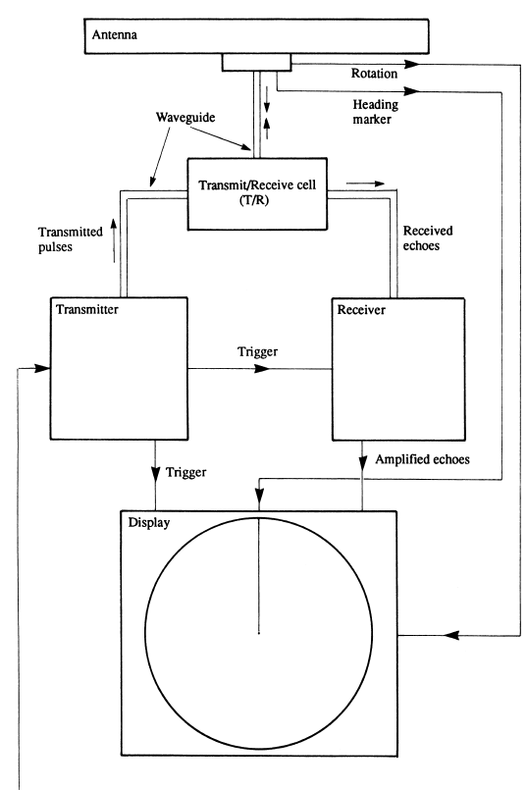
- Power Supply:
  - Power Amplifier: The power amplifier boosts the signal generated by the transmitter to a level suitable for transmission.
- Data Interface:
  - Networking Interfaces: Radar systems may have interfaces to share data with other navigation and communication systems on the vessel, contributing to integrated bridge systems.
- Scanner:
  - Rotating or Fixed Array: The scanner moves the radar antenna, scanning the surrounding area. It can be a rotating antenna for 360-degree coverage or a fixed array for sector scanning.
- Automatic Radar Plotting Aid (ARPA):
  - Target Tracking System: Some radar systems feature ARPA, which automatically tracks and predicts the movement of targets, providing additional information to the operator.
These components work together to emit radar pulses, receive echoes, process signals, and present information on a display, enabling mariners to navigate safely and avoid collisions in various maritime conditions.

Points to remember

- Antenna: The parabolic reflector is a curved dish that reflects radar waves to a focal point.
Its shape helps focus the emitted radar energy into a directed beam, enhancing the system's range and resolution. Larger antennas generally provide better resolution and longer range capabilities.
- Transmitter: Magnetron or Klystron: The transmitter is responsible for generating high-power radar pulses. Magnetrons and klystrons are types of vacuum tubes used to produce and amplify microwave signals. They play a critical role in determining the frequency and power of the radar pulses.
- Duplexer: Switching Device: The duplexer is a crucial component that alternates the radar system between transmission and reception modes. It ensures that the high-power pulses generated by the transmitter do not damage the sensitive receiving components of the radar system.
- Receiver: Low Noise Amplifier (LNA): The LNA is part of the receiver and amplifies weak signals received by the antenna. It minimizes additional noise to improve the signal-to-noise ratio.
- Mixer: The mixer combines the received signal with a portion of the transmitted signal to create an intermediate frequency (IF) signal. This process enables the extraction of information from the received echoes.
- Signal Processor: The signal processor analyzes the IF signal, extracting valuable information about the targets, including range, bearing, and velocity.
- Display System: Radar Display: The radar display visually presents information about the surrounding maritime environment.
It may include features such as range scales, target symbols, and alarms for collision avoidance.
- Control Unit: The control unit allows the operator to adjust various radar settings, including range, gain, and display modes.
- Power Amplifier: The power amplifier increases the strength of the signal generated by the transmitter to a level suitable for transmission over long distances.
- Data Interface: Networking Interfaces: Radar systems often have interfaces to share data with other navigation and communication systems on the vessel. Integration with electronic chart systems enhances overall situational awareness.
- Scanner: Rotating or Fixed Array: The scanner is responsible for moving the radar antenna to scan the surrounding area. It can be a rotating antenna for a full 360-degree coverage or a fixed array for sector scanning.

