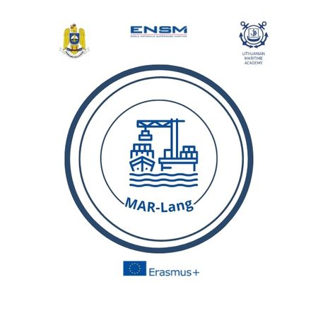
APPLICATION FORM

For attending the A4.2 Short term joint STUDENTS training events
MAR-Lang project
Constanta, ROMANIA, April 08th – 12th, 2024
COUNTRY
UNIVERSITY
POC:
Email:
Phone number
Attendees:
1 | Military / Civilian |  | Rank/Title |  |  | Sex |  | Date of birth  DD/MM/YY |  |  | ID/Passport  number
 | M C |  |  |  |  | F M
 | Name (first / last)
2 | Military / Civilian |  | Rank/Title |  |  | Sex |  | Date of birth  DD/MM/YY |  |  | ID/Passport  number
 | M C |  |  |  |  | F M
 | Name (first / last)
ITINERARY*
3 | Military / Civilian |  | Rank/Title |  |  | Sex |  | Date of birth  DD/MM/YY |  |  | ID/Passport  number
 | M C |  |  |  |  | F M
 | Name (first / last)
ITINERARY*
Arrival |  | Plane Bus Personal Car Other
Date / Hour |  |  |  |  |  |  | Flight no.
Airport |  |  |  |  |  |  | Airport transfer |  | YES NO
Departure |  | Plane Bus Personal Car Other
Date / Hour |  |  |  |  |  |  | Flight no.
Airport |  |  |  |  |  |  | Airport transfer |  | YES NO
ACCOMMODATION FORM**
07/04/2024 to 08/04/2024 |  |  |  | YES NO |  |  | Number of rooms |  |  | The students may apply for accomodation in the RNA hostel, but not obligatory,  They can also choose, on their expense, the following alternatives:  https://lira-pacific.ro  https://hoteloxford.ro  https://carolhotel.ro
08/04/2024 to 09/04/2024 |  |  |  | YES NO |  |  | Number of rooms
09/04/2024 to 10/04/2024 |  |  |  | YES NO |  |  | Number of rooms
10/04/2024 to 11/04/2024 |  |  |  | YES NO |  |  | Number of rooms
11/04/2024 to 12/04/2024 |  |  |  | YES NO |  |  | Number of rooms
SPECIAL REQUESTS & QUESTIONS (please include any food restrictions)
The lunches for students/teachers will be provided in the RNA messhall – please mention if any dietary restrictions.

Notes: *The participants are recommended to arrive to Bucharest (via Henri Coandă International Airport – Otopeni – IATA code BUH/OTP) or Constanța (via Mihail Kogălniceanu International Airport Constanța). For shuttle transfer Bucharest – Constanța, the participants are recommended to book the transfer online, on next link: https://alt-transportpersoane.ro/eng.

