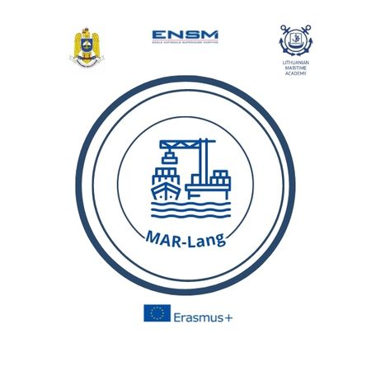

Le Havre, 18th of January, 2023

Dear Partners,

MAR-Lang is a cooperation partnership in higher education on Linguistic Diversity in European Maritime Higher Education Institutions. This project has received the European Union support through Erasmus + Key Action 2.

I am pleased to invite you for the launch day of the project on the 2nd of February, 2023, in Le Havre, France.

For administrative purposes, please find attached the registration form to be submitted no later than January 27th. The Point of Contact (POC) for the registration process and for further administrative guidance is Gersende Le Dimna who can be reached by e-mail at: gersende.le-dimna@supmartime.fr.

Yours faithfully,
François LAMBERT
ENSM Managing Director
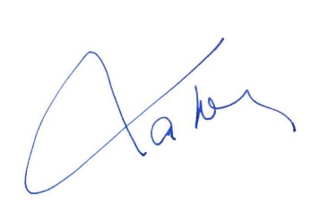

APPLICATION FORM
For attending the first meeting of MAR-Lang project
Le Havre, FRANCE, 2nd. Feb. 2023
COUNTRY
UNIVERSITY
POC:
Email:
Phone number
Attendees:
1 | Military / Civilian |  | Rank/Title |  |  | Sex |  | Date of birth  DD/MM/YY |  |  | ID/Passport  number
 | M C |  |  |  |  | F M
 | Name (first / last)
2 | Military / Civilian |  | Rank/Title |  |  | Sex |  | Date of birth  DD/MM/YY |  |  | ID/Passport  number
 | M C |  |  |  |  | F M
 | Name (first / last)
ITINERARY
Arrival |  | Plane Bus Personal Car Other
Date / Hour |  |  |  |  |  |  | Flight no.
Airport |  |  |  |  |  |  | Airport transfer |  | YES NO
Departure |  | Plane Bus Personal Car Other
Date / Hour |  |  |  |  |  |  | Flight no.
Airport |  |  |  |  |  |  | Airport transfer |  | YES NO
ACCOMMODATION FORM
01/02/2023 to 03/02/2023 |  |  |  | YES NO |  |  | Number of rooms
01/02/2023 to  03/02/2023 |  |  |  | YES NO |  |  | Number of rooms
SPECIAL REQUESTS & QUESTIONS (please include any food restrictions)

