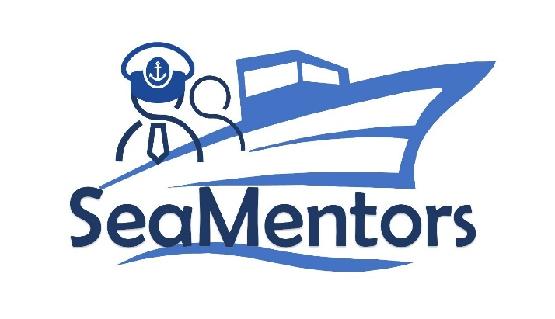

SEA MENTORS
SEAfarers Experiential Knowledge Based MENTORS Project number: KA220-VET-93A876D8

PROJECT JOURNAL
for SEA MENTORS

, 2022

Author:

Revision History [not for public deliverables]
Date | Version | Author | Changes
../../2022 | 1.0

Current version: 1.0

Project Details:

Title: SEA MENTORS – SEAfarers Experiential Knowledge Based MENTORS
Acronym: SEA MENTORS
Start Date: 01-11-2021
End Date: 01-11-2023
Coordinator: Mircea cel Batran Naval Academy

SEA MENTORS Consortium

This document is part of SEA MENTORS project, funded with support from the European Commission within the framework of "Erasmus+ Programme" approved by the Agentia Nationala pentru Programe Comunitare in Domeniul Educatiei si Formarii Profesionale, project number KA220-VET-93A876D8.
The following partners are involved in the SEA MENTORS project:

- Mircea cel Batran Naval Academy (Contractor) – www.anmb.ro

- Maritime Innovators (Turkey) - www.maritimeinnovators.com

- Lithuanian Maritime Academy (Lithuania) – http://www.lajm.lt

- Polish Naval Academy (Poland) – www.amw.gdynia.pl

- SPINAKER Proizvodnja Trgovina In Trzenje Doo (Slovenia) – www.spinaker.si

- NVNA (Bulgaria) – www.naval-acad.bg

Project Journal participants

The following participants from the project partners have taken an active part in the work leading to the elaboration of this document, even if they might not have directly contributed writing parts of this document:

- Catalin POPA (MBNA)
- Uğurcan Acar (MARITIME INNOVATORS)
- Indre Mickeviciute (LMA)
- Artur Bogdanowicz (PNA)
- Tomaž Gregorič (Spinaker)
- Kalin Kalinov (NVNA)

Executive Summary

RO01 - Agentia Nationala pentru Programe Comunitare in Domeniul Educatiei si Formarii Profesionale
Title: "SEAfarers Experiential Knowledge Based MENTORS (SEA MENTORS)"
Duration: 24 months (01/11/2021 - 01/11/2023)
Online Project Journal (A9) available in Drive will include chronological records that will organise and save information that might otherwise be lost or misplaced; to assure historical information is always available for the reference of management and partners; as an aid when compiling the interim (D4) and final project reports (A6); and to reduce conflicts and misunderstandings.
MARITIME INNOVATORS will keep the Online Project Journal (A9) that is coordinated on a rotational basis and which will be available as an information source to all partners.

Contents
SEA MENTORS Consortium 3
Project Journal participants 4
Executive Summary 5
Month 1 – February 2022 7
Month 2 - March 2022 7
Month 3 - April 2022 7
Month 4 - May 20222 7
Month 5 - June 2022 7
Month 6 - July 2022 7
Month 7 - August 2022 7
Month 8 - September 2022 7
Month 9 - October 2022 7
Month 10 – December 2022 7
Month 11 – November 2022 7
Month 12 – January 2023 7
Month 13 – February 2023 7
Month 14 - March 2023 7
Month 15 - April 2023 7
Month 16 - May 2023 7
Month 17 - June 2023 7
Month 18 - July 2023 7
Month 19 - August 2023 7
Month 20 - September 2023 7
Month 21 - October 2023 7
Month 22 – December 2023 7
Month 23 – November 2023 7
Month 24 – January 2024 7

Month 1 – February 2022

Month 2 - March 2022

Month 3 - April 2022

Month 4 - May 20222

Month 5 - June 2022

Month 6 - July 2022

Month 7 - August 2022

Month 8 - September 2022

Month 9 - October 2022

Month 10 – December 2022

Month 11 – November 2022

Month 12 – January 2023

Month 13 – February 2023

Month 14 - March 2023

Month 15 - April 2023

Month 16 - May 2023

Month 17 - June 2023

Month 18 - July 2023

Month 19 - August 2023

Month 20 - September 2023

Month 21 - October 2023

Month 22 – December 2023

Month 23 – November 2023

Month 24 – January 2024

