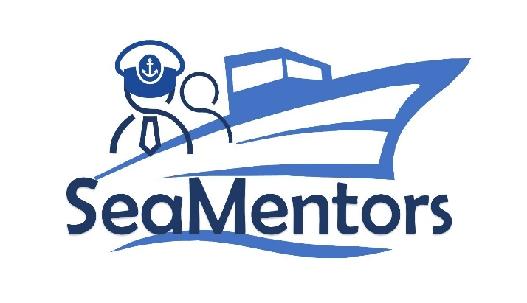

SEA MENTORS
SEAfarers Experiential Knowledge Based MENTORS Project number: KA220-VET-93A876D8

Document Title
Document subtitle

[Month] [Year]

Author:

Revision History [not for public deliverables]
Date | Version | Author | Changes

Current version: XX

Project Details:

Title: SEA MENTORS – SEAfarers Experiential Knowledge Based MENTORS
Acronym: SEA MENTORS
Start Date: 01-11-2021
End Date: 01-11-2023
Coordinator: Mircea cel Batran Naval Academy

Contents
Introduction 4
Short description 4
Objective 4
Learning Outcomes 4
[Activity title] 4
[Unit title] 4
[Subunit title] 4
Conclusion 4

Introduction

Short description
xxxxxxxxxx

Objective
xxxxxxxxx

Learning Outcomes
By the end of this activity, you should know:
- Xxx
- Xxx
- Xxx

[Activity title]

Module X, Unite X, Level XX

[Unit title]

Xxxxxxxx

[Subunit title]

Xxxxxxxxx

Conclusion

xxxxxxxxxx

