KA220-VET - Cooperation partnerships in vocational education and training
2023-1-RO01-KA220-VET-000156711

MARitime Soft Skills for Onboard Healthy Nutrition and CULinary Arts in Seagoing Services – CUL-MAR-Skills

ONBOARD TRAINING NUTRITION
Knife Skills and Food Preparation Techniques

  - AUTHORS: VASILIKI BOUNTZIOUKA
  - ANTONIOS KOUTELIDAKIS

2024

BLANK PAGE

FOREWORD
The Knife Skills and Food Preparation Techniques module provides comprehensive training in essential knife skills, efficient food preparation methods, and the safe handling of kitchen equipment. Learners will develop the foundational skills needed to ensure high standards of food safety, creativity, and efficiency in the galley, including selection of appropriate knives for various tasks, efficient food preparation while adhering to high safety standards, creation of nutritious meals with minimal resources and time, and safely kitchen operations.
This course is designed to provide galley staff with practical knowledge and hands-on skills essential for operating in compact and high-demand kitchen environments. By focusing on fundamental knife techniques, efficient preparation methods, and the safe use of kitchen equipment, this course empowers learners to optimize both food quality and safety. Main topics covered include:
- Introduction to knife skills and cutting techniques: Learn about basic knife types and their uses, different cutting techniques (i.e., chopping, slicing, dicing, and mincing), and knife safety and maintenance.
- Efficient food preparation methods: Learn about various healthy cooking techniques (i.e., steaming, grilling, roasting, and sautéing), flavour enhancement strategies using herbs, spices, and marinades, and time management and batch cooking.
- Safe handling of kitchen equipment: What are the common kitchen appliances, including their proper use and maintenance, how to maintain electrical safety and prevention of hazards, and how to handle hot or sharp equipment with a focus on fire safety.
The course is structured with interactive presentations, case studies, quizzes, and real-world scenarios to reinforce learning and encourage practical application of the concepts.

Contents
1. INTRODUCTION TO KNIFE SKILLS AND CUTTING TECHNIQUES 9
1.1 Basic knife types 9
1.2 Essential cutting techniques 10
1.3 Knife Safety and Maintenance 11
2. EFFICIENT FOOD PREPARATION METHODS FOR HEALTHY CUISINE 11
2.1 Healthy Cooking Techniques 11
2.2 Flavour Enhancement 11
2.3 Time Management 11
3. SAFE HANDLING OF KITCHEN EQUIPMENT 12
3.1 Common Kitchen Equipment 12
3.2 Electrical Safety 12
3.3 Handling Hot or Sharp Equipment 12
4. SUMMARY AND BEST PRACTICES 12
4.1 Key takeaways for knife skills 12
4.2 Best practices for knife skills and food preparation 13

INTRODUCTION TO KNIFE SKILLS AND CUTTING TECHNIQUES

LEARNING OBJECTIVES
By the end of this module, learners will be able to:
- Identify and use different types of knives effectively for specific tasks.
- Perform essential cutting techniques with precision, consistency, and safety.
- Practice proper knife care, including storage and sharpening, to maintain efficiency and longevity.
- Select and utilize healthy cooking techniques that retain nutrients and enhance flavor.
- Integrate herbs, spices, and marinades to create balanced, flavorful meals.
- Implement time-saving strategies like batch cooking and meal planning to streamline workflow.
- Operate common kitchen appliances safely, adhering to maintenance guidelines.
- Follow best practices for electrical safety to prevent accidents.
- Manage fire safety and handle hot or sharp equipment confidently in high-pressure situations.

Basic knife types
Knives are essential tools in any kitchen, and mastering their use is fundamental for efficient and safe food preparation. Understanding and utilizing the right knife for the job enhances precision and safety in food preparation. Basic knife types are:
- Bread knife: Otherwise called serrated knife, is used to slice breads of all varieties, or torting cake layers, or cutting a tomato without losing any juices. Is used in a back-and-forth sawing motion and allows the knife to tear through the crust of a loaf without crushing it, preserving its texture.
- Boning knife: Is used for removing bones and other similar tasks such as breaking down chicken and other poultry, separating cartilage and trimming fat from meat, or sectioning fruit and vegetables.
- Carving knife: Is suitable for cutting precise slices or pieces for different types of meat or fish. They are often used with a carving fork to assist in slicing meat pieces easily.
- Chef’s knife: An essential tool for any kitchen, used for almost any kitchen task. Is suitable for cutting meat, fish and vegetables and chopping herbs. The chef’s knife is slightly curved, which promotes the rocking method to finely and quickly chop the ingredients.
- Cleaver: Is used for chopping large cuts of meat, cutting pork ribs, or mince meat. Beyond cutting meat, a cleaver can be used to crush garlic, ginger, toasted spices, and other aromatics; as well as split open tough vegetables like pumpkin or squash. It has a stable and broad rectangular blade.
- Paring knife: Is small, short, and has a razor-sharp blade. A paring knife is ideal for small kitchen tasks that require precision, like segmenting citrus, peeling fruit, coring vegetables, and mincing herbs.
- Utility knife: Otherwise known as all-purpose knife, it can be used for almost any task in the kitchen. It has a serrated edge, which makes it ideal for cutting smaller ingredients, for which that a larger serrated bread knife may be too big for. It is best suited for cutting fruit and vegetables, but also rolls and cold meat.
Basic knife types are shown in Figure 1.
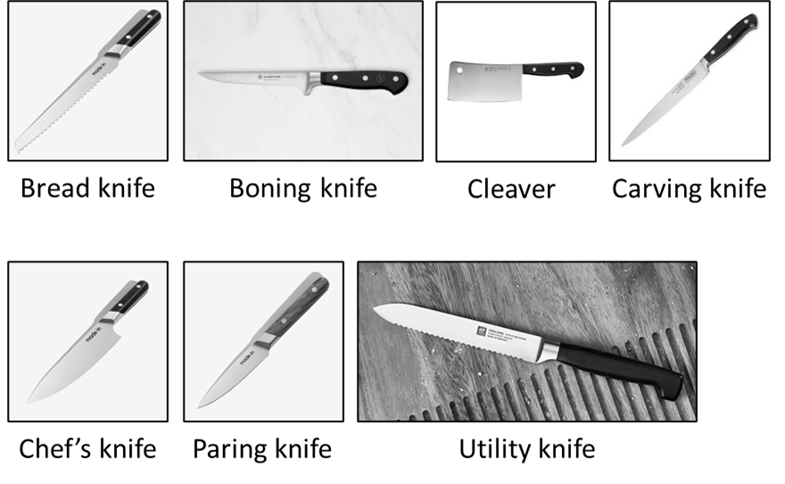
Figure 1 Basic knife types.

Essential cutting techniques
To prevent accidents knives should be hold firmly by their handle, kept sharp and always use the right knife for the job. Mastering cutting techniques ensures consistency, enhances presentation, and saves time. Use the “pinch grip” technique for control (Figure 2). Pinch the blade at its base with thumb and forefinger while wrapping other fingers around the handle.
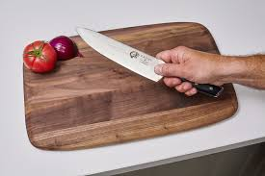
Figure 2 The pinch grip technique.

Cuts should be precise and consistent. Always watch your fingers. Consider wearing a glove for cutting. Essential cutting techniques are:
- Chopping: Quick and uniform cuts, ideal for herbs and vegetables.
- Slicing: Precise thin cuts for delicate ingredients like fish or tomatoes.
- Dicing: Produces uniform cubes, often used for soups or salads.
- Mincing: Fine chopping, suitable for garlic or ginger.
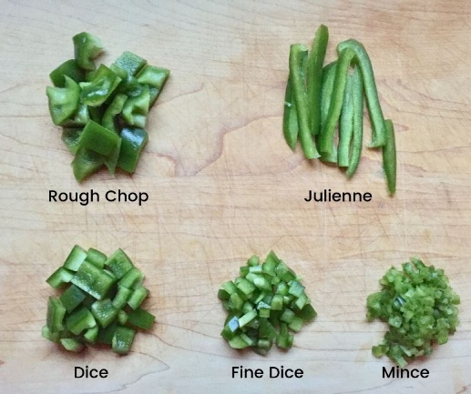
Figure 3 Essential cutting techniques.

Knife Safety and Maintenance
Proper care and handling of knives not only prevent injuries but also extend their lifespan.
- Handling: Always carry knives with the blade pointed downward. Avoid leaving knives in sinks or under clutter where they may cause cuts.
- Storage: Use a knife block, magnetic strip, or blade guards to keep knives safe and accessible.
- Maintenance: Sharpen knives regularly to ensure smooth cutting and reduce risks of slipping. Clean and dry knives immediately after use to prevent rust.
- Common Accidents and Prevention: Cuts often result from using dull blades. It is therefore crucial to maintain sharpness. Secure cutting boards with a damp cloth underneath to prevent slipping.

EFFICIENT FOOD PREPARATION METHODS FOR HEALTHY CUISINE

Efficient and creative food preparation contributes to healthy eating while saving time and resources.

Healthy Cooking Techniques
Cooking methods significantly impact the nutritional value and taste of food. Basic cooking techniques include:
- Steaming: Preserves nutrients and moisture, ideal for vegetables and seafood.
- Grilling: Adds flavour through char and reduces excess fat.
- Roasting: Creates caramelized textures while maintaining nutrients in meats and vegetables.
- Sautéing: Quick cooking with minimal fat, enhancing the natural taste of food.

These methods help retain nutrients, minimize added fats, and enhance natural flavours.

Flavour Enhancement
Healthy cuisine does not compromise on flavour. It focuses on enhancing natural tastes. Simple means to enhance flavour are to:
- use herbs like basil, cilantro, and rosemary to add aroma and freshness,
- add spices like cumin, paprika, or turmeric for depth and complexity,
- incorporate acidity from lemon juice or vinegar to brighten flavours,
- create texture contrasts using nuts, seeds, or crispy vegetables,
- marinate ingredients to infuse bold and layered flavours.

Time Management
Efficient preparation ensures smooth workflow in a professional kitchen or galley.
- Meal Planning: Plan menus in advance to streamline preparation. Balance proteins, vegetables, and grains for variety and nutrition.
- Batch Cooking: Prepare large quantities of food to save time over multiple meals.
- Prepping Techniques: Chop, portion, and label ingredients ahead of time. Store prepped items in airtight containers for freshness.

SAFE HANDLING OF KITCHEN EQUIPMENT
Understanding kitchen equipment and their safe use is vital to maintaining a hazard-free cooking environment.

Common Kitchen Equipment
Proper use and maintenance of appliances prevent accidents and improve kitchen efficiency.
- Stove and Oven: Regularly clean surfaces to avoid grease build-up. Check for proper functionality to avoid gas leaks or overheating.
- Blender and Food Processor: Secure all parts before use to prevent accidents. Avoid overloading to protect the motor.
- Maintenance Tips: Clean equipment immediately after use. Inspect for damage and replace worn-out parts promptly.

Electrical Safety
Safe electrical practices reduce risks of shocks and fires.
- Precautions: Avoid overloading power outlets. Keep cords and plugs dry at all times.
- Inspection: Regularly check electrical cords for fraying or damage. Replace faulty equipment immediately.
- Unplug Appliances: Disconnect appliances when not in use to prevent hazards.

Handling Hot or Sharp Equipment
Proper handling of high-risk tools and appliances safeguards the galley and its staff.
- Fire Safety: Keep fire extinguishers accessible and ensure all staff knows their location and use. Never leave cooking unattended.
- Hot Equipment: Use oven mitts or heat-resistant gloves. Let hot equipment cool before cleaning or storing.
- Sharp Tools: Use the appropriate tool for each task to avoid injuries. Focus on safety by maintaining sharp blades and stable surfaces.

SUMMARY AND BEST PRACTICES
This module has provided a comprehensive overview of the basic knife types and cutting techniques.

Mastering knife skills and food preparation techniques is essential for ensuring safety, efficiency, and creativity in the kitchen. From selecting the right knife for specific tasks to maintaining proper cutting techniques, these skills contribute to both the quality and presentation of meals. Employing healthy cooking methods such as steaming or grilling, enhancing flavors with natural ingredients, and practicing effective time management are vital for preparing nutritious and appealing dishes. Safe handling of kitchen equipment, adherence to electrical safety measures, and maintaining a fire safety plan are critical for minimizing risks and fostering a secure galley environment. Consistently applying these best practices promotes professionalism and ensures the safety and satisfaction of all involved.

Key takeaways for knife skills
- Knife Skills: Choose the correct knife for each task and prioritize safety through proper handling, grip, and maintenance.
- Healthy Cooking: Embrace techniques that preserve nutrients while enhancing flavor naturally.
- Efficiency: Plan meals, batch-cook where possible, and optimize preparation workflows.
- Safety First: Maintain a secure environment by adhering to equipment safety protocols and keeping a fire safety plan in place.
- Continuous Improvement: Regularly refine your skills and stay up-to-date on best practices to enhance your culinary expertise.

Best practices for knife skills and food preparation
- Choose the Right Knife for the Task: Use specialized knives (e.g., chef's knife for chopping, paring knife for peeling) to enhance efficiency and precision.
- Maintain a Proper Grip: Hold the knife with a firm grip for better control. Position the other hand in a “claw” shape to protect fingers while cutting.
- Keep Knives Sharp: Regularly sharpen knives to reduce the risk of accidents caused by dull blades. Use a sharpening stone or honing steel correctly.
- Safe Knife Handling: Always cut on a stable, non-slip cutting board. Avoid cutting directly on countertops or glass surfaces. Pass knives safely by placing them on a flat surface and letting others pick them up.
- Proper Storage: Store knives in designated racks, magnetic strips, or protective sheaths to prevent damage and accidental injuries.
- Practice Essential Techniques: Master basic cuts (e.g., slicing, dicing, julienne) for precision and consistency in food preparation.
- Follow Sanitation Protocols: Wash hands before handling food and between tasks to prevent cross-contamination. Use separate cutting boards for raw and cooked foods.
- Organize Ingredients (Mise en Place): Prepare and measure all ingredients in advance for smooth workflow and accurate recipes.
- Use Healthy Cooking Techniques: Opt for methods like steaming, grilling, or roasting to preserve nutrients and enhance flavors. Minimize the use of unhealthy fats and instead rely on herbs, spices, and natural marinades for flavor.
- Ensure Proper Cooking Temperatures: Use a food thermometer to verify that dishes reach safe internal temperatures. Avoid overcooking to retain texture and nutrients.
- Prioritize Efficiency: Group similar tasks together, such as chopping all vegetables at once. Use tools like mandolines or food processors to save time.
- Maintain a Clean Workspace: Clean as you go to avoid clutter and reduce the risk of contamination. Dispose of waste promptly and sanitize surfaces after completing tasks.

REFERENCES
- The Culinary Institute of America. The Professional Chef. 10th edition. Willey (2024).
- Lumb M. Kitchen Knife Skills. Apple Press; UK ed. edition (2009).
- Dornenburg A, Page K. Culinary Artistry. 1st ed. Willey (1996).

