WEEK 1 - INTRODUCTION TO MARITIME NUTRITION
This chapter focuses on
- Introduction to the syllabus and course objectives,
- Overview of maritime nutrition and the role of meal planning on board ships,
- Understanding the importance of providing nutritious and balanced meals at sea.
By the end of this course, the participants will be able to:
- Understand the nutritional requirements specific to seafarers, including macro- and micronutrients essential for health and endurance at sea.
- Identify and address common nutritional deficiencies and health issues that may arise in the seafaring population.
- Develop balanced meal plans that can be implemented on board, considering limitations in food storage, preparation facilities, and available ingredients.
- Promote best practices for food safety, storage, and handling in maritime settings to prevent spoilage and foodborne illnesses.
- Advocate for the importance of nutrition in fostering a healthy and safe environment on board.
1. Introduction to the syllabus and course objectives.
This is a course focused on the proper nutrition of seafarers, so the syllabus introduction emphasizes the importance of nutrition for seafarers' health, safety, and performance in the demanding environment of life at sea. The introduction and outline of the course objectives are given below:
Syllabus Introduction
This course will explore the vital role that nutrition plays in maintaining the health, energy, and well-being of seafarers. Working at sea presents unique physical and mental challenges, from long hours and physical labor to isolation and limited access to fresh foods. Proper nutrition is essential for sustaining energy, preventing illness, and enhancing overall safety and performance on board.
Course Overview
This course provides an in-depth look at the nutritional needs of seafarers and the practical ways to meet them. During the course, the specific dietary requirements for those working on ships, common nutrition-related health issues faced by seafarers, and best practices for meal planning and food storage in a maritime setting will be studied. There will also be parts focusing on victualling, blue skills, entrepreneurship, and sustainability onboard. Through interactive lessons, case studies, and practical assignments, the students will gain the knowledge and skills needed to ensure proper nutrition for themselves or crew members in challenging maritime conditions.
Course Policies and Expectations
Active participation is encouraged, as there will be discussions and group activities that allow the participants to apply what they learn in real-world scenarios. The course will be a mix of lectures, discussions, and hands-on projects through case studies. The grade will be based on participation, assignments, case studies, and a final project where you will create a comprehensive nutrition plan for a specific type of seafaring vessel.
Support Resources
Supplemental resources and recommended readings are available on the course portal to help deepen your understanding.
Key Elements for the Syllabus Introduction
1. Relevance to Seafaring: Why nutrition is particularly important for seafarers, given the unique challenges of life on board a ship, like limited access to fresh foods and physical demands.
2. Hands-on Learning: Practical assignments, such as creating meal plans or analyzing case studies on seafarer health, will help students apply what they’re learning.
3. Outcome-Oriented Objectives: What skills or knowledge students will gain, focusing on practical outcomes like meal planning, understanding nutrient needs, and addressing food safety?
4. Support and Inclusivity: A supportive classroom environment and the real-world impact this knowledge can have on seafarers' health and performance.
Through these activities, the participants will see the direct relevance of their learning and feel motivated to apply it to real-world maritime challenges.

2. Overview of maritime nutrition and the role of meal planning on board ships.
2.1. Overview of maritime nutrition
Seafarers need to take care of their physical and mental health both on land and at sea and take preventive measures to stay healthy in the long term. Good health is a prerequisite for being an efficient seafarer. One of the factors that makes life on board difficult for seafarers, who are deprived of many of the conveniences of living on land, is the lack of access to a hospital or doctor whenever needed.
Since it is vital for seafarers to look after their health and wellbeing at sea and ashore they have to take many issues more seriously than those working on land. One of these issues is a healthy diet. They should make healthy, nutritious food choices and ensure a balanced diet consisting of carbohydrates, protein, fat and fiber, vitamins, and minerals with minimum salt, fat, and sugar levels. Proper nutrition, adequate rest and sleep, regular exercise, and good hygiene help prevent diseases and improve health overall. Access to healthy food options and variation are cornerstones of healthy food onboard.
Many people may not know the difference between “eating” and “eating healthy”, or they may not fulfill the requirements of a healthy diet for various reasons. In this case, these people can be reminded of the importance and rules of healthy eating with some stimuli from the environment. In a ship environment, these stimuli can take the following forms:
- Encouraging and stimulating the crew members to eat healthily.
- Offering variation in food
- Acting as role models on board, especially captains and officers setting an example in terms of dietary habits
- Providing healthy drinks and snacks.
- Providing information (posters or leaflets) on healthy food in every place where food is available onboard.
- Giving crew members the possibility to suggest and try new recipes.
- Ensuring that the menu consists of healthy and balanced meals for seafarers
- Being patient since behavioral changes take several months and benefits may take even longer to become measurable.
- Making wholesome food choices and maintaining a balanced diet with minimal amounts of salt, fat, and sugar and a good mix of carbs, protein, fat, fiber, vitamins, and minerals.
A healthy diet, enough sleep and rest, frequent exercise, and proper hygiene all contribute to illness prevention and general health improvement. The foundations of healthy food onboard are variety and accessibility to healthy food options.
There are a few things that seafarers should be aware of. Meals must include enough carbs, the proper quantity of fats for energy, and enough proteins to build and repair bodily tissues. They must also provide enough minerals to strengthen bodily tissues. Vitamins and antioxidants are also necessary to maintain the proper functioning of the body. Importantly, drinking water of high quality must be consumed. Crucially good quality drinking water needs to be drunk in large quantities, at least 1,5 liters per day.

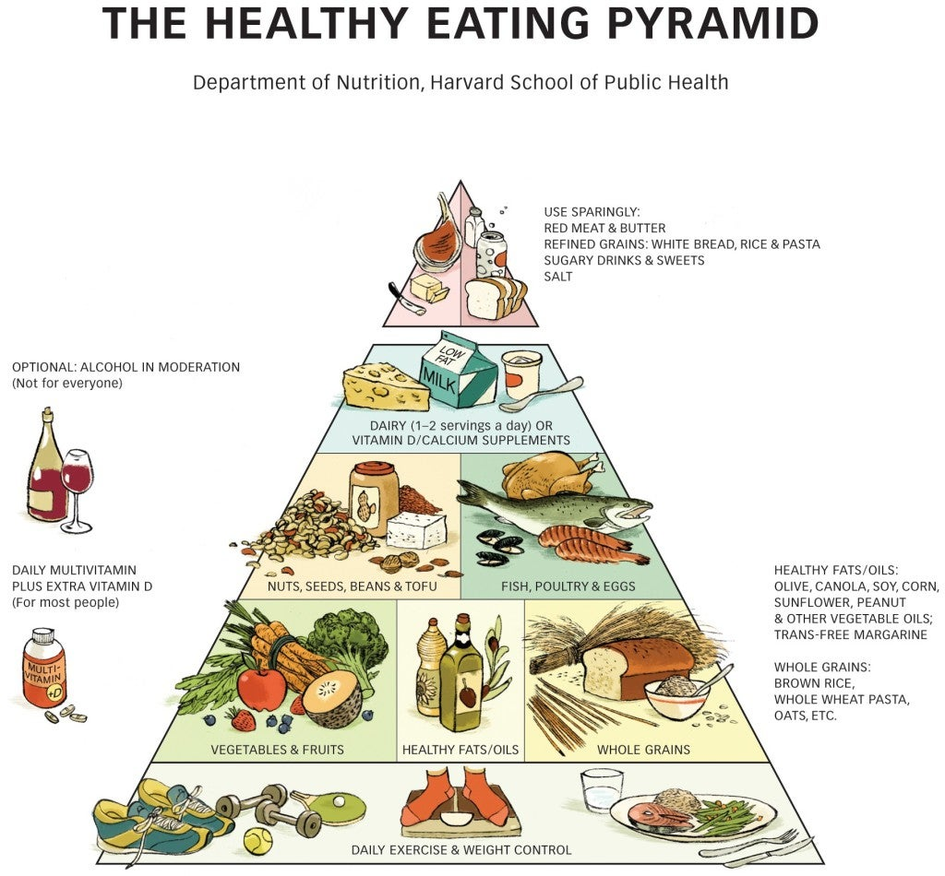
https://nutritionsource.hsph.harvard.edu/healthy-eating-pyramid/
There should be sufficient protein for the formation and repair of body tissues, an adequate supply of minerals to reinforce body tissues, sufficient carbohydrates the right amount of fats for energy, and vitamins to keep the brain, nerves, and other vital organs functioning.
Seafarers should eat a variety of foods or a varied diet, balance is the key message, eat plenty of fruit (3 servings/day), vegetables (300 g / day), and potatoes (3-5 / day): choose more dark green and bright colored vegetables and orange fruits. They should reduce the amount of meat (+/- 100 g / day), fat (< 35%), oil, sugar, and salt they eat and drink plenty of safe drinking water (> 1.5 liters/day or 6 to 8 glasses/day) [1]
Rice, whole grain products, and potatoes
Rice, noodles, bread, pasta, cereals, potatoes, porridge, lontong, chapati, naan, idli, and biscuits are at the base of the pyramid. Complex carbohydrates, vitamins, minerals, and dietary fiber are all abundant in these foods. Five portions per day are advised, with one serving of wholegrain goods ideally included. Every day, the average person consumes 180–300 g of rice, 210–350 g of potatoes (3-5 pieces), and 175–420 g of bread (5–12 slices). When working in shifts, it is preferable to take this group around the conclusion of the shift rather than at the start.
1 serving =
* 1 slice of bread
* ½ Cup (C.) cooked grains, pasta, rice, etc.
* 1 C. of most cold cereals
* ¼ C. low-fat granola, Grape Nuts, Muesli
* ½ C. hot cereals
* 3-4 C. low-fat microwave popcorn
* ½ large fl our tortilla
* 6 saltine crackers
* ½ hamburger roll or small bagel
* ¼ of a large muffin or bagel
* ½ pita
Fruit
This category includes canned, frozen, dried, and fruit liquids, while fresh fruit is preferred. They are abundant in potassium, flavonoids, fiber (apart from fruit juices), and vitamins A and C. Consume two to three servings daily, particularly the ones that are bright or rich in color (yellow, orange).
1 serving =
* 1 piece of medium fruit (e.g., apple, orange, peach)
* ½ piece of large fruit (e.g., banana, grapefruit)
* ½ C. of cooked or dried pieces of fruit
* ½ C. of fruit juice (unsweetened)
Vegetables
This group consists of leafy, non-leafy, cruciferous, and root vegetables. They are rich sources of vitamins A, C, folic acid, minerals such as calcium, iron, potassium, fiber, and phytochemicals. Eat 2 servings a day and include 1 serving daily of dark green or yellow-orange vegetables.
1 serving =
* ½ C. cooked vegetables
* 1 C. vegetable juice
* 1 C. raw vegetables
Meat, fish, and alternatives
This group includes meat, poultry, fish, and seafood. Alternatives are soya, pulses, nuts, and seeds. These foods are excellent sources of protein, iron, and zinc. 100 g per day is sufficient.
1 serving =
* 100 g meat, poultry, or fish. 100 g is about the
size of a deck of cards or the palm of your hand.
* ½ C. cooked beans, legumes or nuts
* 2 eggs or 4 egg whites
Milk, dairy products, and alternatives
These foods are great for getting B vitamins, calcium, and protein. Consume two to three glasses of yogurt or skimmed or half-fat milk each day. Try to have two portions of cheese as well. Keep in mind how much fat these items contain, and wherever you can, try to use low-fat options.
1 serving =
* 250 g or 1 C. of skimmed or half-fat milk or yogurt.
* 50 g hard cheese; lower-fat versions are
recommended (you will need to read the labels)
* ½ C. low-fat cottage cheese
Fats, oil, salt & sugar
Excess fat can result in weight gain and elevated cholesterol levels, despite the fact that it provides energy and contains vital vitamins A, D, E, and K. In order to avoid eating too much fat, it is crucial to monitor how much you consume. Chips, mayonnaise, fat sauces, cream, and other items in this category should only be consumed in small amounts. Consuming a lot of salt can increase blood pressure, which increases the risk of heart disease. Sugar-filled foods and beverages are high in calories but low in nutrients. These foods are a key cause of tooth decay as well.
1 serving =
* 1 teaspoon oil, butter or margarine
* 2 teaspoons Tahini paste
* 1 tablespoon of regular salad dressing
Water
Water is essential to our bodies even though it is not included in this food pyramid and does not provide us with energy. 1.5 liters should be consumed daily under normal conditions. Drinking extra water is essential when engaging in vigorous physical activity and participating in sports in warm regions. If the quality of the drinking water is unknown, it is best to drink it from unopened bottles. Certain forms of mineral water have significant levels of minerals, therefore not everyone can drink them. The secret is variation!
Caffeine-containing products, like tea, coffee, and soft drinks, should not be consumed five hours before bedtime or more than three times during a shift [2].
Healthy Food and Safety
The relationship between exhaustion and dietary deficiencies (iron and vitamin B) is widely established, despite the fact that it is still challenging to quantify the effect of inadequate nutrition on workplace accidents.
Fatigue, loss of dexterity, and decreased productivity are all consequences of iron deficiency.
On board a ship, going without food can make you drowsy.
Low blood sugar, or hypoglycemia, can cause people to pay less attention and process information more slowly. A quick energy boost is provided by snacking on sugary foods and beverages, but the body may feel even more exhausted afterward.
Healthy Food and Shift work
Meals cannot be consumed at "normal" regular times when working shifts. Working shifts can disrupt the regular eating schedule. Bad habits can cause fatigue, stomach issues, and disturbed sleep. Lean meat, salads, and soups are the finest light meals. Eat foods high in protein, such as milk, yogurt, and lean meat, at the start of your shift. Consume carbohydrates such as bread, fruit, whole grains, potato salad, and pasta salad later in the shift.
• Try consuming fewer spicy, fatty, and fried foods as well as sweets. Reduce your coffee consumption and, for a change, try fruit juice.
• Consume light snacks such as a glass of milk, yogurt, or fruit.
• Before the shift begins, have a meal that will provide you adequate energy.
Smoking is unhealthy, as we all know. When you light up, try to cut down and think about other people. When people are eating, never smoke.
Engage in regular exercise, ideally for at least half an hour each day [3].
Eat a warm lunch at midday rather than in the middle of your shift if you work afternoon or nighttime shifts.
Try to have "breakfast" in the late afternoon or early evening if you are working at night. Eat a small snack after work to prevent feeling hungry right before bed.
Caffeine
A natural substance having stimulant properties is caffeine. Coffee, tea, cola, chocolate, guarana, yerba mate, and more than 60 more items include it. Caffeine stimulates the heart, muscles, central nervous system, and blood pressure-regulating regions. Although caffeine can increase blood pressure, regular users may not experience this impact. Additionally, caffeine can behave as a "water pill" to stimulate the flow of urine. Caffeine is most frequently used for mental alertness, headaches, migraines, memory, sports performance, and obesity. In addition, it is used to treat depression, low blood pressure, ADHD, asthma, gallbladder disease, and many other illnesses, but the majority of these additional uses lack solid scientific backing [4]. It also keeps one awake, but this does not lead to better physical performance.
Duty and watchkeeping can raise the consumption of coffee or tea drastically and besides the presumed stimulating effect of caffeine, this also has negative effects. Too much caffeine can cause side effects such as tension (stress), restlessness, trembling, insomnia, headaches, and heart palpitations.
The maximum dose of caffeine is 400 mg per day. Seafarers should try to drink a maximum of 3 cups of coffee or tea per shift.
Breakfast
- Breakfast is the most important meal of the day :
- It gives you a fantastic start to the day, and a nutritious meal gives you 20 to 25 percent of your daily energy.
- Having breakfast enhances focus and agility throughout the morning.
- When people skip breakfast, they typically consume extra snacks and overindulge in a huge, high-fat, high-sugar lunch to make up for the energy loss.
- Bread, grain goods, rice, and pasta are all rich sources of carbohydrates, which make them great energy providers.
- For breakfast, milk and milk products are a good source of protein.
- It is recommended that you eat several portions of fruit every day. It's a wise decision to start the day with fruit or fruit juice.as well as compote or stewed fruit, since fresh fruit may not always provide all the nutrients needed.
- Fats
- Some fats are essential for your health. - Fats in foods are made up of 4 different types of fatty acids
Omega 3 is an essential fat and plays a crucial part in the development of the brain and the nervous system it prevents cardiovascular disease and supports the immune system.
Omega-3 fatty acids are generally insufficient in the foods consumed in the West. Since both omega 3 and omega 6 employ the same enzymes for metabolism, maintaining a balance between them is especially crucial. Algae, plankton, rapeseed, linseed, walnuts, and soy oil are all sources of omega-3. Omega-3 fatty acids are abundant in fatty fish and fish oil.

Snacks
Make sure that a nutritious option, like fruit or yogurt, is always available if snacks are offered during the day. Try to persuade the crew to choose one of these options rather than a less healthful one.
Don't serve sugary and fatty snacks.
Working in extreme heat: Salt and Fluid Supplements
Sweating causes a person who works hard or in a hot location, like the engine room, to lose salt and water. You should consume additional salt and water to make up for this salt.
What goes out must come in: fluid intake and loss should be equal. To replenish the fluid loss, one liter of water may be needed every hour on average.
Employees should be urged to drink water every 15 to 20 minutes, even if they are not thirsty, and there should be an abundance of cold drinking water (1 to 15 C) easily accessible. Workers can also stay adequately hydrated with sports drinks that are specifically made to replenish bodily fluids and electrolytes.
A person who is accustomed to working in hot conditions or lifting large objects perspires more "efficiently."
Compared to laborers who are not accustomed to such work, they perspire more frequently and more heavily, but they also consume less salt in their sweat. Because of this, the salt in a typical diet is typically sufficient to keep the electrolyte balance stable and the body functioning properly.
Using salt in your food might be a smart idea for employees who are not accustomed to manual labor or working in hot conditions, as they will lose more salt through perspiration. However, since salt does not enter the human system as quickly as water or other fluids, salt pills are not a good substitute. In addition to making someone feel thirsty or ill, too much salt can raise body temperature. Employees on salt-restricted diets should discuss their job-related salt requirements with their physician.
Certain beverages have the potential to produce more urine than is actually ingested; in other words, more is expelled than is taken in. Avoid or limit caffeinated drinks like coffee and some sodas if you want to keep hydrated, comfortable, and healthy in a hot climate. Soft drinks and energy drinks lack nutrients (vitamins and minerals) but provide comparatively large levels of energy (additional sugar). They are merely calorie-dense waste.
Additionally, drinking soft drinks might exacerbate digestive issues and harm teeth.
Although light or dieting drinks have fewer calories, they are higher in artificial sweeteners. A maximum of two to three glasses of these beverages should be consumed per day [5].
2. 2. The Role of Meal Planning Onboard Ships
Seafarers face unique nutritional challenges in the course of their duties. As such, it becomes imperative to factor in meal planning and careful meal selection. A proper meal can replenish dipping energy levels and promote work efficiency
Variety Chief Cooks plan nutritionally balanced meals ahead of time. This should include adequate amounts of:
- Carbohydrates - ideally whole grain meals because of their high fiber content.
- Proteins - These take the longest to digest, therefore sustaining seafarers for a longer period. Sources of protein include poultry, beef, legumes, and dairy products.
- Vitamins and minerals are not only present in fresh fruits and vegetables but in all sorts of foods.
- Fats and oils are super-important for immune health. In addition, all hormones depend on fatty-rich foods. Good fats are unsaturated and have a lower risk of disease. These include olive oil, nuts, seeds, and avocado. On the other hand, bad fats contained in fatty meat, butter, ghee, and processed foods should be avoided.
Sustainability Onboard a sea vessel, Chief Cooks must monitor consumption levels and adhere to the recommended calories across the key food groups Meal planning reduces food waste and, as a result, mitigates the potential man-made greenhouse gas emissions crisis. Proper meal planning also ensures that provisions are ordered and utilized correctly according to the desired quantity and the expiration date. Provisions are normally utilized using the First-In-First-Out approach. In addition, fresh and perishable provisions are used first before frozen and canned provisions.
Economical and efficient food production In their meal planning, chief cooks need to consider the cost, quality, and quantity of ingredients required to maximize utility and minimize waste. Different cooking methods are used for different types of meals. Cooking methods may include braising, boiling, stewing, and roasting. Menu planning comes in handy for chief cooks to determine the cooking method that is most suitable for a particular meal. The cooking methods also influence the flavor, texture, and appearance of food. “In the long run, meal planning helps manage weight better, ensures a balanced diet, presents healthier food options, and limits food waste."
IFS Dietician, Pettie Peeters says “Our Chief Cooks are guided by the data provided in our IFS food monitoring software. The interface provides shipowners and ship managers with precise cost, nutritional value, and quantity information. At IFS, looking out for the well-being of our crew and seafarers is paramount. Being a data-driven company, we are keen to source wholesome, healthy, and quality food even within a controlled budget [6].
Balanced meals that meet the crew's nutritional needs.

Maintaining proper nutrition and well-being onboard—whether on a ship, an aircraft, or any situation where people are away from typical food sources and routines—requires a thoughtful approach to diet, exercise, mental health, and hydration. Here are the key principles:
1. Balanced Nutrition
A balanced diet is essential for energy, mental clarity, and overall health, especially in environments where physical demands might be high.
- Macronutrients: Ensure meals include adequate protein (for muscle maintenance and repair), healthy fats (for sustained energy), and complex carbohydrates (for quick energy and fiber).
- Micronutrients: Include a variety of fruits and vegetables for essential vitamins and minerals that support immunity, cognitive function, and general health.
- Portion Control: Since physical activity might be limited on board, overeating can lead to unwanted weight gain. Adjust portion sizes based on activity level.
- Limited Processed Foods: Where possible, prioritize whole, minimally processed foods to avoid excess salt, sugar, and unhealthy fats, which are common in processed snacks and ready-made meals.
2. Hydration
Dehydration can be a common issue onboard due to limited access to water and dry environments (like the recycled air on planes
Adequate Water Intake: Aim for at least 2-3 liters of water daily, adjusting based on the individual's weight, climate, and activity levels.
Minimize Caffeinated and Sugary Beverages: While coffee and tea are stimulating, caffeine can be dehydrating in excess. Additionally, sugary drinks can cause energy crashes and deplete minerals.
3. Exercise and Physical Activity
Being sedentary for long periods, especially on long voyages or flights, can negatively impact physical health and mental well-being.
Daily Physical Activity: Aim for at least 30 minutes of movement daily, whether through body-weight exercises, resistance bands, or just walking around if space allows.
Stretching: Incorporate regular stretching to prevent stiffness and improve circulation. Simple stretches and mobility exercises can prevent injury and relieve muscle tension.
Strength and Cardio Options: If possible, include strength exercises (like squats, lunges, and push-ups) and cardiovascular activities to maintain fitness levels.
4. Mental Well-being
Isolation, confined spaces, and long hours can lead to mental stress and fatigue. Nutrition plays a critical role in managing stress, but mental health practices are equally essential.
Mental Health Support: Access to counseling or check-ins with a mental health professional (via telemedicine if needed) can be beneficial.
Mindfulness and Relaxation: Techniques like meditation, deep breathing exercises, or journaling can help manage stress, reduce anxiety, and improve focus.
Adequate Sleep: Establishing a regular sleep schedule is important for mental clarity and mood stability. Aim for 7-9 hours of sleep, as uninterrupted as possible, to prevent fatigue.
5. Regular Health Checks
Routine health checks help to identify potential health issues early and promote a proactive approach to health.
Health Screenings: Regular blood pressure, glucose, and cholesterol checks can identify health risks.
Metrics: Monitoring body weight, hydration levels, and muscle mass can provide insights into whether current practices are effective or need adjustment.
6. Personalized Nutritional Needs
Each crew member or passenger may have unique dietary needs based on their health, fitness level, and personal preferences.
Dietary Restrictions and Preferences: Catering to dietary restrictions (like allergies, intolerances, or personal choices) is crucial for individual well-being.
Supplementation: Where access to fresh produce is limited, supplements like multivitamins, omega-3s, and probiotics may support nutrient intake.
7. Emergency Preparedness
Ensure there is adequate stock of healthy emergency food and water supplies in case of unexpected delays or detours.
Non-Perishable Food Options: Nut butters, whole-grain crackers, canned fruits (in water, not syrup), and freeze-dried vegetables are options for nutrient-dense, long-lasting foods.
Electrolytes: Emergency hydration packs or electrolyte tablets can help maintain hydration in cases of high activity or extreme heat.
Conclusion
By addressing these principles, those onboard can maintain their physical and mental health, stay energized, and enjoy greater comfort. Tailoring these guidelines to specific needs and conditions will further enhance well-being, promoting resilience and morale for everyone involved.
Relation Between Healthy Nutrition and Wellbeing Onboard
Healthy nutrition plays a foundational role in supporting well-being onboard, impacting not only physical health but also cognitive performance, mood, and overall resilience. Here’s how proper nutrition relates to different aspects of well-being in onboard environments:
1. Energy and Stamina
Onboard tasks can be physically and mentally demanding, especially for crew members, and a balanced diet provides the energy needed to meet these demands.
Stable Energy Levels: Nutrient-dense meals rich in complex carbohydrates, proteins, and healthy fats help stabilize blood sugar, avoiding energy spikes and crashes. This is essential for maintaining consistent energy and preventing fatigue.
Endurance and Physical Strength: Proteins, vitamins, and minerals are necessary for muscle maintenance and recovery. A diet rich in these nutrients supports stamina, which is particularly important for physically demanding tasks on ships, planes, or long-haul transport vehicles.
2. Cognitive Performance and Focus
Nutrition directly impacts brain health and cognitive abilities, both of which are crucial for alertness and decision-making onboard.
Mental Clarity and Focus: Foods high in omega-3 fatty acids (found in fish, walnuts, and flaxseed) are known to support brain function and may improve focus and memory, while foods rich in antioxidants (like berries and leafy greens) reduce oxidative stress that can impair cognition.
Stress Management: Nutrients such as B vitamins, magnesium, and amino acids from protein sources are known to regulate stress hormones. Consistent intake of these nutrients supports calmness, reduces anxiety, and helps in managing onboard stress.
3. Mood and Emotional Health
Living and working in confined spaces, often far from home, can affect mental health. Nutrition can help balance mood and improve emotional resilience.
Mood Regulation: Certain nutrients like tryptophan (found in turkey, bananas, and oats) are precursors to serotonin, a neurotransmitter linked to mood regulation. A steady intake of these foods can help uplift mood and decrease irritability or feelings of isolation.
Reduction of Stress-Related Cravings: Balanced nutrition helps prevent stress-induced cravings for unhealthy, sugary, or processed foods, which can negatively impact emotional health and lead to energy crashes.
4. Physical Health and Immunity
Healthy nutrition strengthens the immune system, which is essential for anyone onboard who may be more vulnerable to contagious illnesses due to close quarters and shared spaces.
Enhanced Immunity: Foods rich in vitamin C (citrus fruits, peppers), zinc (nuts, seeds), and other antioxidants help the body fight infections. This is especially important onboard, where medical facilities may be limited and disease prevention is key.
Prevention of Chronic Illnesses: A nutritious diet that limits processed foods, unhealthy fats, and added sugars reduces the risk of chronic diseases such as hypertension, diabetes, and obesity, which are more challenging to manage in isolated or confined environments.
5. Hydration and Environmental Adaptation
Different onboard environments (like aircraft cabins or maritime vessels) often have dry air and limited water access, which can lead to dehydration and related health issues.
Hydration for Vital Functions: Water is essential for digestion, circulation, and temperature regulation, all of which are necessary to function well. Staying hydrated is crucial for maintaining mental focus, energy, and physical endurance.
Nutrient Absorption: Adequate hydration improves the body’s ability to absorb and transport essential nutrients, ensuring maximum benefit from the foods consumed.
6. Resilience Against Fatigue and Jet Lag
Poor diet and dehydration can amplify the effects of fatigue and jet lag, which are common in long-haul travel or extended shifts.
Balanced Blood Sugar Levels: Regular, nutrient-rich meals with whole grains, lean proteins, and healthy fats prevent blood sugar crashes, helping reduce the sensation of fatigue and supporting stable energy throughout the day.
Adaptation to Time Zone Changes: Proper timing of meals and consuming foods that support melatonin production (like cherries and tomatoes) can help regulate sleep-wake cycles, aiding in quicker recovery from jet lag.
7. Enhanced Social and Community Well-being
Good nutrition supports a positive onboard community, contributing to morale and teamwork.
Shared Meals and Social Connection: Sharing healthy, enjoyable meals can foster a sense of camaraderie, reducing isolation and promoting a positive atmosphere.
Positive Work Environment: Proper nutrition reduces irritability and stress, helping crew members or passengers maintain a cooperative and harmonious environment onboard.
As a result, healthy nutrition is more than just fuel for the body; it is a critical component of well-being that affects energy, focus, mood, immunity, and even social dynamics onboard. By prioritizing balanced and nutrient-dense meals, individuals and teams can enjoy greater resilience, mental clarity, and emotional stability, leading to a safer, more enjoyable experience for all onboard.
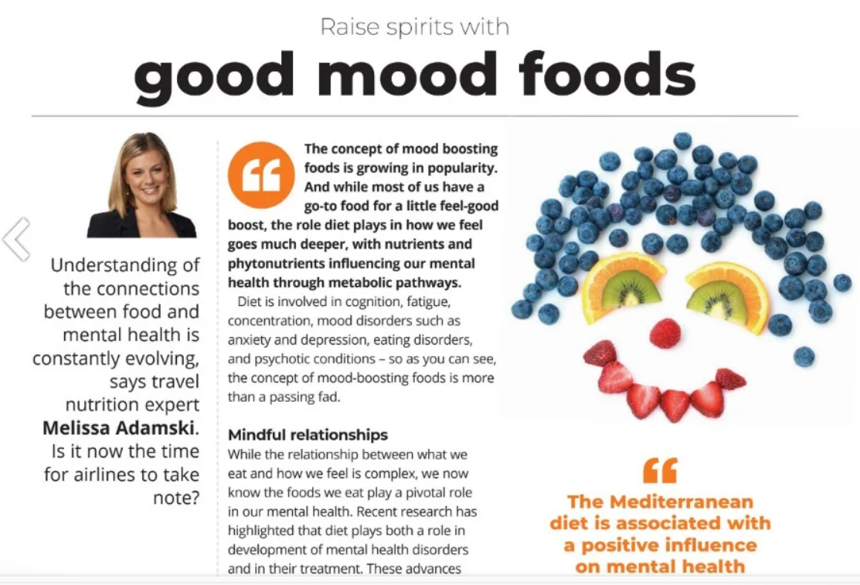
3. Understanding the importance of providing nutritious and balanced meals at sea
Providing nutritious and balanced meals at sea is essential for several key reasons:
1. Physical Health and Stamina
• Energy Needs: Life at sea demands high energy due to physically intensive tasks like operating machinery, handling cargo, and standing long hours on watch. Nutrient-rich meals supply the energy necessary for sailors to perform these tasks effectively.
• Preventing Deficiencies: Limited access to fresh food can lead to nutrient deficiencies, such as vitamin C deficiency, which historically led to scurvy among sailors. Balanced meals help prevent these health issues by ensuring an adequate intake of essential vitamins and minerals.
2. Mental Health and Cognitive Function
• Concentration and Alertness: Long shifts and unpredictable hours require high levels of concentration. Nutritious meals support cognitive function, which is crucial for making sound decisions, staying alert, and ensuring safety in potentially hazardous conditions.
• Mood and Morale: Nutrient-rich meals can improve mood and reduce stress, which helps maintain a positive work environment. Poor diet, on the other hand, can lead to irritability, fatigue, and decreased morale, which can affect teamwork and productivity.
3. Immune System Support
• Resistance to Illness: At sea, sailors are often isolated for extended periods, and illness can spread quickly in close quarters. Balanced nutrition supports immune health, making crew members less susceptible to infections, which is critical as medical resources are limited on board.
4. Adaptability to Harsh Conditions
• Weather Resilience: Working in extreme weather conditions, like cold or intense sun, places additional strain on the body. A diet rich in antioxidants, healthy fats, and proteins helps the body adapt and withstand these stresses.
• Recovery and Endurance: Sea duties are taxing, and proper nutrition aids in faster recovery from physical exertion, minimizing injury risk and maintaining endurance over long voyages.
5. Long-Term Health and Safety
• Chronic Disease Prevention: Balanced diets help reduce the risk of long-term health issues such as obesity, cardiovascular disease, and diabetes. Keeping crew members healthy reduces downtime and ensures they remain fit to work.
• Operational Safety: When sailors are healthy, alert, and energized, they’re better able to perform tasks safely and efficiently, which is essential for preventing accidents and maintaining a secure work environment.
In summary, nutritious and balanced meals are crucial at sea to support both physical and mental well-being, enhance immune function, foster adaptability to conditions, and ensure long-term health and safety of the crew [8, 9].
REFERENCES
[1] Healthy Food. https://www.iswan.org.uk/wp-content/uploads/SHIP-HealthyFood_A5_20151209_LR-4.pdf
[2] Focusing on Seafarer Wellbeing – Healthy diet and lifestyle https://www.standard-club.com/fileadmin/uploads/standardclub/Documents/Import/news/2019-news/3167952-standard-club_seafarer-wellbeing-poster_physical-wellbeing_healthy-diet-and-lifestyle.pdf
[3] Ship/ FIT ONBOARD www.seafarershealth. Org
[4] Caffeine - Uses, Side Effects, and More. https://www.webmd.com/vitamins/ai/ingredientmono-979/caffeine
[5] SHIP Seafarers’ Health Information Programme. Guidelines for Healthy Food Onboard Merchant Ships
https://www.iswan.org.uk/wp-content/uploads/SHIP-Healthy-Food-A4_20151209_LR-4.pdf
[6] Keys to Successful Meal Planning at Sea. https://ifs.be/healthy-habits/the-keys-to-success-in-meal-planning-at-sea/#:~:text=
[7] TALKING POINT: Healthy, enjoyable food for all on board. https://www.iswan.org.uk/news/talking-point-healthy-enjoyable-food-for-all-on-board/
[8] Hjarnoe, L., & Leppin, A. (2014). What does it take to get a healthy diet at sea? A maritime study of the challenges of promoting a healthy lifestyle at the workplace at sea. International Maritime Health, 65(2), 79-86.
[9] https://www.seaandjob.com/a-guide-to-taking-care-of-your-mental-health-while-onboard/

