KA220-VET - Cooperation partnerships in vocational education and training
2023-1-RO01-KA220-VET-000156711

MARitime Soft Skills for Onboard Healthy Nutrition and CULinary Arts in Seagoing Services – CUL-MAR-Skills

(TYTLE STYLE)

ONBOARD TRAINING NUTRITION

(course title)

  - AUTHORS: TEACHER ONE
  - TEACHER TOW
  - SUBTYTLE STYLE

2024

BLANK PAGE

FOREWORD

Write a few ideas about this text box (manual).
Please use the Styles predefined in this model. For example, for this paragraph the style is Normal. The figure below has the style Figures and the figure’s name has the style Figure’s style.
Figure 1 – The representation of different styles

Contents
1. HEADING 1 STYLE 9
1.1 HEADING 2 STYLE 9
1.1.1 This is a level 3 heading 9
1.2 ENUMERATIONS 9
1.3 FIGURES 9
1.4 EQUATIONS 9
1.5 TABLES 9
2. THE NAME OF THE CHAPTER 2 10
2.1 CONTENT TABLE 10
2.2 FINAL DETAILS 10

HEADING 1 STYLE

LEARNING OBJECTIVES
Learning objectives are stated at the beginning of each chapter. These learning objectives serve as a preview of the information you are expected to learn in the chapter. The comprehensive check questions at the end of the chapter are based on the objectives. The learning objectives are listed below.
Upon completion of this chapter, you should be able to:
- State what wave motion is, define the terms reflection, refraction, and diffraction, and describe the Doppler effect. [List Paragraph style]
- State what sound waves are and define a propagating medium.
- List and define terms as applied to sound waves, such as cycle, frequency, wavelength, and velocity.
- List the three requirements for sound.
- Define pitch, intensity, loudness, and quality and their application to sound waves.
- State the acoustical effects that echoes, reverberation, resonance, and noise have on sound waves.
- Define light waves and list their characteristics.
- List the various colors of light and define the terms reflection, refraction, diffusion, and absorption as applied to light waves.
- State the difference between sound waves and light waves.
- State the electromagnetic wave theory and list the components of the electromagnetic wave.

HEADING 2 STYLE
Please use Heading styles for chapters and subchapters. See Figure 2 below!

This is a level 3 heading
Don’t forget to use Normal style for normal text.

This is a level 4 heading
If you want to emphasize something please use Normal bolt style for normal text.

ENUMERATIONS
Please use List Paragraph and List Paragraph level 2 styles for enumerations (see below):
- First enumeration
- Second enumeration
  - First enumeration of level 2
  - Second enumeration of level 2

FIGURES
Figures and pictures use Figures style and the text below the figures use Figure’s style.
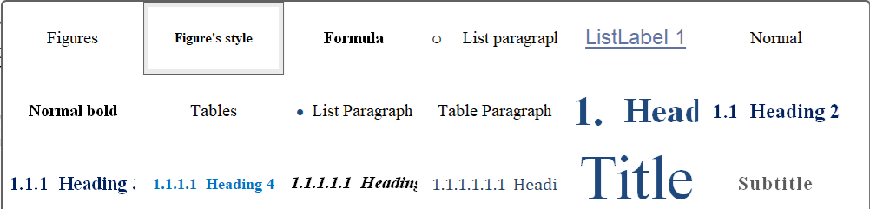
Figure 2 Styles used in this text box model

EQUATIONS
For equations or formula please use Formula Style (see below):
${\left(x+a\right)}^{n}=\sum_{k=0}^{n}{\left({n \atop k}\right)x^{k}a^{n-k}}$ (1.4.1)
$f\left(x\right)=a_{0}+\sum_{n=1}^{∞}{\left(a_{n}\cos{\frac{nπx}{L}}+b_{n}\sin{\frac{nπx}{L}}\right)}$ (1.4.2)

TABLES
For Tables, please use the Tables style as below:
Table 1 – Just another table for students
Text | Numbers | Examples
asdada | 23425325

REVIEW QUESTIONS
By successfully completing the tests, you indicate that you have met the objectives and have learned the information of this chapter.
- What is propagation? [Intense Emphasis style]
- How is a wave defined as it applies to wave propagation?
- What is wave motion?
- What are some examples of wave motion?
- What are some examples of transverse waves?
- What example of a longitudinal wave was given in the text?
- What is the law of reflection?
- When a wave is reflected from a surface, energy is transferred. When is the transfer of energy
- greatest?
- When is the transfer of energy minimum?

REFERENCES
Course references edited in APA Style in references.

