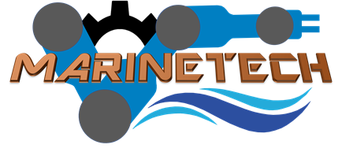
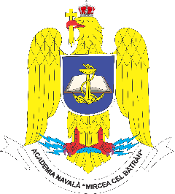

MARINTECH
Romanian - Norwegian Strategic Cooperation in Maritime Higher Education for enhancement human capital and knowledge base in field of marine intelligent technologies

Activity C1: Short-term joint staff training events - Bathymetry and oceanography
“Mircea Cel Batran” Romanian Naval Academy (MBNA),
Constanta, Romania
May 16nd - 20rd, 2022

ACTIVITY AGENDA

Sunday, May 15st
Arrival estimated time upon the teams’ confirmation
TBD/TBA - Team arrivals – Bucharest OTP / Constanta MKN airport (transfer by private bus operators)

Monday, May 16th
09.00-09.30 – transfer to Naval Academy campus
09:30-10.00 – welcome, course registration, team members acquaintance
10:00-10:05 – Kick-off meeting, Opening welcome, project coordinators induction (MBNA as Lead Partner)
10:05-10:30 – Partner teams’ acquaintance and short induction of the partner institutions (Team members)
10:30-12:00 – Training sessions
12:00-13:00 – Visit of the Naval Academy – the tour of main campus
13:00-13:45 – Lunch (to be facilitated by MBNA)
13.45-14.15 – Discussions – debates, Q&A session
14:15-14.30 – Closing remarks (MBNA as Lead Partner)
14:30-15:00 – Transfer to the hotel (to be provided by MBNA)
15:00-18:00 – Refreshing time
18:00-21:00 – Welcome dinner – TBD (offered by MBNA)
21:00 – Leisure time

Tuesday, May 17th
09.00-09.30 – transfer to Naval Academy campus
09:30-10.00 – welcome, resuming details from previous day (MBNA and the Partners)
10:00-14:00 – Training sessions:
10:45-11:00 – Coffee break
14:00-14.30 – TM Minute drafting, closing remarks (MBNA as Lead Partner)
14:30-15:00 – Transfer to the hotel (to be provided by MBNA)
15:00 -16.00 –Leisure time
16.00-18.00 – Training sessions
18.00 –Transfer to the hotel (to be provided by MBNA)

Wednesday, May 18th
09.00-09.30 – transfer to Naval Academy campus
09:30-10.00 – welcome, resuming details from previous day (MBNA and the Partners)
10:00-14.00 – Training sessions:
10:45-11:00 – Coffee break
14:00-14.30 – TM Minute drafting, closing remarks (MBNA as Lead Partner)
14:30-15:00 – Transfer to the hotel (to be provided by MBNA)
15:00 -16.00 –Leisure time
16.00-18.00 – Training sessions
18.00 –Transfer to the hotel (to be provided by MBNA)

Thursaday, May 19th
09.00-09.30 – transfer to Naval Academy campus
09:30-10.00 – welcome, resuming details from previous day (MBNA and the Partners)
10:00-14:00 – Training sessions
10:45-11:00 – Coffee break
14:00-14.30 – TM Minute drafting, closing remarks (MBNA as Lead Partner)
14:30-15:00 – Transfer to the hotel (to be provided by MBNA)
15:00 -16.00 –Leisure time
16.00-18.00 – Training sessions

Friday, May 20th
09.00-09.30 – transfer to Naval Academy campus
09:30-10.00 – welcome, resuming details from previous day (MBNA and the Partners)
10:00-14:00 – Training sessions
10:45-11:00 – Coffee break
14:00-14.30 –Activity closing remarks, Discussions – debates, Q&A session (MBNA as Lead Partner)
14:30-15:00 – Transfer to the hotel (to be provided by MBNA)
15:00 – Leisure time

Saturday, May 21st
Departure estimated time upon the teams’ confirmation
TBD/TBA - Team departure – Bucharest OTP / Constanta MKN airport (transfer by private bus operators)

