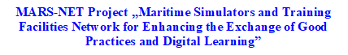

AN OUTLINE for THE PREPARATION of
DIGITAL COURSE CONTENT

DIGITAL COURSE CONTENT PREPARATION OUTLINE
Distance education, the foundations of which were laid with the conveniences provided by technology was triggered by the needs arising during the pandemic period and has become a popular method of education, and been the subject of many research.
Research in this field includes topics such as increasing the effectiveness of education, motivating students, choosing the most appropriate teaching method suitable for subject, and establishing a fair evaluation system in the context of digital education. One of these topics has been preparing the content of digital courses effectively. In the following lines the steps to be taken for the preparation of an effective course content are given.
- Creating interesting and attractive learning outcomes
Students should know exactly what they will learn and what skills they will acquire when they start the course. The benefits, outcomes, consequences and awards of taking the course should be clearly explained to the student at the beginning of the course. Setting an appropriate learning plan and curricular outcomes is the first step in creating effective content. The instructor should decide for each ‘learning outcome’ what he or she is trying to achieve for the learners:
Is he/she trying to:
Get them to ‘understand’ something (knowledge / comprehension)
Get them to be able to ‘do’ something (apply / demonstrate / implement)
Get them to be aware of or familiar with something (awareness)
Get them to review, analyze or critique something
Get them to feel something or no longer feel a certain way
Get them to have a perspective, attitudinal or behavioral adjustment
When the objectives of the course are well defined, it is easier to determine its content precisely. That’s why determining the outcomes correctly and making them attractive is important for an efficient teaching experience.
- Structuring Modules and Course Plan
It is easier to prepare the program if the lesson is on a simple topic without complicated steps. However, if it is more complex, similar themes, tips and ideas can be grouped into modules and then the lessons in the modules are structured in the most progressive and logical way so that they form a coherent and streamlined sequence of lessons.
The following points are recommended to be taken into account at this stage:
Creating instructural design models like a storyboard.
Instructional design models are frameworks developed by psychologists and educational researchers that organize “creating instruction” (e.g., building an eLearning course) into a streamlined process that follows research-based best practices (Burton, 2022).
Storyboarding is a planning technique that has its roots in movie production. Originally, storyboards were used to pre-visualize sequences of events in motion pictures and animations. In education, storyboarding helps plan the contents of a course, lesson, lecture, or any kind of learning experience. It can help prioritize information, arrange the elements of a training program into a logical sequence, map out video materials, plan audio narration, and more.
This may sound like adding an extra step to the course development process. But it’s like using a good project management tool — it will ultimately save you a lot of time and arrive at optimal solutions without the trial and error.
Relying on an instructional design storyboard template will help you:
- Keep your training focused on research-backed best practices
- Hit all the important points in your audio and visual materials
- Simplify production and post-production by lowering the chance that you have to go back and reshoot things.
- Plan exercises, quizzes, and activities that facilitate the retention of new knowledge and skills.
There are various designs for storyboard template. One of the most popular one of them is Bloom’s Taxonomy. It is a well-established pedagogical framework for helping teachers effectively meet the needs of their students and states that there are 6 consecutive steps to mastering new knowledge or skills:
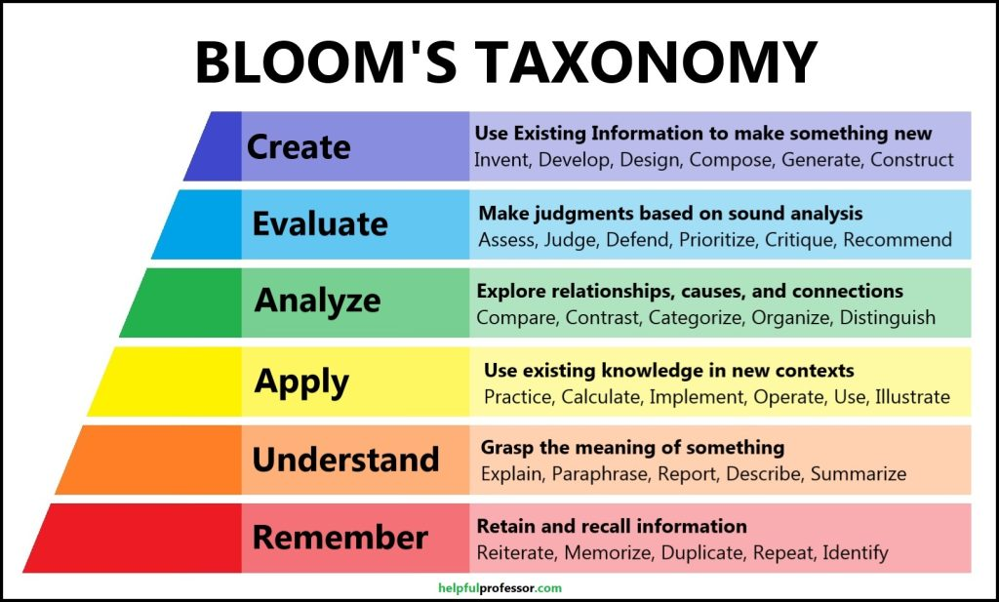
Figure 1. All 6 Levels of Understanding (On Bloom’s Taxonomy) (Derw, 2023)
This hierarcy is called “the hierarcy of online learning” by Scribani (2020). Bloom’s hypothesis was simple: if you cannot remember a concept, you do not understand it; if you do not understand something, you cannot apply it. You cannot distinguish between correct and incorrect answers, or argue the benefits and downfalls; any expertise or depth of argument is impossible without first establishing foundations of remembering and understanding. With that in mind, he developed a continuum of cognition, divided it into six stages, and designated each with a noun to describe the skill or level of cognition a student should master before moving on to the next level. This continuum is often presented as a pyramid to illustrate the levels’ dependency upon one another: a student cannot apply before they understand, and they cannot evaluate before they learn to analyze.
Special applications for course creators and educators in a digital classroom on the basis of Bloom’s Taxonomy are given in the following table:
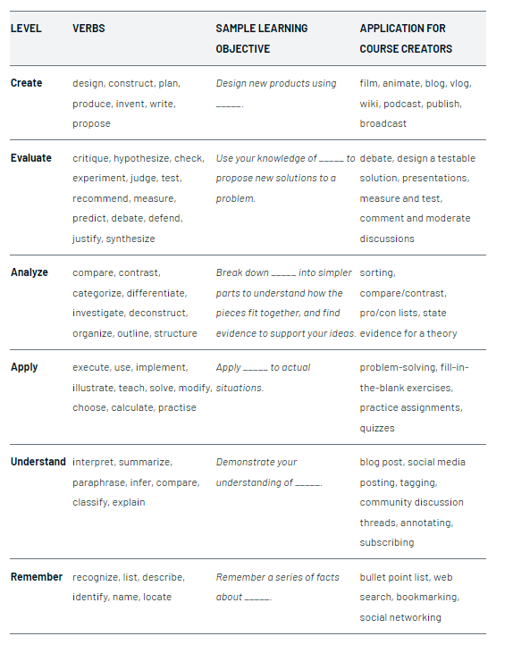
Table 1. Special Applications for a Digital Classroom (Scribani, 2020).
There are other instructional design storyboards to create a logically structured and effective online course. One of them is ADDIE storyboard template. It is a popular instructional design model that outlines 5 steps of instructional design:
- Analyze
- Design
- Develop
- Implement
- Evaluate
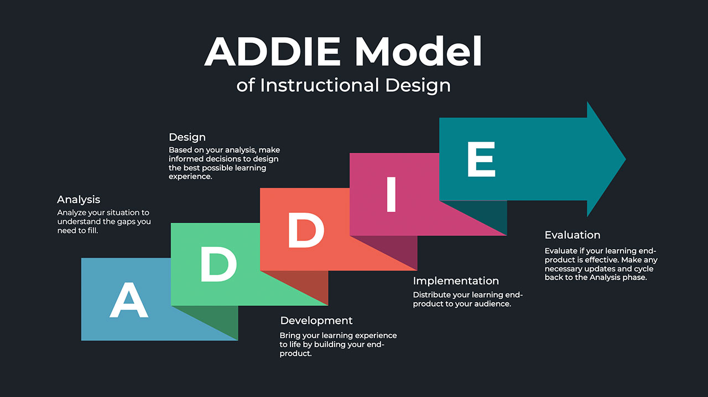
Figure 2. ADDIE Model of Instructional Design (DeBell, 200)
This template will help you plan and organize your pre-and post-launch tasks within your course development project. It will also remind you to plan for a post-launch analysis and work towards optimizing your eLearning program even after it goes live.
- Determining the most engaging and effective delivery methods for each lesson

When figuring out the best way to create an online course, the instructor needs to be aware of the different learning preferences and ways he or she can deliver information so it’s as engaging as possible. That is, the following points should be considered:
- If videos, reading content, activities, audio content will be used,
- What type of visuals will be used?
- Will there be community learning areas?
- How will the course be made fun and engaging?
- How will the students with different learning styles be helped?

The tips to design effective learning content (Cordiner ,2023):
- Designing course content that is engaging
Traditional classroom experiences do not always translate nicely to engaging online learning experiences. Therefore, it is important to find ways to make the online course a delight to take. Here are a few ways to for this:
- Bringing storytelling into teaching
- Creating a learning community
- Hosting live lessons
- Using both synchronous and asynchronous learning
- Using gamification to motivate your students and reward smaller milestones
- Designing the course to be accessible
A lot of thought goes into building the best learning experience. Engagement strategies like gamification can be fun and somewhat easy to incorporate, but accessibility should also be considered. To achieve this Universal Design for Learning should be used. It is to remove barriers to learning. Barriers to learning exist in a wide swath of the population at different times and in different environments. They can be physical and mental, social and medical and may impact everyone in the learning environment to some degree. There are 7 principles of universal design, which are
1.Equitable Use.
2.Flexibility in Use
3.Simple and Intuitive Use
4.Perceptible Information
5. Tolerance for Error
6. Low Physical Effort.
7.Appropriate Size and Space for Approach and Use (Universaldesign, 2023).
Building your course using universal design learning principles will ensure your course is accessible by anyone so that everyone gets to enjoy the fruits of your labor.
- Creating the online course with an ideal length in mind
There’s no one-size fits all approach to creating an online course. In many cases, smaller micro learning can be just as impactful as a lengthy online course.
A few factors that may influence the length of your course may include:
- The complexity of the topic – A course on rocket science will probably be longer than a course on how to source healthy local ingredients.
- Required course lengths for continuing education credits – if you’re hoping to get your course certified for continuing education, your students may need to complete a certain number of hours.
- Considering social elements, like learning communities and cohort-based learning
We are social animals and lack of social interaction is one of the biggest challenges with self-paced online learning.
- Producing online course: filming, recording, and editing
The way the course is presented will be directly linked to the expectations and learning styles of the target audience. The most preferred methods to ensure that the lesson is taught effectively are the following:
Talking heads – This is when just the instructor’s upper body is in frame for the video. The instructor may or may not have a greenscreen behind him/her for things like presentation slides, visuals, or something else.
Screen recording – This is where the instructor is recording the device’s screen. Typically this is done to walk viewers through a process or demonstrate something digitally. The instructor may or may not be featured on screen.
Voiceovers – A voiceover is similar to screen recording, except The instructor is narrating what’s happening on screen. Often, this is done for presentations, and the instructor is not shown on screen.
- Setting up the online course
It’s essential to choose an online course platform that fits all the needs such as what kinds of gamification can be included, what the website will look like.

Keys to Preparing Effective Online Course Content
There are some hints presented by Rapanta (2020) on effective approaches to digital course design and implementation. These were collected after counseling the experts on the field.
The aspects that online learning design and delivery is different from face-to-face teaching and learning.
Good online teaching requires careful student-centred design ahead of any classes taking place. It shifts the focus of classes from teacher and subject matter to student and activity-based learning.
Online learning is more reliant on materials (text, video, exercises) than direct personal interaction (discussion, presentation).
To be effective, it requires clear communication and instruction from teachers as there is less opportunity for refinement through interaction.
Extra communication channels are needed so instructors can get key messages to all students, be aware of their needs and make it easy for students to talk to one another, sharing experiences and tips. At least one channel or chatroom should be private to the students with no teacher access.
Remote students are more autonomous, so online courses should offer flexibility, making students the owners of their learning process.
Evaluation and assessment require a total overhaul of traditional exams with continuous evaluation or a separation of formative and summative evaluations.
Greater empathy is needed for students struggling to adapt to new modes of learning, the stress of pandemic and associate upheaval of "normal" life. Loss of face-to-face behavioural cues means that teachers must be more proactive in touching base with students.
What makes online teaching and learning successful?
Student-centred design: thinking about what students will have to do to learn. Focusing on content can result in poor-quality video, which will not achieve its goal, while focusing on what learners will do puts them in motion and creates opportunities to help them learn.
Proper task analysis: thinking about the practicalities of students’ situations and how they will interact with, say, a text, video or podcast. If students cannot easily print, avoid sending a 30-page text, for example. It is advisable to acquire some knowledge of learners’ needs, aptitudes and abilities. Hosting a welcome forum or activity can help instructors get to know the learners and establish class rapport.
Flexibility: enable students to find a balance with their own "new normal" by, for instance, allowing flexi-time, asynchronous classes and avoiding several hours in a row of videoconferencing. Also, allow for customisation of the curriculum so that you can offer personalised learning pathways and individualised support.
Active involvement of learners: encourage student co-design of learning activities. Enabling students to modify tasks teachers set for them and reconfigure learning environments, recommended tools and resources and working relationships will boost their engagement and foster self-regulation. Instructors can construct guiding questions and discussion prompts to encourage probing, interrogating, critiquing and relating to content and other learners.
Effective planning: chunking and pacing content, designing a schedule of assignment due dates and setting a regular schedule for activities makes progress easier for students and teachers.
Learning is social: we learn from and with others, even if at a distance. Teachers should be present online by providing timely and accurate feedback, both on questions and evaluations, alongside video lectures and seminars. Individualised feedback is a powerful learning engine.
Excellent communications skills: set well-explained tasks with clear rationales and listen carefully to what students are saying about their experiences, what is working well for them and what is not. Working online, a challenge is the loss of normal face-to-face cues, so learners and instructors must work harder to pick up on and correctly interpret the cues available.
Promote peer contact and collaboration: this should be formal and informal, through group assignments or by introducing peer-teaching or peer-assessment.
Wise use of technology: use learning analytics to shape course design decisions and monitor student progress. Always think about the pedagogical purpose first, then select the technology that will support this.
Learner prep: help students prepare themselves to engage in online learning with a welcome message setting out the structure, types of assignments and tips for success prior to the course start date.
Recommendations to non-expert colleagues who follow a materials-based approach to online teaching?
Good teachers are mediators between the content and the learners. They create pathways so that everyone can learn, whatever their cognition, motivation and self-esteem. When we are online, materials alone cannot provide the mediation, a teacher is needed to provide guidance, feedback, answer questions, monitor student progress and much more.
If a course offered only pre-prepared materials, with no dialogue, feedback or opportunity for teachers to adapt, then the risks of failure would be high and struggling students will go unnoticed.
Nonetheless, good materials are a key ingredient in online teaching and should be accurate and accessible to students and support the appropriate level of autonomy.
Recommendations to to colleagues who follow a tools-based approach to online teaching?
Very often, institutions and educators start thinking about the tool first rather than the pedagogical issues. The pedagogical purpose must come first, then the tool chosen to support it.
Tools such as videoconferencing can offer useful ways to engage in live interaction (Q&A, feedback, project reviews) but should not be used as a vehicle to move face-to-face teaching content online, such as hour-long lectures, without redesigning the style of teaching and content to suit the tool being used.
What are the effective ways of monitoring students’ engagement and learning during online courses? How can they inform assessment?
Continuous assessment is key in online education, so collecting information in the form of work, artefacts and reflections that can be measured against competence performance criteria throughout the course is crucial.
Teachers can monitor students’ activities and ongoing progress via the Learning Management System (LMS) – so-called learning analytics. This means identifying key indicators and setting up a way to measure and control them. Key indicators could be downloading a text, posting to a forum, logging in and accessing the course at least once a week. If these indicators are properly defined and communicated to students, they can form part of an ongoing evaluation.
The use of ePortfolios, for example, is a strategy that is highly recommended for online education. It allows the students to collect evidence of their learning and reflect about it and the teacher to facilitate the monitoring of the process.

References
Burton,C. (2022). Instructional Design Storyboard Templates For Online Course Creators. Retrieved from https://www.thinkific.com/blog/instructional-design-storyboard-templates/
Cordiner, S. (2023). 10 Steps To Creating A Wildly Successful Online Course. Retrieved from https://www.thinkific.com/blog/10-steps-creating-successful-online-course/#engaging-effective
DeBell, A. (2020). What is the ADDIE Model of Instructional Design? https://waterbearlearning.com/addie-model-instructional-design/
Drew, C. (February 17, 2023). All 6 Levels of Understanding (on Bloom’s Taxonomy). Helpful Professor. Retrieved from https://helpfulprofessor.com/levels-of-understanding/
Rapanta, C. (2020). A guide to effective digital course design and delivery from four online teaching experts. Retrieved from https://www.timeshighereducation.com/campus/four-online-teaching-experts-effective-digital-course-design-and-implementation
Scribani, J. (2020). Bloom’s Taxonomy: A Crash Course For Online Course Creators. Retrieved from https://www.thinkific.com/blog/blooms-taxonomy-a-crash-course-for-online-course-creators/
Universaldesign (2023). The 7 principles. Retrieved from https://universaldesign.ie/what-is-universal-design/the-7-principles/

NOTES:
Education is the foundation for economic growth and human development. Universities should spend their efforts to prevent (or reduce) the risks of divergence and adversities impacting the education systems for institutional resilience in order to meet the rapidly changing expectations of the society and respective stakeholders. Using new technologies and methodologies to produce and update the knowledge they teach is becoming more important. In this aspect, digitalization of learning is becoming vital to enhance joint research activities and attain an international character to address a larger student and academics body under cooperative and competitive structure. In the journey to the perfectionism in education, constantly changing conditions of the global work markets and expectations from the students need to be taken into consideration to prepare the students for the future.
The remote teaching and learning efforts that universities applied during the COVID-19 do not resemble what we think of as traditional online education. Quality online learning programs are high-input operations, requiring both time to develop and significant investments to run. On the other hand, we should understand that digital tools are complements, not substitutes, for the intimacy and immediacy of face-to-face learning.
Universities, which had no experience in distance education before the pandemic, partially survived this critical period with the commercially available programs they used, but they returned to the traditional education system again because they did not invest in online education.
Universities, which saw this period as an opportunity and made online education the focal point of their strategic plans, understood the importance of this new education approach is essential in order to maintain their existence and generate new income opportunities, and included online education management in their academic leadership structures and processes. Internet has started reshaping education and education will not be the same in the next decade. There is no going back, and the traditional classroom must be transformed. Many universities/colleges may not survive by the end of this decade unless they start adopting these new requirements in their academic leadership structures and processes.
For the innovation in maritime, the maritime universities are the correct stakeholders of maritime cluster to manage the maritime digitalization and respective solutions. An advanced Platform may be established, and basic and refresher training can be offered for network members in remote areas. New results from different digitalization projects from the stakeholders can be used with tailor made classrooms for best possible technology in order to develop a Maritime E-platform (E-campus).
Once the e-learning platform designed, the tutorial ready and resources uploaded the university shall conduct the e-campus onset by setting up the procedures for uploading, accessing and maintenance of the virtual campus, enforcing the enrolling rules of the e-campus members. All the faculties/departments should offer support for building and uploading the e-learning system with the projected learning materials for students, making possible the dynamic access within the virtual campus of all didactic resources, on common and harmonized basis. Virtual E-campus on didactic resources and learning materials - didactic network ADL – Advanced Distributed Learning System -Building a virtual e-campus will consist in several progressive activities as following:
− Setting up the e-learning platform under MOODLE or similar environment
− Setting up the course catalogue roots
− Creating video-media tutorial
− Instructing the administrators – administration procedures, enrolling policies
− Design of digital resources format
− Uploading the learning resources
− E-campus launching and management

Practical tips to consider in online meetings for the efficient classroom leadership
- Good planning (Focusing, recognizing the participants, knowing the possibilities and limitations, rehearsal)
- Focusing
During the presentation, no other work should be done (phone, e-mail, etc.)
Distracting home environment (TV, music, family members, pets) should be avoided.
- Proper use of technology
If your computer hangs and freezes from time to time, turn it off and on before the call starts.
Don't keep the participants waiting
Start with the camera on, the microphone off, and don't open without speaking
Connect at least 15 minutes early:
Check the programs you need to install or update when using a new program/device
- Consider alternative ways
Make sure you have alternative means of communication in case something goes wrong.
Make sure your internet connection: Make sure someone isn't downloading a large, loaded file during the video conference. Internet speed is important in such conversations. Since the sound is also related to the connection speed, try not to occupy the internet connection.
- Close other programs
If it's a conversation you're joining from a computer, close programs like Photoshop. If there are any programs you are not using, close them as well. So your conversation will not be interrupted. Also, if you are connecting from a laptop or netbook, make sure you have enough charge.
- look at the camera
Just as eye contact is important in face-to-face meetings, the same is true here. Sit in the position where you can see the camera best and where the camera can see you best. Try to make eye contact with everyone.
use appropriate language
- Pay attention to the background
If you are staying at home, the laundry hanging behind you and the dirty dishes do not create a pleasant image.
Test Screen sharing options before the class and open your sharing documents in advance. Otherwise, students will be distracted when you are searching for documents.
Consider Pre-sharing some documents in large volumes and especially videos via e-mail.
Video should not be used if it is not mandatory. If used, test them in advance that they play properly, and the voice is also shared.

