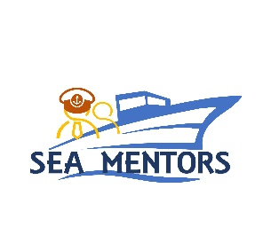 | LITHUANIAN MARITIME ACADEMY  I. Kanto str. 7, LT-92123, Klaipeda, Lithuania  Tel. No.: +370 46 397 240  email: lajm@lajm.lt

Klaipeda, October 27th 2022

INVITATION LETTER

Dear Partners,
Based on the fruitful and traditional cooperation developed between our institutions in the field of Maritime Education and Training, we are honoured to renew our esteemed consideration in respect of your valuable contribution provided, as ongoing support, for initiating and implementing joint projects and programmes for research and development.
Taking under consideration the implementation calendar of the joint project “SEAfarers Experiential Knowledge Based MENTORS” (SEA MENTORS) awarded to our partnership under Erasmus+ KA220 - Cooperation Partnerships in Vocational Education and Training,
we would like to invite 2 (two) representatives of your institution, selected from the nominated project team members, to participate in the Transnational Meeting No. 2 (TM2), organized and conducted by the Lithuanian Maritime Academy during November 7th – 8th, 2022.
In this event will partners will work on planning and checking the project objectives and tasks progress, finalise the drafts for the second Newsletter, also enforcing the knowledge and exchange good practices between the project members, opening new paths of joint cooperation among project partners.
For administrative purposes, please find attached the registration form, as to be submitted no later than November 4th. Point of contact (POC) for registration and for further assistance and guiding has been appointed Rima Mickiene, who can be reached by e-mail: r.mickiene@lajm.lt or by phone: +370 699 112 45.

Respectfully Yours
Deputy Director for academic affairs Rima Mickiene

