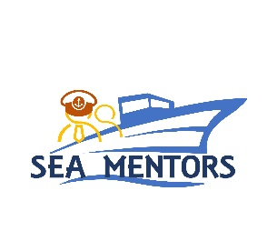
Romanian Naval Academy
1st Fulgerului Street, Constanta, Romania, 900218
Tel/fax: +40-241-643096

e-mail: international@anmb.ro

Constanta, February 11th 2022

INVITATION LETTER

Dear Partners,
Based on the fruitful and traditional cooperation developed between our institutions in the field of Maritime Education and Training, we are honoured to renew our esteemed consideration in respect of your valuable contribution provided, as ongoing support, for initiating and implementing joint projects and programmes for research and development.
Taking under consideration the implementation calendar of the joint project SEA MENTORS - ” SEAfarers Experiential Knowledge Based MENTORS” awarded to our partnership under Erasmus+ KA220 - Cooperation Partnerships in Vocational Education and Training, we would like to invite 2 (two) representatives of your institution, selected from the nominated project team members, to participate in the Transnational Meeting No. 1 – TM1: “Keek-off meeting”, organized and conducted by the Romanian Naval Academy as Lead Partner, during March 29th – 30th.
This event will be a great opportunity not only for planning and checking the project objectives and tasks progress, but also for enforcing the knowledge and good practices exchange between the project members, opening new paths of joint cooperation among our universities.
For administrative purposes, please find attached the registration form, as to be submitted no later than March 04th. Point of contact (POC) for registration and for further assistance and guiding has been appointed LtCdr (N) Marius CUCU, who can be reached by e-mail: erasmus@anmb.ro, or by phone: +40-761.689.616 and fax: +40.241.643096.

Respectfully Yours,
COMMANDANT (RECTOR) OF THE ROMANIAN NAVAL ACADEMY

CAPTAIN (Navy) Alecu TOMA
Associate Professor, Eng. PhD

