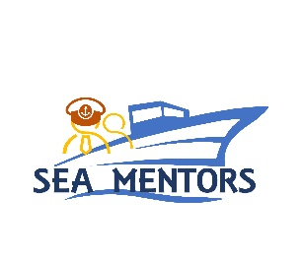
„SEAfarers Experiential Knowledge Based MENTORS”
KA220 - Cooperation Partnerships in Vocational Education and Training,
2021-1-RO01-KA220-VET-000029622

APPLICATION FORM
Transnational Meeting no. 1: “Project Management-Kick-off Meeting”
March 29-30, 2022, Constanta/ROMANIA
COUNTRY |  |  | ROMANIA
UNIVERSITY |  |  | ROMANIAN NAVAL ACADEMY MIRCEA CEL BATRAN
POC: |  |  | Marius Cucu
Email: |  |  | erasmus@anmb.ro
Phone number |  |  | +40761689616
Attendees:
1 | Military / Civilian |  | Title |  | Sex |  |  | Date of birth  DD/MM/YY |  |  | ID/Passport  number
 | M C |  |  |  | F M
 | Name (first / last)
2 | Military / Civilian |  | Title |  | Sex |  |  |  | Date of birth  DD/MM/YY |  | ID/Passport  number
 | M C |  |  |  | F M
 | Name (first / last) |  |  | Elena-Rita Avram
ITINERARY
Arrival |  | Plane Bus Personal Car Other
Date / Hour
Airport
Departure |  | Plane Bus Personal Car Other
Date / Hour
Airport
ACCOMMODATION FORM – to be booked individually or by the organizer
28/03/2022 to 29/03/2022 |  |  |  | YES NO |  |  | Recommended hotels:  Oxford Hotel***,  Pacific Hotel***
29/03/2022 to 30/03/2022 |  |  |  | YES NO
30/03/2022 to 31/03/2022 |  |  |  | YES NO
SPECIAL REQUESTS & QUESTIONS

Notes: The participants are recommended to arrive to Bucharest (via Henri Coandă International Airport – Otopeni – IATA code BUH/OTP) or Constanța (via Mihail Kogălniceanu International Airport Constanța). For shuttle transfer Bucharest – Constanța, the participants are recommended the online booking on https://alt-transportpersoane.ro/en/.

