KA220-VET - Cooperation partnerships in vocational education and training
2023-1-RO01-KA220-VET-000156711

MARitime Soft Skills for Onboard Healthy Nutrition and CULinary Arts in Seagoing Services – CUL-MAR-Skills

ONBOARD COOKING SKILLS

Training module IV, Week 2

Nutrition and Dietary Requirements

  - AUTHOR: UĞUR KAÇAN

2025

FOREWORD

Food provision at sea carries significance far beyond the preparation of meals. In the demanding maritime environment, where crews face isolation, limited resources, and irregular routines, the galley becomes a central factor in safeguarding health, morale, and efficiency. Nutrition directly influences endurance, focus, and safety, making the role of the maritime cook essential to both individual wellbeing and operational stability.This module, Onboard Cooking Skills: Nutrition and Dietary Requirements, recognizes that dietary planning on board must combine scientific knowledge with cultural sensitivity and regulatory compliance. Historical challenges, such as scurvy, shaped the foundations of nutritional science and continue to remind us of the dangers of deficiency. Today, risks such as obesity, fatigue, and poor dietary balance remain pressing concerns that can undermine crew performance and safety.By integrating theory with practice, this training fosters a professional identity rooted in precision, creativity, and responsibility. The maritime cook is presented not simply as a provider of meals but as a guardian of health, a mediator of cultural differences, and a contributor to safe and sustainable ship operations.

COURSE STRUCTURE

This course introduces the fundamental principles of nutrition in the maritime context, emphasizing the balance of macronutrients and the importance of micronutrients in sustaining health and performance at sea. Learners begin by exploring how energy and nutrient needs are shaped by the physical demands and irregular routines of seafaring life. The module then focuses on dietary planning, teaching strategies for incorporating healthy carbohydrates, proteins, and fats while preserving vitamins and minerals through appropriate cooking methods. Special attention is given to hydration and its role in maintaining both physical and cognitive performance onboard. The course also addresses cultural, religious, and medical dietary considerations, ensuring that meal planning supports inclusivity as well as nutrition. Practical exercises reinforce theoretical knowledge by guiding learners to design balanced meal plans adapted to long voyages, fluctuating supplies, and diverse crew needs.

Contents
INTRODUCTION TO THE COURSE 4
1. MACRONUTRIENTS: ENERGY AND BUILDING BLOCKS 4
1.1 CARBOHYDRATES 4
1.1. PROTEINS 5
1.2. FATS 6
1.3. BALANCED INTAKE 6
2. MICRONUTRIENTS: VITAMINS AND MINERALS 7
3. CULTURAL AND DIETARY CONSIDERATIONS 8
3.1 DIVERSITY OF DIETS 8
3.2 RELIGIOUS DIETARY RESTRICTIONS 8
3.3 OTHER DIETARY NEEDS 9
4. MENU PLANNING STRATEGIES FOR SHIPS 9
5. REVIEW QUESTIONS 12
6. REFERENCES 13

INTRODUCTION TO THE COURSE

LEARNING OBJECTIVES

Nutrition is a cornerstone of health and efficiency for seafarers living in the unique environment of a ship. A well-nourished crew member is not only healthier but also more alert and capable of performing duties effectively . Ensuring adequate nutrition at sea is crucial for maintaining crew morale and physical endurance during long voyages. In fact, studies have found that seafarers’ diets are often too high in fat and sugar, contributing to elevated risks of obesity, metabolic syndrome, and cardiovascular disease – underscoring why deliberate nutritional planning is so important. However, the shipboard setting presents distinct challenges. Limited access to fresh produce means that fruits and vegetables consumed early in a voyage must later be replaced with canned or preserved alternatives, which may not provide the same nutritional value . Storage constraints and resupply intervals force a heavy reliance on non-perishable foods . Moreover, meal monotony can set in – eating similar foods repeatedly can lead to “food fatigue,” reducing appetite and nutrient intake . A multinational crew also brings a variety of cultural dietary preferences that make it complex to satisfy everyone’s needs with a single menu. Given these factors, it is imperative for maritime cooks to carefully plan balanced diets that meet all dietary requirements. Indeed, international maritime regulations such as the Maritime Labour Convention (MLC) 2006 mandate that seafarers be provided with food of suitable quantity, quality, and nutritional value for the duration and nature of the voyage. The MLC 2006 further stipulates that cultural preferences and religious restrictions must be considered in meal planning to ensure all crew members’ needs are met. In summary, proper nutrition at sea is not only a matter of personal health but also a legal and operational priority for the ship – one that requires knowledge of nutrients, sensitivity to the crew’s diverse background, and strategic menu planning.
By the end of this unit, learners will be able to:
• Recognize the importance of proper nutrition for seafarers’ health, well-being, and work performance.
• Identify the major macronutrients (carbohydrates, proteins, fats) and micronutrients (vitamins, minerals) and explain their roles in a balanced diet.
• Understand cultural, religious, and dietary considerations in planning meals for a multicultural crew, and the need to accommodate diverse needs.
• Apply effective menu planning strategies in a maritime context, ensuring balanced, varied, and nutritionally adequate meals within the constraints of shipboard life.

MACRONUTRIENTS: ENERGY AND BUILDING BLOCKS

Macronutrients—carbohydrates, proteins, and fats—are required in large amounts to supply energy and sustain the body’s essential functions. They form the foundation of every diet, providing fuel for physical activity, growth, repair, and overall health. Each macronutrient plays a distinct role: carbohydrates are the body’s primary energy source, proteins support muscle and immune function, and fats provide long-term energy while enabling the absorption of vital vitamins.

For seafarers, whose duties involve physically demanding work performed under irregular schedules, the importance of balanced macronutrient intake is even greater. Adequate proportions of carbohydrates, proteins, and fats help maintain stamina during long shifts, promote recovery from physical strain, and ensure resilience in challenging conditions at sea (Oldenburg & Jensen, 2012).

CARBOHYDRATES

Carbohydrates are the body’s primary energy source, supplying glucose that fuels the brain, muscles, and other vital organs. For seafarers engaged in physically demanding duties such as deck operations, cargo handling, or engine maintenance, carbohydrates are indispensable in sustaining work capacity and concentration. Complex carbohydrates—such as whole-grain bread, rice, pasta, legumes, and potatoes—release energy slowly, providing a steady supply of glucose and helping to maintain stable blood sugar levels. In contrast, simple sugars from sweets, sodas, or refined white bread cause rapid spikes and drops in energy, which can lead to fatigue and reduced alertness. To ensure stable performance, maritime diets should emphasize complex carbohydrate sources that align with long and irregular work shifts (World Health Organization [WHO], 2006).

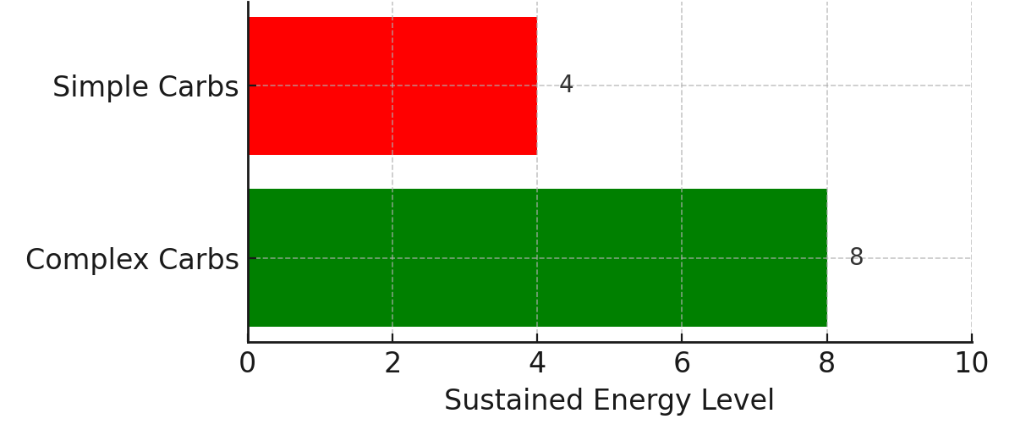
Figure 1Comparison of energy release from complex and simple carbohydrates. Complex carbohydrates provide sustained energy, while simple carbohydrates cause quicker spikes and drops in blood sugar.

The quantity and quality of carbohydrate intake must also be carefully considered on ships, where provisioning is limited and food must be planned weeks in advance. Nutrition guidelines recommend that 45–60% of daily energy intake should come from carbohydrates, ideally from whole-grain and fiber-rich sources. These foods not only provide energy but also contribute dietary fiber, which supports digestion and prevents gastrointestinal issues—a common concern on long voyages with limited access to fresh produce. Practical examples include incorporating oatmeal or whole-grain cereals at breakfast, offering rice or pasta as side dishes, and using legumes as both a carbohydrate and protein source. By planning meals with a balance of complex carbohydrates and fiber, maritime cooks can ensure that crew members remain energized and resilient.

Finally, the cultural and psychological role of carbohydrate-based foods should not be overlooked. Staple carbohydrate dishes often provide emotional comfort and familiarity for multinational crews. Rice, bread, or pasta may be central to different cultural food traditions, making them valuable not only nutritionally but also socially. By offering carbohydrate choices that reflect crew diversity—such as rice for Asian seafarers, bread for Europeans, or cassava for African crews—cooks can strengthen inclusivity and morale on board. In this way, carbohydrate planning contributes to both physical endurance and cultural harmony at sea.

PROTEINS

Proteins are essential for the repair and growth of body tissues, the maintenance of muscle strength, and the functioning of the immune system. For seafarers performing heavy physical tasks—such as lifting cargo, maintaining machinery, or working in harsh weather—protein intake is vital for recovery and endurance. Unlike carbohydrates, which primarily serve as energy fuel, proteins provide the amino acids necessary to rebuild muscles after strenuous activity or injury. Adequate protein also supports immune resilience, which is critical in the isolated environment of a ship where medical care may be limited and contagious illnesses can spread quickly (Grappasonni et al., 2013).

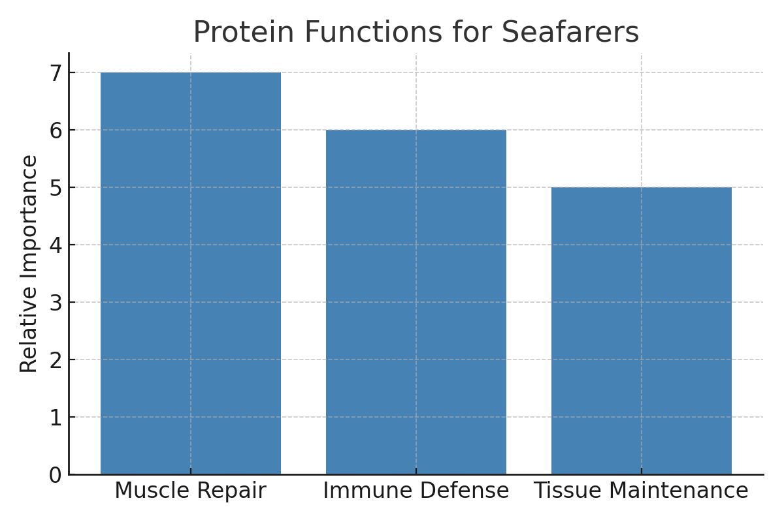
Figure 2 Key protein functions for seafarers. Protein supports muscle repair, immune defense, and tissue maintenance, all of which are vital in physically demanding maritime work.

High-quality protein sources suitable for maritime kitchens include lean meats such as poultry, a wide variety of fish and seafood, eggs, dairy products, and plant-based options such as beans, lentils, and soy products. Including a protein component in every main meal ensures a steady supply of amino acids and helps balance energy distribution throughout the day. Practical meal examples include fish stews, lentil curries, or grilled chicken with vegetables. Guidelines suggest that roughly one-quarter of a balanced plate should consist of protein-rich foods. This proportion ensures sufficient intake without overconsumption, which can strain limited storage and increase provisioning costs.

Cultural and religious considerations also shape protein planning. Some seafarers may follow vegetarian diets or avoid certain meats for religious reasons, requiring careful substitution with legumes, dairy, or eggs to maintain nutritional adequacy. By diversifying protein options and offering culturally appropriate alternatives, maritime cooks can both sustain health and promote inclusivity. In doing so, protein provision strengthens not only physical resilience but also cohesion among multinational crews.

FATS

Fats are a dense source of energy, providing more than double the calories per gram compared to carbohydrates or proteins. They are essential for the absorption of fat-soluble vitamins (A, D, E, and K), hormone regulation, and brain function. For seafarers, whose work often involves long hours of physical exertion and high energy expenditure, fats provide sustained fuel and help prevent early fatigue. However, the type of fat consumed is crucial: while healthy fats contribute to cardiovascular and cognitive health, excessive intake of unhealthy fats increases risks of obesity, hypertension, and heart disease (Oldenburg & Jensen, 2012).

Healthy fats should make up approximately 20–35% of daily caloric intake, with an emphasis on sources such as oily fish (salmon, sardines, mackerel), nuts, seeds, and plant-based oils like olive or canola oil. Omega-3 fatty acids from fish are especially valuable, as they reduce inflammation, support brain function, and protect against cardiovascular strain. Maritime cooks can incorporate these fats into menus by preparing grilled fish, adding seeds or nuts to salads, or cooking with olive oil instead of butter. By contrast, saturated fats—commonly found in fatty meats, butter, and deep-fried foods—should be limited. These fats can raise cholesterol levels, increasing the risk of long-term cardiovascular illness.

Cooking methods play an important role in managing fat intake on board. Baking, steaming, stir-frying, or grilling with small amounts of oil allows cooks to provide flavorful dishes without excessive fat content. Recipes such as baked fish with olive oil and herbs or vegetable stir-fry with sesame oil offer healthier alternatives to fried meals. Balancing the intake of fats not only improves energy levels and long-term health but also aligns maritime catering practices with international nutrition guidelines. For seafarers, who rely on food as both fuel and comfort, managing fat quality and quantity ensures that meals remain both nourishing and safe over extended voyages (Rahman et al., 2022).

BALANCED INTAKE

The balance between carbohydrates, proteins, and fats is the key to maintaining crew stamina and preventing fatigue. A useful guideline is the “half-vegetable plate” model: half the plate with vegetables, one-quarter with lean protein, and one-quarter with complex carbohydrates. This approach supports portion control while ensuring variety and nutrient adequacy. Energy intake should also be matched to energy expenditure; crew performing strenuous deck or engine work will require higher caloric intake, while sedentary duties demand moderation to prevent weight gain. Studies of seafarers’ diets reveal a tendency toward excessive sugar and fat consumption, which can lead to obesity and metabolic issues if not corrected (Oldenburg & Jensen, 2012). By focusing on complex carbohydrates for fuel, sufficient protein for repair, and healthy fats for long-term energy, maritime cooks can provide meals that safeguard health and sustain performance at sea.

Component | Recommended Proportion | Example Foods (Shipboard)
Vegetables | ~50% of plate | Cabbage, carrots, frozen mixed vegetables, salads
Protein | ~25% of plate | Fish, poultry, eggs, beans, lentils
Carbohydrates | ~25% of plate | Rice, potatoes, whole-grain bread, pasta
Healthy Fats | 20–35% of calories | Olive oil, canola oil, nuts, seeds, oily fish
Table 1Balanced plate model for maritime meals. The table illustrates recommended proportions of vegetables, protein, carbohydrates, and healthy fats, along with practical shipboard food examples.

MICRONUTRIENTS: VITAMINS AND MINERALS

While macronutrients supply energy and basic building blocks, micronutrients—vitamins and minerals—are equally vital for the body’s functions, even though they are needed in much smaller quantities. A deficiency in key vitamins or minerals can quickly lead to health problems, which on a ship can compromise a crew member’s ability to work and even become life-threatening if not addressed (WHO, 2006).

Vitamins. These organic compounds support a range of bodily processes, including immune defense, vision, bone health, and wound healing. For example, vitamin C (ascorbic acid) is crucial for collagen formation and immune support. A lack of vitamin C historically led to scurvy, a disease once rampant among sailors on long voyages without fresh food. Scurvy was so devastating that it killed over two million sailors between the 16th and 19th centuries—causing more deaths at sea than storms, shipwrecks, or combat (Carpenter, 2012). Modern ships now carry ample vitamin C sources such as citrus fruits, juices, and potatoes to prevent deficiencies. Vitamin A (from carrots or sweet potatoes) is needed for vision and skin health; B-complex vitamins (from whole grains, meats, dairy) support energy metabolism and nerve function; vitamin D (from sunlight, oily fish, or fortified foods) works with calcium for bone strength. Deficiencies in vitamins A, B, C, or E, or minerals like zinc, iron, and selenium can weaken immunity, making crew members more vulnerable to illness in confined living quarters (Grappasonni et al., 2013).

Minerals. These inorganic nutrients—including iron, calcium, potassium, iodine, and magnesium—are critical for physiological functions. Iron (in red meat, legumes, leafy greens) is essential for producing hemoglobin; insufficient iron can lead to anemia, fatigue, and reduced endurance. Calcium (from dairy or fortified foods) supports bone health and muscle function, important for balance and injury prevention on a moving vessel. Electrolytes such as potassium and sodium regulate hydration and muscle contractions, vital in hot engine rooms or on deck. While preserved foods and sea salt provide sodium, excess intake raises cardiovascular risk. Guidelines recommend limiting sodium to under 5–6 grams of salt daily (WHO, 2021). The ship’s cook should include mineral-rich foods such as leafy vegetables (magnesium, potassium), milk or yogurt (calcium), and lean meat or beans (iron) to maintain balance.

Ensuring Adequate Micronutrients. Unlike on land, where fresh foods or supplements are easily available, at sea the provision of micronutrients relies on careful planning. A varied diet remains the best way to secure vitamins and minerals, ideally including at least five daily portions of fruits and vegetables (“5 A Day”) to supply antioxidants and fiber (WHO, 2006). On ships, fresh produce is consumed in the first weeks of a voyage, after which frozen, canned, or dried options should be used. Examples include canned tomatoes, frozen spinach, and dried fruits. The Chief Cook should monitor for signs of deficiencies—such as fatigue or frequent illness—and adjust menus accordingly, adding vitamin-rich dishes or fruit servings as needed. Supplementation (e.g., multivitamins or vitamin C tablets) can act as a backup but should not replace real food.

Hydration. Adequate hydration is equally crucial. Dehydration impairs cognitive and physical performance, causing headaches, weakness, and reduced alertness. Seafarers should consume at least 2–3 liters of water daily, with higher intake in hot climates or during heavy work (Oldenburg & Jensen, 2012). Proper hydration allows nutrients to function effectively and prevents kidney stones or heat exhaustion. In compliance with the Maritime Labour Convention (MLC, 2006), ships must provide safe drinking water free of charge to all crew members. By ensuring adequate micronutrients and hydration, maritime cooks support not just calorie needs but long-term crew health and safety.

Category | Function(s) | Food Sources (Shipboard) | Deficiency / Excess Risks
Vitamin C | Collagen formation, immune support | Citrus fruits, juices, potatoes | Scurvy, poor wound healing
Vitamin A | Vision, skin health | Carrots, sweet potatoes, leafy greens | Night blindness, skin issues
B-Complex | Energy metabolism, nerve function | Whole grains, meats, dairy | Fatigue, neurological problems
Vitamin D | Works with calcium for bone strength | Oily fish, fortified foods, sunlight | Rickets, bone weakness
Iron | Hemoglobin production, oxygen transport | Red meat, beans, lentils, leafy greens | Anemia, fatigue, reduced endurance
Calcium | Bone and muscle function | Dairy, fortified foods, leafy greens | Weak bones, risk of fractures
Potassium | Muscle contraction, hydration regulation | Bananas, leafy greens, legumes, potatoes | Muscle cramps, dehydration
Magnesium | Enzyme activity, nerve and muscle function | Leafy greens, nuts, beans | Weakness, cramps, arrhythmias
Sodium | Fluid balance, muscle contraction | Salt, preserved foods | Excess → hypertension, cardiovascular strain
Hydration | Nutrient transport, cognitive/physical function | Drinking water, soups, fruits, vegetables | Dehydration → fatigue, kidney stones, heat stress
Table 2 Key vitamins, minerals, and hydration requirements for seafarers, with functions, food sources, and health implications.

CULTURAL AND DIETARY CONSIDERATIONS

Modern merchant vessels and cruise ships often host crew members from a wide array of nationalities, cultures, and religious backgrounds. This diversity enriches life on board but also introduces cultural and dietary considerations that must be respected in meal planning. A food that is a staple for one group may be unfamiliar to another, and certain ingredients can be prohibited by religious rules or personal ethics. The ship’s cook (or chief steward) has the important responsibility of designing menus that are both nutritionally balanced and culturally inclusive (International Labour Organization [ILO], 2006).
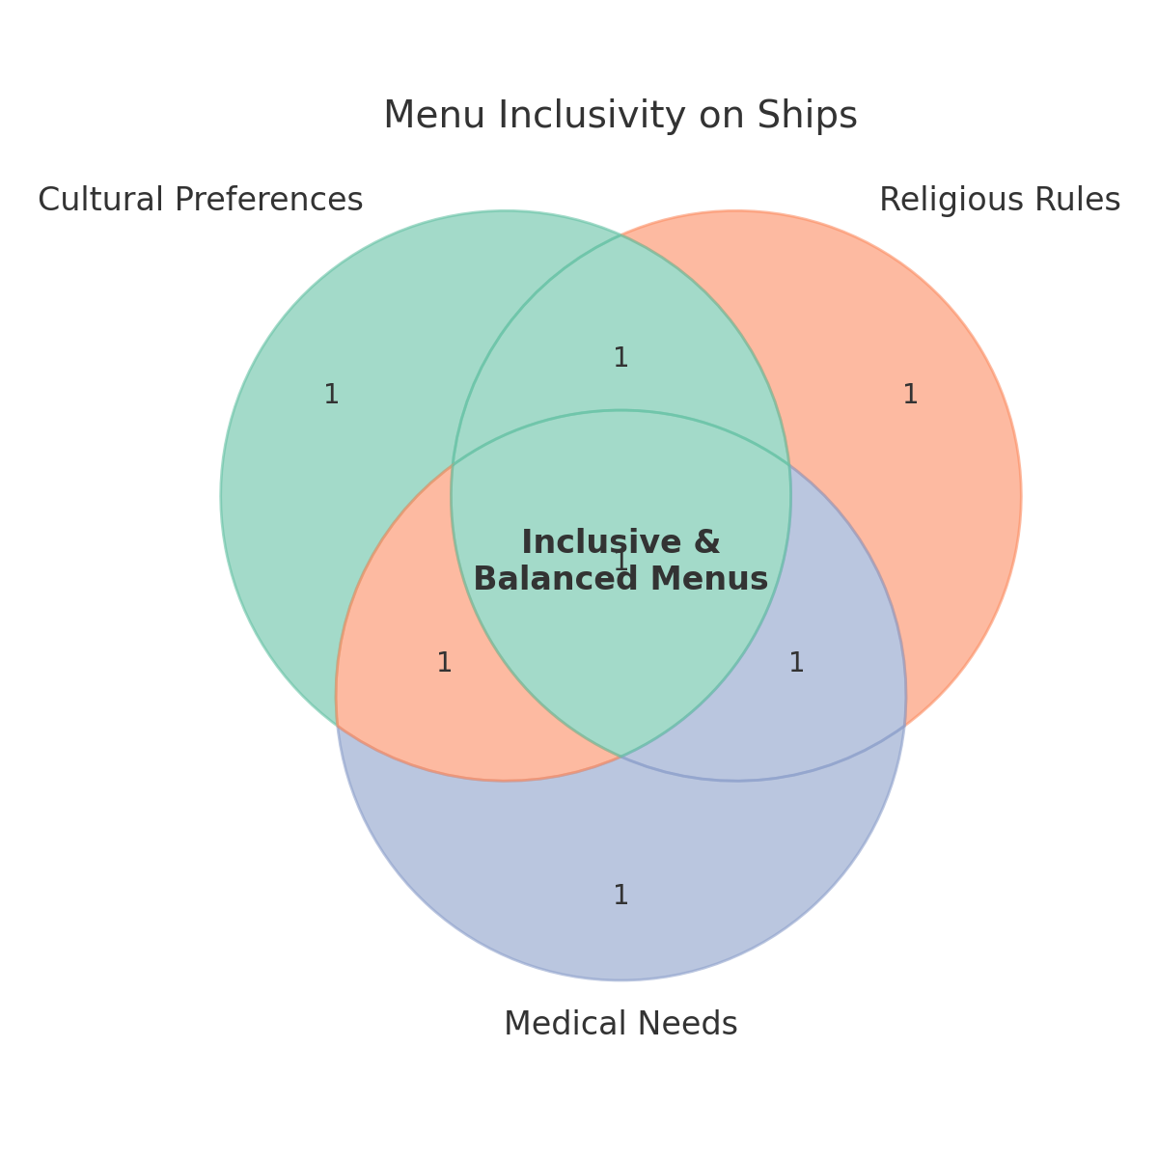
Figure 3. Venn diagram illustrating the three main considerations in shipboard menu planning: cultural preferences, religious rules, and medical needs. The overlap represents the goal of providing inclusive and balanced menus for all crew members.

DIVERSITY OF DIETS

It is common for a ship’s crew to include, for example, Southeast Asian, South Asian, Middle Eastern, and European seafarers working side by side. Each may have distinct dietary habits—rice-based meals with particular spices for some, bread or pasta for others; some may prefer seafood while others avoid it. There may also be vegetarians or crew who abstain from certain meats (such as pork or beef) for religious reasons. Catering to such a heterogeneous crew is challenging: as Sampson and Ellis (2019) note, cooks often struggle to meet every national preference, especially when they themselves come from a different cultural background. Nonetheless, effort should be made to ensure everyone has something they can eat and enjoy at each mealtime. This requires menu variety and flexibility—for example, providing a meat dish and a vegetarian option in parallel. Many larger vessels already offer such alternatives as standard practice. Over a week, rotating cuisines (e.g., curry, pasta, rice with fish) both respects cultural diversity and reduces diet monotony, which is a common source of dissatisfaction among seafarers (Oldenburg & Jensen, 2012).

RELIGIOUS DIETARY RESTRICTIONS
A cook must be aware of crew members who follow religious dietary laws, as these significantly influence what foods can or cannot be served. For example, Muslim seafarers require halal-certified food and strictly avoid pork and alcohol, Hindu crew typically avoid beef (with some adopting vegetarianism), and Buddhist or other vegetarian seafarers may abstain from all forms of meat. These restrictions must be carefully respected in daily menu planning. It is essential not only to label dishes clearly but also to ensure separate preparation areas or utensils when handling restricted items such as pork, in order to prevent cross-contamination. Such measures demonstrate respect for religious observance and help maintain trust between the galley and the crew.
Religious practices may also affect the timing and composition of meals. During Ramadan, Muslim crew members fast from dawn to sunset, requiring the kitchen to provide meals before sunrise and after sunset that are both nutritious and easy to digest. These meals should include fluids, fruits, and lighter proteins to prevent dehydration and fatigue during working hours. Similarly, observances such as Lent for Christian seafarers may involve abstaining from meat or favoring fish dishes. The Maritime Labour Convention (2006) explicitly requires that cultural and religious needs be taken into account in food provision, making this not just a matter of morale but also of regulatory compliance (ILO, 2006). Failing to address these needs risks lowering morale, creating feelings of exclusion, and in some cases violating seafarers’ rights.
Practical approaches to managing these requirements include stocking alternatives—for instance, serving chicken or fish alongside pork, or offering a vegetarian protein such as lentils or tofu when beef is on the menu. Varying protein sources across the week (pork one day, chicken the next, then fish, then legumes) can navigate around many dietary restrictions while keeping menus interesting. Small gestures such as providing condiments, spices, or side dishes familiar to different cultural groups can also make meals more acceptable and enjoyable. In addition, involving the crew directly by asking for feedback or hosting “cultural food nights” can strengthen inclusivity. Research shows that such practices not only accommodate dietary needs but also boost social cohesion and morale on board, turning the galley into a site of cultural exchange and community building (Sampson & Ellis, 2019).

OTHER DIETARY NEEDS
Beyond culture and religion, individual crew members may also present dietary requirements linked to specific medical conditions, and these must be taken just as seriously as cultural or religious needs. Common conditions encountered among seafarers include diabetes, hypertension, lactose intolerance, celiac disease, and food allergies. These conditions may not affect the majority of the crew, but failing to accommodate even a single individual can jeopardize their health and, in severe cases, their ability to carry out duties on board. For this reason, it is critical that such needs are communicated clearly to the galley staff at the start of the voyage and that these requirements are factored into menu planning and provisioning (WHO, 2006).
For example, diabetic crew members require meals that are low in refined sugars and include balanced proportions of carbohydrates, proteins, and fats to support stable blood glucose levels. They may also benefit from fiber-rich foods such as whole grains, legumes, and vegetables, which slow down glucose absorption. Similarly, crew members with hypertension should avoid high-sodium foods; instead, meals should be seasoned with herbs, spices, garlic, or lemon to provide flavor without excess salt. Lactose-intolerant individuals need alternatives such as lactose-free milk, yogurt, or plant-based substitutes like soy or almond milk, which must be provisioned in advance given the limited supply options at sea. Those with celiac disease require strictly gluten-free diets—meaning not only avoiding bread, pasta, or other wheat-based products but also preventing cross-contamination with gluten-containing foods during preparation. In some cases, food allergies (to nuts, shellfish, or eggs) may also require strict separation to avoid potentially life-threatening reactions.
Although these cases may represent a minority of the crew, addressing them demonstrates a commitment to comprehensive nutritional care. Importantly, many of the adjustments made for medical diets—such as reducing excess salt or sugar—benefit the entire crew, not only those with medical needs. By adopting a proactive approach, cooks can create meals that support overall health while ensuring that no crew member feels excluded or at risk. This reflects the principle that every seafarer, regardless of medical condition, has the right to safe and adequate food. Ultimately, respect and flexibility are key: when galley staff acknowledge the diverse makeup of the crew and adapt their provisioning accordingly, they foster not only health but also inclusivity, trust, and morale on board.

MENU PLANNING STRATEGIES FOR SHIPS

Planning menus for a seafaring voyage requires balancing nutrition, variety, storage limitations, and operational practicality. Unlike a shore-based restaurant that can source ingredients daily, a ship’s kitchen (galley) must work with what is on board for extended periods, making strategic menu planning essential. Below are key strategies for effective menu planning in the maritime context:
- Advance Planning and Cycle Menus: It is common practice to prepare a cycle menu, which is a planned set of meals that repeats every certain number of days (for example, a 7-day or 14-day cycle). A cycle menu helps ensure variety and balanced nutrition across each week. By planning in advance, the chef can distribute different protein sources, cuisines, and ingredient groups throughout the cycle. For instance, if beef stew is served on Monday of Week 1, fish curry on Tuesday, pasta with tomato sauce on Wednesday, and so on, the crew experiences a new main course each day and the pattern repeats in Week 3. This approach avoids back-to-back repetition of similar meals and can be aligned with the ship’s supply schedule. It also simplifies provisioning – the cook knows exactly which ingredients and quantities are needed for the cycle and can order appropriately before the voyage.
- Balanced Meal Composition: Each planned meal should be nutritionally balanced on its own and as part of the day’s overall intake. As discussed under macronutrients, balanced meals include a source of carbohydrates, protein, and fat, plus a serving of vegetables or fruit. For example, a dinner menu might consist of grilled fish (protein and healthy fat), boiled potatoes or rice (carb), and a side of mixed vegetables or salad, followed by fruit for dessert. This ensures the crew gets carbohydrates for energy, protein for tissue repair, and vitamins and fiber from vegetables. Menu planning should also account for the total daily intake – typically, providing three main meals (breakfast, lunch, dinner) and possibly additional lighter snacks or tea breaks. Breakfast could emphasize energy and protein (e.g., eggs, wholegrain bread, porridge, fruit), lunch and dinner can be heavier meals with substantial protein and veg content. It’s important to spread out nutrient-rich foods: for instance, if breakfast has dairy and fruit, lunch might emphasize vegetables and meat, and dinner includes fish and whole grains, achieving balance over the day. The planner should be mindful of not repeating the same type of food in every meal (avoid giving fried foods or sugary pastries at every turn). A good practice is to incorporate the “plate model” mentioned earlier (½ veg, ¼ protein, ¼ carb) in each main meal’s design .
- Variety and Preventing Menu Fatigue: Variety is not just about catering to different cultures, but also about providing a range of flavors, textures, and appearances in food to keep the crew interested in eating. A monotonous diet can lead to decreased appetite and nutrient intake. To prevent this, menu planning should rotate not only main ingredients but also cooking methods and cuisines. For example, alternate between stew, grilled, baked, and stir-fried dishes; include both hearty dishes and lighter ones; use spices and herbs to create different flavor profiles on different days. Even limited ingredients can be made interesting with different recipes (one day serve chicken as a curry, another day as a grilled herb chicken, another as a tomato-based stew). Including occasional treats or special meals can also boost morale – such as a weekly barbecue on deck, or a themed dinner (e.g., an Italian night with pasta and garlic bread, or an Asian night). These need not compromise nutrition if planned carefully (e.g., include salads and vegetable sides even on “burger night”). Variety extends to breakfast and desserts as well: instead of only offering eggs every morning, alternate with oatmeal, yogurt, or pancakes on some days; rotate different fruit or pudding desserts after dinner. A well-thought-out variety ensures all essential nutrients are covered and keeps the crew eager to eat, which in turn maintains their health .
- Using Fresh, Frozen, and Preserved Foods Wisely: Given that fresh produce has a limited shelf life, a smart strategy is to use fresh fruits, vegetables, and dairy products generously at the beginning of the voyage, and gradually transition to frozen or canned products later. For example, the first week’s salads can use fresh lettuce, tomatoes, and cucumbers, whereas by week three the salad might rely on hardy vegetables (cabbage, carrots) or canned beans. Similarly, offer fresh fruit (bananas, apples, oranges) daily while they last, then move to canned fruit or long-lasting options (citrus, melons) and finally to dried fruit or fruit juices when fresh supplies are depleted. Frozen vegetables are a nutrient-preserving alternative to fresh and should be included in stores – they can be just as nutritious as fresh and help extend the availability of greens on board. Proper inventory management is crucial: the cook should keep an inventory of perishable foods and plan menus to use items before they spoil. For instance, leafy greens and berries (which spoil quickly) might be used in the initial days, whereas pumpkins or cabbages (which keep longer) are saved for later. Coordination with port calls is another strategy: if the ship will enter port mid-voyage, the menu can be planned to run down supplies just in time for restocking, and then the cycle menu can refresh with new fresh goods after resupply . Whenever possible, taking aboard fresh produce at ports of call helps avoid nutrient gaps and prevent deficiencies . Cooks should also ensure proper storage conditions (refrigeration, humidity control) to prolong the life of fruits, vegetables, and meats . For example, root vegetables and unripe fruits can be kept in cool, ventilated storerooms; green leafy veg in refrigerated crispers; meat and fish in freezers or very cold fridges and thawed as needed. Good storage and handling practices (rotation of stock, checking temperatures, keeping stores clean and pest-free) are part of menu planning logistics that ensure the planned menu can actually be executed safely.
- Health-Conscious Cooking and Substitutions: Menu planning should incorporate current nutritional guidelines to promote health. This means limiting recipes that are deep-fried or overly rich in salt and fat, and favoring cooking techniques that preserve nutrients (steaming, grilling, baking) without excess oil. For example, instead of deep-frying fish, a menu might feature baked fish with herbs and a drizzle of olive oil, or stir-fried fish with vegetables. Salt intake can be controlled by using herbs, spices, garlic, and acids (like lemon juice or vinegar) to enhance flavor rather than relying on salt alone . The cook can prepare low-sodium soy sauce or salt substitutes if necessary. Sugar consumption should be moderated: rather than offering sugary pastries every day, incorporate naturally sweet options like fruit, and use moderate sugar in desserts. The menu can include a fruit salad or yogurt parfait as dessert on some days instead of cake. Providing healthier snack options is also a strategy, especially because ship crew often work in shifts and might need to eat at odd hours. Planning for snacks such as nuts, dried fruit, yogurt, whole-grain crackers, or boiled eggs can prevent crew from resorting too often to candy bars or instant noodles when they get hungry between meals . For late-night or watch-keeping crew, ensure there are leftover meals or easy-to-heat healthy options available (a soup or stew in the warmer, for instance). This kind of planning acknowledges the irregular meal times some seafarers face and helps maintain nutrition around the clock. Additionally, special diets should be integrated into the menu plan: if you know a crew member requires a low-cholesterol diet, incorporate sufficient grilled fish, oatmeal, and fruits that day for everyone (not just a separate meal), which will benefit the whole crew’s health as well. Essentially, planning with the “healthiest choice” in mind for each category of food will result in a menu that naturally steers clear of the worst dietary pitfalls. Shipping companies and marine catering services nowadays often provide nutritional guidelines or even software to help ship cooks analyze the menu’s nutritional content . Using these tools, a cook can verify that the planned meals meet approximate daily requirements for calories, protein, vitamins, etc., and adjust if something is lacking.
- Contingency Planning: A good menu plan also includes contingency options. Sea conditions or operational demands can sometimes disrupt meal schedules or preparation. For instance, rough weather might make cooking complicated dishes unsafe – in such cases, the cook should have simple, ready-to-eat meals planned (sandwiches, pre-made stew, etc.). The menu should be flexible to swap days if needed (e.g., if a planned barbecue on deck is rained out, have an indoor-friendly meal ready). Additionally, enough emergency rations (like long-life meals, protein bars) should be on board beyond the planned menu, in case the voyage is extended or resupply is delayed. While these are not part of the everyday menu, they are part of prudent planning for nutrition under unexpected circumstances.

Strategy | Key Practices | Practical Applications on Board
Advance Planning & Cycle Menus | Use 7–14 day repeating menus to ensure variety and simplify provisioning | Example: rotate beef, fish, poultry, vegetarian dishes; align menu with supply schedule
Balanced Meal Composition | Include carb, protein, fat + vegetables/fruit in each meal; spread nutrients | Breakfast with eggs/porridge + fruit; lunch with meat + veg; dinner with fish + whole grains
Variety & Preventing Fatigue | Rotate cuisines, cooking methods, and flavor profiles to avoid monotony | Curry one day, pasta another; alternate grilled, baked, stewed dishes; include cultural food nights
Using Fresh, Frozen & Preserved Foods | Use fresh produce early; switch to frozen/canned/dried later; manage inventory | Fresh lettuce/tomatoes week 1; cabbage/carrots later; frozen spinach, canned beans mid-voyage
Health-Conscious Cooking | Favor steaming, grilling, baking; reduce salt, sugar, fried foods | Bake fish instead of frying; season with herbs/spices; fruit salad or yogurt instead of pastries
Contingency Planning | Prepare simple backups and emergency rations for rough seas or delays | Sandwiches or ready stews in bad weather; protein bars or long-life meals as reserves
Table 3. Menu planning strategies for maritime catering: key practices and applications.

Example Scenario: Consider a chief cook preparing for a 30-day ocean crossing without port stops. He develops a 14-day cycle menu that will repeat twice, and a special meal for day 30 to celebrate voyage’s end. In week 1 of the cycle, he uses most of the fresh produce: green salads, fresh tomatoes, tropical fruits, and fresh milk are featured. By week 2, salads transition to coleslaw (using cabbage and carrots which last longer), fruit choices shift to oranges and apples (which have longer shelf life), and UHT milk replaces fresh milk in cooking. The menu includes fish four times a week (fresh fish for the first two weeks, then frozen fish), meat or poultry on other days, and a vegetarian protein (like a bean stew) once a week. Each dinner has two sides: a starchy side (potatoes, rice, or pasta) and a vegetable side (using fresh veggies early on, canned or frozen later). He also schedules two baking days per week to produce fresh bread and a healthy treat (like oatmeal raisin cookies with reduced sugar) to boost morale. Knowing the crew has both Asian and European members, he alternates between Asian-style meals (curry, stir-fry with rice) and Western-style meals (roast meat with potatoes, pasta) through the cycle, ensuring each group gets some familiar tastes. The cook plans healthier snacks (nuts, fruit, crackers) to be available in the mess, and posts reminders about drinking enough water. By anticipating the voyage length and crew needs, and planning a detailed menu accordingly, he can provision the right quantities and deliver a nutritionally adequate, varied diet throughout the passage. This level of planning aligns with maritime best practices and the requirements of MLC 2006 to provide high-quality food that keeps seafarers healthy .

REVIEW QUESTIONS

Macronutrients
What are the three main macronutrients, and what role does each play in supporting seafarers’ health and performance?
Why are complex carbohydrates preferred over simple carbohydrates for long working shifts at sea?
Micronutrients & Hydration
Give two examples of key vitamins and two examples of key minerals that are important for seafarers. What are their main food sources on board?
Why is hydration critical in maritime environments, and how much water should seafarers consume daily?
Cultural & Religious Needs
How can a cook plan meals to respect religious dietary restrictions such as halal, vegetarian, or fasting during Ramadan?
Why does the Maritime Labour Convention (2006) require consideration of cultural and religious diversity in food provision?
Medical & Individual Dietary Needs
Describe two medical conditions that may affect dietary requirements at sea. What adjustments should galley staff make for each?
Why is it important to communicate dietary needs at the start of a voyage?
Menu Planning Strategies
What is a cycle menu, and why is it useful for ships with limited provisioning opportunities?
How can using frozen or canned foods extend the nutritional adequacy of shipboard diets?
Critical Reflection
Imagine you are the ship’s cook on a vessel with a mixed crew of Filipino, Turkish, and Indian seafarers, including one diabetic and one vegetarian. Outline one day’s menu plan that addresses cultural, medical, and nutritional needs.

ANSWERS
1. Macronutrients
- What are the three main macronutrients, and what role does each play in supporting seafarers’ health and performance?
Answer: Carbohydrates provide primary energy, proteins repair muscles and support immunity, and fats supply long-term energy while aiding vitamin absorption and brain function.
- Why are complex carbohydrates preferred over simple carbohydrates for long working shifts at sea?
Answer: Complex carbs (e.g., rice, whole grains) release glucose slowly, providing steady energy and preventing spikes and crashes. Simple sugars cause rapid spikes followed by fatigue.

2. Micronutrients & Hydration
- Give two examples of key vitamins and two examples of key minerals that are important for seafarers. What are their main food sources on board?
Answer: Vitamin C (citrus, potatoes) prevents scurvy; Vitamin D (fish, fortified foods, sunlight) supports bone health. Iron (red meat, beans) prevents anemia; Calcium (dairy, leafy greens) supports bones and muscles.
- Why is hydration critical in maritime environments, and how much water should seafarers consume daily?
Answer: Hydration prevents fatigue, cognitive decline, and heat-related illness. Seafarers should drink 2–3 liters daily, more in hot climates or during heavy work.

3. Cultural & Religious Needs
- How can a cook plan meals to respect religious dietary restrictions such as halal, vegetarian, or fasting during Ramadan?
Answer: By labeling dishes clearly, avoiding cross-contamination, and offering alternatives (e.g., chicken instead of pork, lentils instead of beef). During Ramadan, meals must be provided before dawn and after sunset.
- Why does the Maritime Labour Convention (2006) require consideration of cultural and religious diversity in food provision?
Answer: Because seafarers have the right to adequate and appropriate food, and respecting cultural/religious needs boosts morale and prevents discrimination (ILO, 2006).

4. Medical & Individual Dietary Needs
- Describe two medical conditions that may affect dietary requirements at sea. What adjustments should galley staff make for each?
Answer: Diabetes → provide low-sugar, balanced meals; Hypertension → reduce salt, use herbs/spices. Other examples: lactose intolerance (use lactose-free milk), celiac disease (provide gluten-free foods).
- Why is it important to communicate dietary needs at the start of a voyage?
Answer: To allow galley staff to provision appropriately, prevent health risks, and ensure safe, adequate food for all crew.

5. Menu Planning Strategies
- What is a cycle menu, and why is it useful for ships with limited provisioning opportunities?
Answer: A repeating set of meals (7–14 days) that ensures variety, simplifies provisioning, and avoids repetition.
- How can using frozen or canned foods extend the nutritional adequacy of shipboard diets?
Answer: They preserve vitamins and minerals, extend shelf life, and allow crews to maintain balanced meals after fresh supplies are depleted.

6. Critical Reflection
- Imagine you are the ship’s cook on a vessel with a mixed crew of Filipino, Turkish, and Indian seafarers, including one diabetic and one vegetarian. Outline one day’s menu plan that addresses cultural, medical, and nutritional needs.
Sample Answer:
  - Breakfast: Oatmeal with fruit (suitable for diabetic and vegetarian), boiled eggs, yogurt.
  - Lunch: Grilled chicken adobo (Filipino), lentil curry with rice (Indian vegetarian), mixed salad.
  - Dinner: Fish stew (Turkish style), vegetable stir-fry, whole-grain bread, fruit dessert.
Meals avoid excess sugar/salt, include protein variety, and provide vegetarian/diabetic-friendly options.

REFERENCES

- Carpenter, K. J. (2012). The history of scurvy and vitamin C. Cambridge University Press.
- Grappasonni, I., Petrelli, F., Scuri, S., Mahdi, S. S., & Kracmarova, L. (2013). Knowledge and attitudes on food hygiene among ship’s catering staff: Results from an international survey. International Maritime Health, 64(4), 199–204.
- International Labour Organization (ILO). (2006). Maritime Labour Convention (MLC 2006). Geneva: ILO.
- International Transport Workers’ Federation (ITF). (n.d.). Healthy eating. ITF Seafarers’ Health Section.
- Oldenburg, M., & Jensen, H. J. (2012). Food and nutrition on board: The neglected safety factor. International Maritime Health, 63(4), 210–216.
- Rahman, S., Hasan, M., & Karim, M. (2022). Sustainable food sourcing and waste reduction strategies in maritime catering. Journal of Marine and Island Cultures, 11(2), 85–97.
- Sampson, H., & Ellis, N. (2019). Seafarers’ mental health and wellbeing: The role of food and social life at sea. Maritime Policy & Management, 46(7), 861–875.
- World Health Organization (WHO). (2006). Guiding principles for feeding of seafarers and offshore workers. Geneva: WHO.
- World Health Organization (WHO). (2021). Guideline for sodium intake in adults and children. Geneva: WHO.

