KA220-VET - Cooperation partnerships in vocational education and training
2023-1-RO01-KA220-VET-000156711

MARitime Soft Skills for Onboard Healthy Nutrition and CULinary Arts in Seagoing Services – CUL-MAR-Skills

ONBOARD COOKING SKILLS

Training module IV, Week 1

Introduction to Maritime Culinary Arts

  - AUTHOR: UĞUR KAÇAN

2025

BLANK PAGE

FOREWORD
In maritime operations, food is more than daily sustenance; it is central to crew health, morale, safety, and operational efficiency. A ship may have advanced navigation systems, powerful engines, and skilled officers, but without a well-fed and motivated crew, the voyage cannot succeed. The galley is the vessel’s heart, where maritime culinary professionals balance limited space, constrained provisions, constant motion, and strict international regulations with adaptability, technical skill, and creativity. Meals foster community, strengthen bonds among multinational crew members, and provide a sense of belonging in distant waters. Sustainable practices—such as waste reduction, responsible sourcing, and energy-efficient cooking—are increasingly crucial as the shipping industry strives to limit its environmental impact. Studies in culinary education emphasize the importance of integrating sustainability and ethical practices to cultivate responsible future chefs (Sathatip et al., 2025). The course on Maritime Culinary Arts equips participants with the knowledge and skills to meet seafarers’ nutritional demands, uphold hygiene and safety standards, encourage multicultural teamwork, and embrace sustainable operations. Learners will not only master cooking at sea but also lead, innovate, and uphold the values essential to the next generation of maritime culinary professionals.

COURSE STRUCTURE
This unit begins with techniques for enhancing the flavor of nutritious meals using healthy ingredients. Learners explore how to highlight natural tastes from fresh produce, whole grains, and lean proteins while reducing reliance on excess fats, sugars, and salts. Emphasis is placed on creative pairings and preparation methods that maximize limited provisions at sea without compromising nutritional value (Nestle, 2021).The course then turns to the role of seasoning, herbs, and spices in building balanced flavors. Participants learn to combine both familiar and globally inspired seasonings, applying them to transform simple dishes into satisfying meals. Special attention is given to balancing salty, sweet, sour, and bitter notes while reducing the need for unhealthy additives.Building on this foundation, learners examine cooking techniques that help retain essential nutrients, with a focus on steaming, grilling, and light sautéing. Careful temperature control and minimal processing are emphasized as strategies to preserve vitamins and minerals and ensure meals contribute to long-term health.Finally, the unit concludes with practical cooking sessions designed to replicate galley conditions. Learners apply the knowledge gained to prepare meals that are efficient, visually appealing, and nutritious. These exercises highlight time management, plating, and teamwork, demonstrating how efficiency and quality can coexist in maritime food service.

Contents
1. INTRODUCTION TO THE COURSE 4
1.2. DEFINITION AND SCOPE OF MARITIME CULINARY ARTS 5
1.3. UNIQUE CHALLENGES OF WORKING IN A GALLEY 5
1.4. CORE RESPONSIBILITIES OF GALLEY STAFF 6
1.5. THE ROLE OF FOOD IN CREW MORALE AND OPERATIONAL EFFICIENCY 7
2. UNDERSTANDING THE IMPORTANCE OF PROVIDING NUTRITIOUS AND BALANCED MEALS AT SEA 8
2.1. NUTRITIONAL REQUIREMENTS OF SEAFARERS (MACRONUTRIENTS, MICRONUTRIENTS, HYDRATION) 8
2.2. THE IMPACT OF DIET ON HEALTH, PERFORMANCE, AND SAFETY 8
2.3. PSYCHOLOGICAL AND CULTURAL VALUE OF FOOD IN MARITIME LIFE 9
2.4. MENU PLANNING FOR LONG VOYAGES AND LIMITED PROVISIONS 10
2.5. SUSTAINABILITY AND WASTE MANAGEMENT IN MARITIME KITCHENS 11
3. REVIEW QUESTIONS 11
4. REFERENCES 12

INTRODUCTION TO THE COURSE
LEARNING OBJECTIVES
This unit is designed to provide learners with a foundational understanding of maritime culinary arts and their impact on seafaring life. The objectives highlight both technical and cultural aspects of galley work, preparing learners to appreciate the strategic importance of food at sea.
By the end of this unit, learners will be able to:
- Explain the scope and significance of maritime culinary arts in relation to crew health, morale, and operational safety.
- Identify the core responsibilities of galley staff and the skills required to perform effectively in shipboard kitchens.
- Recognize the constraints of the galley environment and propose strategies to overcome challenges such as limited space, motion, and supplies.
- Describe the cultural and social dimensions of food at sea, including its role in building cohesion among multinational crews.
- Evaluate how nutrition, hygiene, and menu planning contribute to both individual wellbeing and overall voyage success.

DEFINITION AND SCOPE OF MARITIME CULINARY ARTS
Maritime culinary arts can be defined as the specialized branch of gastronomy that deals with the preparation, management, and service of food within the unique conditions of ships and other seagoing vessels. Unlike conventional kitchens on land, galleys operate under strict limitations: reduced space, limited resources, irregular supply chains, and continuous environmental challenges such as vibration and movement at sea (Günüşen & Seferoğlu, 2020). The scope of maritime culinary arts extends far beyond cooking alone. It includes:
- Menu Planning and Design: Crafting menus that balance nutrition, cultural diversity, and resource availability.
- Food Preservation and Storage: Applying freezing, vacuum sealing, and other techniques to prolong shelf life during long voyages.
- Nutritional Management: Ensuring that meals meet the energy and health requirements of seafarers engaged in demanding work.
- Sustainability Practices: Reducing waste, conserving resources, and using eco-friendly methods in line with international maritime regulations.
- Cultural and Social Dimensions: Recognizing food as a means of building cohesion, morale, and inclusivity in multicultural crews.
Maritime culinary arts therefore combine the science of nutrition, the art of cooking, and the logistics of supply management into one integrated discipline essential to maritime operations.

UNIQUE CHALLENGES OF WORKING IN A GALLEY
Working in a galley differs significantly from working in a land-based kitchen. The challenges are unique and demand a high level of creativity, discipline, and adaptability from galley staff. Unlike restaurants on land, where supplies and space are more flexible, shipboard cooks operate in highly constrained conditions that directly affect both the process and the outcome of meal preparation (Grappasonni et al., 2013).
- Restricted Space – Galleys are compact, leaving little room for movement or large-scale equipment. Chefs must maximize efficiency in tight quarters, organize tools precisely, and maintain safety despite congestion. Even routine tasks require spatial awareness and planning.
- Constant Motion – Rough seas and continuous ship movement make cooking physically demanding. Pots, pans, and utensils must be secured, and staff must adapt their techniques to maintain balance and prevent accidents in unpredictable conditions.
- Limited Supplies – Food stocks are planned weeks or months in advance. Fresh produce becomes scarce after departure, leading to reliance on preserved, frozen, or canned items. Effective menu planning is therefore essential to maintain nutrition and variety over time.
- Strict Hygiene and Safety Protocols – The risk of foodborne illness is critical in isolated environments where medical care is limited. Hygiene standards must be uncompromising, with staff following Hazard Analysis and Critical Control Points (HACCP) procedures to prevent outbreaks.
- Time Pressure and High Volume – Galley staff often provide meals for dozens or hundreds of crew members on strict schedules, usually with minimal personnel. This creates intense time pressure, requiring efficiency and teamwork.
- Cultural Diversity – Multinational crews bring varied dietary restrictions, religious practices, and cultural preferences. Respecting these differences is vital not only for nutrition but also for morale and inclusivity at sea.
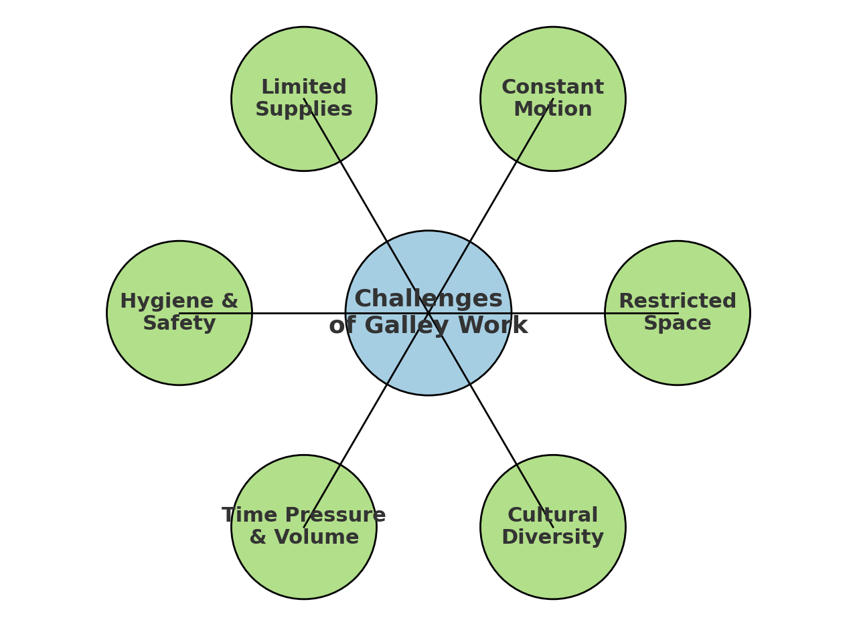
Figure 1Key challenges of working in a shipboard galley, including restricted space, constant motion, limited supplies, strict hygiene and safety requirements, time pressure, and cultural diversity.
These challenges demonstrate why maritime culinary professionals require specialized training that blends practical skills, technical knowledge, and awareness of maritime safety standards. The ability to adapt menus, preserve nutritional value, and ensure cultural inclusivity under such conditions defines the professionalism expected of cooks working at sea.

CORE RESPONSIBILITIES OF GALLEY STAFF
Galley staff are central to the health, morale, and efficiency of shipboard life. Beyond cooking, they manage a complex system where nutrition, safety, and teamwork converge to sustain daily operations at sea. Their responsibilities include:
- Meal Preparation and Service – Cooking daily meals that are nutritious, appealing, and sufficient in portion size. Meals must meet the energy demands of physically intensive maritime work while also being culturally acceptable to a diverse crew.
- Menu Planning – Designing meal cycles that avoid monotony, provide variety, and ensure balanced nutrition over long voyages. Effective menu planning is critical to maintain crew health and prevent deficiencies such as vitamin loss during extended voyages.
- Inventory and Supply Management – Monitoring stock levels, preventing shortages, and minimizing waste. This requires careful calculation of provisions before departure, as replenishment opportunities may be infrequent.
- Food Safety and Hygiene – Implementing Hazard Analysis and Critical Control Points (HACCP) protocols and adhering to international maritime regulations to prevent contamination and illness. Since medical support is limited at sea, prevention is paramount.
- Team Coordination – Working closely with other staff to ensure smooth service in high-pressure conditions. Galley operations demand strong communication and collaboration, especially when meal schedules align with crew watch rotations.
- Adaptability and Problem-Solving – Adjusting menus or techniques when equipment fails, supplies run low, or emergencies arise. Flexibility and creativity ensure continuity of service even under unpredictable circumstances.
These duties are not only technical but also strategic. Galley staff directly influence crew morale, health, and operational efficiency, making their role essential to the overall success of maritime missions (Oldenburg & Jensen, 2012).

THE ROLE OF FOOD IN CREW MORALE AND OPERATIONAL EFFICIENCY
Food at sea is more than sustenance—it is a cornerstone of daily life and operational stability.
- Boosting Morale – Well-prepared meals provide comfort and familiarity, easing stress, homesickness, and isolation. Celebratory meals such as birthdays, holidays, or national festivals strengthen team spirit and reinforce a sense of belonging in the otherwise isolating environment of life at sea (Oldenburg & Jensen, 2012).
- Supporting Health and Safety – Balanced meals sustain physical energy, reduce fatigue, and prevent deficiencies that could compromise both personal wellbeing and shipboard safety. Adequate nutrition has been linked to fewer accidents and improved physical resilience during demanding work at sea (Grappasonni et al., 2013).
- Cultural Inclusivity – Diverse menus respect the backgrounds of multinational crews, reducing cultural friction and promoting unity. Offering culturally sensitive options, such as vegetarian dishes or halal preparations, helps ensure that all crew members feel respected and included.
- Operational Efficiency – A nourished crew is more focused, alert, and capable of performing their duties, which minimizes mistakes and accidents. Inadequate or monotonous diets, by contrast, have been associated with lower work performance and rising tensions on board (Oldenburg & Jensen, 2012).
- Routine and Structure – Regular mealtimes create rhythm in the otherwise unpredictable schedule of maritime life, providing psychological stability. This structure is especially valuable during long voyages, when consistent routines help reduce stress and improve crew adaptability.

In this way, food contributes to both the human element of seafaring—wellbeing, morale, and unity—and the operational element—safety, productivity, and efficiency.

UNDERSTANDING THE IMPORTANCE OF PROVIDING NUTRITIOUS AND BALANCED MEALS AT SEA

NUTRITIONAL REQUIREMENTS OF SEAFARERS (MACRONUTRIENTS, MICRONUTRIENTS, HYDRATION)
Seafarers face physically demanding work, irregular sleep cycles, and stressful environments. Their diets must therefore be carefully designed to provide both immediate energy and long-term health benefits. Research has shown that nutrition directly influences fatigue levels, accident risk, and overall crew performance (Oldenburg & Jensen, 2012).
- Macronutrients – Carbohydrates provide the primary source of energy needed for heavy labor, proteins support muscle repair and immune function, and healthy fats deliver sustained energy as well as cognitive support for decision-making. A balanced intake of these macronutrients is critical to maintaining endurance throughout long shifts at sea.
- Micronutrients – Vitamins and minerals are essential to prevent fatigue, illness, and nutrient deficiencies. For example, vitamin C prevents scurvy, vitamin D supports bone and immune health during long voyages with limited sunlight, and iron ensures effective oxygen transport and stamina (Grappasonni et al., 2013).
- Hydration – Dehydration is a constant risk due to extended working hours, salt exposure, and limited availability of fresh water. Meals can support hydration by incorporating soups, fruits, and vegetables with high water content, helping the crew avoid the concentration lapses and health problems associated with fluid loss.

Balanced nutrition ensures seafarers maintain stamina, concentration, and resilience under challenging conditions, reinforcing both individual wellbeing and operational safety.

THE IMPACT OF DIET ON HEALTH, PERFORMANCE, AND SAFETY
The food served on board has a direct impact on both personal health and the overall safety of maritime operations. In a closed environment like a ship, where the crew’s wellbeing is directly tied to their ability to perform demanding tasks, meals take on a significance that extends far beyond simple nourishment.
• Health – Poor nutrition can result in fatigue, weakened immunity, and long-term vulnerability to chronic conditions such as obesity, hypertension, or cardiovascular disease. In the confined environment of a vessel, even minor health problems can escalate quickly, as access to medical care is limited. A consistently balanced diet, on the other hand, maintains physical strength, supports immune defenses, and reduces the likelihood of illness spreading among crew members.
• Performance – Nutrient-rich meals improve focus, reaction time, and decision-making. These qualities are especially vital in critical shipboard tasks such as navigation, watchkeeping, and engine operations, where lapses in attention or judgment can have immediate and serious consequences. Properly fed crew members are more alert, less prone to errors, and able to sustain performance over long working hours and irregular shifts.
• Safety – Malnourished, fatigued, or dehydrated crew members are significantly more prone to accidents. Whether it is a slip in the galley, a mistake during cargo handling, or misjudgment during emergency procedures, the risks associated with poor nutrition directly endanger the ship, its cargo, and its people. Nutrition is therefore not simply a matter of comfort or morale, but a critical safeguard against operational hazards.
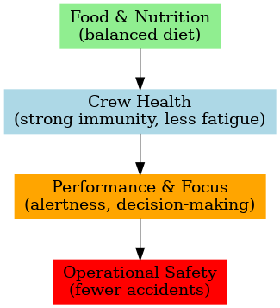
Figure 2. The link between food, crew health, performance, and operational safety. Balanced nutrition strengthens health, supports alertness, and reduces accidents, making food a critical safety factor at sea.

PSYCHOLOGICAL AND CULTURAL VALUE OF FOOD IN MARITIME LIFE
Food at sea also fulfills powerful psychological and cultural functions that go beyond its nutritional value. In the isolated and demanding environment of a vessel, meals become a vital source of comfort, community, and identity for seafarers. The galley is not only where food is prepared but also where the rhythms of daily life are reinforced and the multicultural character of the crew is celebrated (Sampson & Ellis, 2019).
- Emotional Comfort – Warm, well-prepared meals reduce stress, ease anxiety, and counter feelings of homesickness or isolation. The sensory familiarity of certain dishes can reconnect crew members to their families and cultures ashore, providing reassurance during long voyages.
- Routine and Stability – Shared mealtimes bring predictability to an otherwise irregular schedule of watches and duties. This structure offers crew members consistent opportunities to pause, rest, and reset, supporting both mental wellbeing and collective discipline on board.
- Cultural Inclusivity – Ships often have multinational crews, and food is one of the most tangible ways to acknowledge and respect diversity. Incorporating different cuisines, preparing vegetarian or halal options, and honoring religious dietary rules foster mutual respect, reduce cultural friction, and strengthen cohesion among crew members.
- Celebration and Community – Special meals for holidays, birthdays, or port arrivals transform the galley into the vessel’s social heart. These occasions strengthen team spirit, create shared memories, and remind seafarers that they are part of a supportive community despite the physical distance from home.

In short, food at sea nurtures both body and spirit. It functions as a bridge between cultures, a stabilizing anchor of routine, and a source of joy and belonging, reinforcing the essential human dimension of maritime life.

MENU PLANNING FOR LONG VOYAGES AND LIMITED PROVISIONS
Unlike land-based kitchens that can restock frequently, galleys must anticipate the needs of the crew for weeks or even months in advance while working with limited storage capacity. Menu planning in this context becomes a strategic task that links nutrition, morale, and operational safety. It demands not only knowledge of food science but also creativity in designing menus that stay appealing under constraints. Effective planning minimizes waste, prevents shortages, and ensures that the crew receives balanced meals throughout all phases of a voyage.
A well-structured plan also accounts for the changing nature of supplies over time. Fresh produce and dairy may be abundant in the first days after departure, but by the third or fourth week, cooks must rely on frozen, canned, or dried items. A cycle menu helps manage this transition smoothly, maintaining variety while avoiding repetitive dishes that can harm morale. At the same time, provision planning must respect cultural and dietary needs of multinational crews, ensuring inclusivity and avoiding conflict around meals.
Element | Description | Example Application
Preservation Techniques | Freezing, vacuum-packing, and canning extend the usability of provisions and reduce spoilage. | Frozen vegetables replacing fresh produce in mid-voyage menus.
Provision Rotation | Using perishable items first, then transitioning to preserved goods, maintains freshness and balance. | Leafy greens and dairy used in the first week, followed by root vegetables and UHT milk.
Menu Cycles | Structured meal plans prevent monotony, ensure nutritional balance, and allow efficient supply use. | A 14-day rotation including fish twice weekly, legumes twice, and theme nights.
Adaptability | When ingredients run out, cooks substitute creatively without compromising nutrition or taste. | Using canned tomatoes instead of fresh or replacing meat with legumes.
Table 1. Core Elements of Shipboard Menu Planning
Beyond logistics, menu planning also contributes to the psychological stability of seafarers. Knowing that meals are thoughtfully organized gives crew members reassurance and a sense of predictability in an otherwise unpredictable environment. For the galley staff, it provides a framework that reduces daily decision-making stress, allowing them to focus on execution rather than constant improvisation. In this sense, menu planning is not only a technical responsibility but also a morale-boosting tool that shapes the everyday life of the vessel.

SUSTAINABILITY AND WASTE MANAGEMENT IN MARITIME KITCHENS
The responsibility of the galley extends beyond feeding the crew—it also plays a vital role in protecting the environment and ensuring the operational efficiency of the vessel. Because ships are self-contained ecosystems with limited storage and disposal options, sustainable practices are not optional but essential. They help reduce waste, optimize resource use, and demonstrate compliance with both company policies and international maritime regulations such as MARPOL Annex V, which governs garbage management at sea (IMO, 2017).
- Portion Control – Careful portioning prevents overproduction and limits unnecessary food disposal. Standard ladles, scoops, and trays can be used to serve consistent amounts, ensuring fairness for the crew while cutting down on plate waste. This approach also helps stretch provisions over long voyages, lowering costs and reducing the vessel’s environmental footprint.
- Creative Use of Leftovers – Surplus food can be safely transformed into soups, stews, casseroles, or baked goods. This practice not only minimizes waste but also introduces variety into the menu. When done correctly, it reinforces food safety protocols while supporting sustainability goals.
- Eco-Friendly Sourcing – Whenever possible, selecting certified sustainable seafood, seasonal produce, and ingredients with minimal packaging reduces the strain on both the environment and the ship’s limited storage. Ethical sourcing also aligns with global maritime industry efforts to reduce ecological impact and meet consumer expectations for sustainable operations (Rahman et al., 2022).
- Waste Segregation and Recycling – Effective separation of organic, recyclable, and non-recyclable waste ensures compliance with international regulations. Onboard systems such as compactors and designated storage areas are essential for preventing contamination, controlling pests, and ensuring proper disposal when the ship reaches port.
By linking nutrition with sustainability, maritime kitchens safeguard crew health while contributing to global environmental objectives. In this way, every meal served becomes not only a source of nourishment but also a step toward responsible maritime practice and ecological stewardship.

REVIEW QUESTIONS
- Definition and Scope
  - How do maritime culinary arts differ from land-based culinary practices?
  - In what ways do galley staff contribute to both the operational success and the cultural life of a vessel?
- Challenges in the Galley
  - What are the unique challenges of working in a galley, and how do they influence cooking methods and menu planning?
  - How should galley staff adapt to limited space, resources, and constant ship motion?
- Responsibilities of Galley Staff
  - List and explain the core responsibilities of galley staff during long voyages.
  - Why is adaptability considered one of the most important qualities for galley staff?
- Nutrition and Health
  - What are the key macronutrients and micronutrients required for seafarers, and why are they important?
  - How does proper hydration contribute to performance and safety at sea?
- Impact on Performance and Safety
  - In what ways does diet directly affect operational efficiency and safety on board?
  - Provide examples of how poor nutrition might increase the risk of accidents or health issues.
- Psychological and Cultural Role of Food
  - Why are meals considered central to crew morale in maritime life?
  - How can culturally inclusive menus strengthen teamwork and unity among multinational crews?
- Menu Planning and Provision Management
  - What strategies are used to ensure balanced nutrition during long voyages with limited provisions?
  - How do preservation techniques like freezing and vacuum-packing support meal planning?
- Sustainability and Waste Management
  - What practices can galley staff adopt to reduce food waste and operate sustainably?
  - How does sustainability in maritime kitchens connect to global environmental goals?
- Reflection
  - In your opinion, why is food often referred to as both a nutritional necessity and a social anchor in maritime life?

REFERENCES
- Grappasonni, I., Petrelli, F., Scuri, S., Mahdi, S. S., & Kracmarova, L. (2013). Knowledge and attitudes on food hygiene among ship’s catering staff: Results from an international survey. International Maritime Health, 64(4), 199–204.
- Günüşen, N., & Seferoğlu, S. S. (2020). Food and nutrition management on ships: Challenges and best practices. Journal of Maritime Studies, 12(3), 45–59.
- International Labour Organization (ILO). (2006). Maritime Labour Convention (MLC 2006). Geneva: ILO.
- International Maritime Organization (IMO). (2016). International Convention on Standards of Training, Certification and Watchkeeping for Seafarers (STCW), including the Manila Amendments. IMO Publishing.
- International Maritime Organization (IMO). (2017). MARPOL consolidated edition 2017: Articles, protocols, annexes and unified interpretations of the International Convention for the Prevention of Pollution from Ships, 1973, as modified by the 1978 and 1997 Protocols. IMO Publishing.
- Oldenburg, M., & Jensen, H. J. (2012). Food and nutrition on board: The neglected safety factor. International Maritime Health, 63(4), 210–216.
- Rahman, S., Hasan, M., & Karim, M. (2022). Sustainable food sourcing and waste reduction strategies in maritime catering. Journal of Marine and Island Cultures, 11(2), 85–97.
- Sampson, H., & Ellis, N. (2019). Seafarer’s mental health and wellbeing: The role of food and social life at sea. Maritime Policy & Management, 46(7), 861–875.

